

***Winchester City Council***

***LAQM Progress Report 2013***

*Bureau Veritas Air Quality*

*February 2015*



**Document Control Sheet**

|  |  |  |  |
| --- | --- | --- | --- |
| Issue/Revision | Issue 1 | Issue 2 | Issue 3 |
| Remarks | Draft | Final |  |
| Date | 22/11/2013 | 19/02/2015 |  |
| Submitted to | Phil Tidridge | Phil Tidridge |  |
| Prepared by | Samantha Munn | J Clayton |  |
| Signature |  |  |  |
| Approved by | Ben Warren | A Wiatr |  |
| Signature |  |  |  |
| Project number | 7351442 | 7351442 |  |
| File reference | 2903 | 2903 |  |

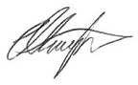Disclaimer

This Report was completed by Bureau Veritas on the basis of a defined programme of work and terms and conditions agreed with the Client. Bureau Veritas’ confirms that in preparing this Report it has exercised all reasonable skill and care taking into account the project objectives, the agreed scope of works, prevailing site conditions and the degree of manpower and resources allocated to the project.

Bureau Veritas accepts no responsibility to any parties whatsoever, following the issue of the Report, for any matters arising outside the agreed scope of the works.

This Report is issued in confidence to the Client and Bureau Veritas has no responsibility to any third parties to whom this Report may be circulated, in part or in full, and any such parties rely on the contents of the report solely at their own risk.

Unless specifically assigned or transferred within the terms of the agreement, the consultant asserts and retains all Copyright, and other Intellectual Property Rights, in and over the Report and its contents.

Any questions or matters arising from this Report should be addressed in the first instance to the report author.

Bureau Veritas UK Limited

Brandon House

180 Borough High Street

SE1 1LB

Telephone: +44 (0) 207 902 6100

Fax: +44 (0) 207 902 6149

Registered in England 1758622 [www.bureauveritas.co.uk](http://www.bureauveritas.co.uk/)

Registered Office

Brandon House

180 Borough High Street

SE1 1 LB

|  |  |
| --- | --- |
| **Local Authority**  **Officer** | Phil Tidridge |
|  |  |
| **Department** | Environmental Health |
| **Address** | Winchester City Council  City Offices Colebrook Street Winchester  SO23 9LJ |
| **Telephone** | 01962 848 519 |
| **e-mail** | [PTridridge@winchester.gov.uk](mailto:PTridridge@winchester.gov.uk) |
|  |  |
| **Report Reference number** | APR Winchester City Council |
| **Date** | February 2015 |

**Executive Summary**

Part IV of the Environment Act 1995 places a statutory duty on local authorities to review and assess the air quality within their area and take account of Government Guidance when undertaking such work. This Annual Progress Report is a requirement of the Fifth Round of Review and Assessment and is a requirement for all local authorities. The Report has been undertaken in accordance with the Technical Guidance LAQM.TG (09) and associated tools (as updated in 2010).

This Annual Progress Report considers all new monitoring data and assesses the data against the Air Quality Strategy objectives. It also considers any changes that may have an impact on air quality.

Updated monitoring showed that there were a number of locations within the existing AQMA where the annual mean objective for NO2 was exceeded, as such the AQMA should remain in place. In addition Site 16, Alresford Road (M3) also showed an exceedence of the annual mean objective. There is no relevant exposure at this monitoring location.

There were three sites where the annual mean concentration was greater than 60µg/m3. An annual mean concentration of greater than 60µg/m3 indicates the potential for exceedence of the 1-hour objective. It is therefore recommended that a Detailed Assessment be

undertaken with respect the 1-Hour Objective for NO2 for the St Georges Street and Romsey

Road areas.

With regards to PM10, the updated monitoring for 2012 shows that the AQS Objectives for

PM10 continue to be met at both monitoring locations within the City.

Winchester City Council have reviewed local developments in the District and have identified three new housing developments which will require further review in the next Updating and Screening Assessment. It is also recommeneded that the current NO2 monitoring locations be reviewed to ensure that identified receptor locations within the area of the Barton Farm development are being monitored.

Proposed actions arising from the 2013 Annual Progress Report are as follows:

Continue NO2 diffusion tube monitoring in the district to identify future changes in pollutant concentrations;

Undertake a Detailed Assessment with regards to the hourly objective for NO2 for the

St Georges Street and Romsey Road areas;

Review the current NO2 diffusion tube monitoring locations to ensure that the area surrounding the Barton Farm developed has monitoring in place at those receptors identified as having the potential to exceed the annula mean objective for NO2; and

Proceed to a Progress Report in 2014.

**Table of Contents**

**1 Introduction 6**

1.1 Description of Local Authority Area 6

1.2 Purpose of Progress Report 6

1.3 Air Quality Objectives 6

1.4 Summary of Previous Review and Assessments 8

**2 New Monitoring Data 11**

2.1 Summary of Monitoring Undertaken 11

2.2 Comparison of Monitoring Results with Air Quality Objectives 21

**3 New Local Developments 41**

3.1 Road Traffic Sources 41

3.2 Other Transport Sources 41

3.3 Industrial Sources 42

3.4 Commercial and Domestic Sources 42

3.5 New Developments with Fugitive or Uncontrolled Sources 42

**4 Local / Regional Air Quality Strategy 44**

**5 Planning Applications 45**

**6 Air Quality Planning Policies 48**

**7 Local Transport Plans and Strategies 49**

**8 Climate Change Strategies 50**

**9 Implementation of Action Plans 51**

**10 Conclusions and Proposed Actions 63**

10.1 Conclusions from New Monitoring Data 63

10.2 Conclusions relating to New Local Developments 63

10.3 Proposed Actions 64

**11 References 65**

**Appendix A: QA:QC Data 67**

**Appendix B: USA Additional Information 74**

**Road Traffic Sources 75**

Narrow Congested Streets with Residential Properties Close to the Kerb 75

Busy Streets Where People May Spend 1-hour or More Close to Traffic 75

Roads with a High Flow of Buses and/or HGVs. 76

Junctions 76

New Roads Constructed or Proposed Since the Last Round of Review and

Assessment 76

Roads with Significantly Changed Traffic Flows 77

Bus and Coach Stations 77

**Other Transport Sources 78**

Airports 78

Railways (Diesel and Steam Trains) 78

Ports (Shipping) 78

**Industrial Sources 79**

Industrial Installations 79

Major Fuel (Petrol) Storage Depots 79

Petrol Stations 80

Poultry Farms 80

**Commercial and Domestic Sources 81**

Biomass Combustion – Individual Installations 81

Biomass Combustion – Combined Impacts 81

Domestic Solid-Fuel Burning 81

**Fugitive or Uncontrolled Sources 82**

**List of Tables**

Table 1-1 Air Quality Objectives included in Regulations for the purpose of LAQM in England 7

Table 2-1 Details of Automatic Monitoring Sites 13

Table 2-2 Details of Non- Automatic Monitoring Sites – City Centre 16

Table 2-3 Details of Non- Automatic Monitoring Sites – District Study 19

Table 2-4 Results of Automatic Monitoring for NO2: Comparison with Annual Mean Objective 23

Table 2-5 Results of Automatic Monitoring for NO2: Comparison with 1-hour Mean Objective 23

Table 2-6 Results of NO2 Diffusion Tubes 2012 – City Study 25

Table 2-7 Results of NO2 Diffusion Tubes 2012 – District Study 28

Table 2-8 Results of NO2 Diffusion Tubes (2008 to 2012) – City Study 30

Table 2-9 Results of NO2 Diffusion Tubes (2008 to 2012) – District Study 33

Table 2-10 Results of Automatic Monitoring for PM10: Comparison with Annual Mean Objective 38

Table 2-11 Results of Automatic Monitoring for PM10: Comparison with 24-hour Mean Objective 39

**List of Figures**

Figure 2-1 Automatic Monitoring Station Locations 12

Figure 2-2 Map of Non-Automatic Monitoring Sites – City 15

Figure 2-3 Trends in Annual Mean NO2 Concentrations Measured at Automatic Monitoring Sites 22

Figure 2-4 Trends in Annual Mean Nitrogen Dioxide Concentrations Measured at Diffusion Tube

Monitoring Sites-City Wide 35

Figure 2-5 Trends in Annual Mean Nitrogen Dioxide Concentrations Measured at Diffusion Tube

Monitoring Sites – District Wide 36

Figure 2-6Trends in Annual Mean PM10 Concentrations 38

**Appendices**

Appendix A QA/QC Data

Appendix B Updating and Screening Assessment Additional Information

**1 Introduction**

**1.1 Description of Local Authority Area**

The district of Winchester lies in the county of Hampshire, in South East England. The city of Winchester lies in the north of the district. There are a number of small villages and towns in the district, the biggest of which are Bishop’s Waltham in the south and New Alresford in the north-east.

The region is serviced by a number of roads including the M3 motorway connecting Winchester to both London and Southampton. In addition to the M3, there is also the A31 which travels to the east from Winchester City and the A34 which travels to the north from Winchester City. Road traffic is the main source of air pollution in Winchester.

**1.2 Purpose of Progress Report**

This report fulfils the requirements of the Local Air Quality Management (LAQM) process as set out in Part IV of the Environment Act (1995), the Air Quality Strategy for England, Scotland, Wales and Northern Ireland 2007 and the relevant Policy and Technical Guidance documents. The LAQM process places an obligation on all local authorities to regularly review and assess air quality in their areas, and to determine whether or not the air quality objectives are likely to be achieved. Where exceedences are considered likely, the local authority must then declare an Air Quality Management Area (AQMA) and prepare an Air Quality Action Plan (AQAP) setting out the measures it intends to put in place in pursuit of the objectives.

Progress Reports are required in the intervening years between the three-yearly Updating and Screening Assessment (USA) reports. Their purpose is to maintain continuity in the Local Air Quality Management process.

Winchester City Council did not produce a USA in 2012, as such any sections required as part of a USA will be presented as in appendix to this document.

**1.3 Air Quality Objectives**

The air quality objectives applicable to LAQM **in England** are set out in the Air Quality

(England) Regulations 2000 (SI 928), The Air Quality (England) (Amendment) Regulations

2002 (SI 3043), and are shown in Table 1.1. This table shows the objectives in units of microgrammes per cubic metre µg/m3 (milligrammes per cubic metre, mg/m3 for carbon

monoxide) with the number of exceedences in each year that are permitted (where applicable).

**Table 1-1 Air Quality Objectives included in Regulations for the purpose of**

**LAQM in England**

|  |  |  |  |
| --- | --- | --- | --- |
| **Pollutant** | **Air Quality Objective** | | **Date to be achieved by** |
| **Concentration** | **Measured as** |
| **Benzene** | 16.25 µg/m3 | Running annual mean | 31.12.2003 |
| 5.00 µg/m3 | Annual mean | 31.12.2010 |
| **1,3-Butadiene** | 2.25 µg/m3 | Running annual mean | 31.12.2003 |
| **Carbon monoxide** | 10 mg/m3 | Running 8-hour mean | 31.12.2003 |
| **Lead** | 0.50 µg/m3 | Annual mean | 31.12.2004 |
| 0.25 µg/m3 | Annual mean | 31.12.2008 |
| **Nitrogen dioxide**  **(NO2)** | 200 µg/m3 not to be exceeded more than 18 times a year | 1-hour mean | 31.12.2005 |
| 40 µg/m3 | Annual mean | 31.12.2005 |
| **Particulate Matter (PM10) (gravimetric)** | 50 µg/m3, not to be exceeded more than 35 times a year | 24-hour mean | 31.12.2004 |
| 40 µg/m3 | Annual mean | 31.12.2004 |
| **Sulphur dioxide** | 350 µg/m3, not to be exceeded more than 24 times a year | 1-hour mean | 31.12.2004 |
| 125 µg/m3, not to be exceeded more than 3 times a year | 24-hour mean | 31.12.2004 |
| 266 µg/m3, not to be exceeded more than 35 times a year | 15-minute mean | 31.12.2005 |

**1.4 Summary of Previous Review and Assessments**

The first round of Review and Assessment carried out by Winchester City Council in December 1998 concluded that a Detailed Assessment was required for carbon monoxide, nitrogen dioxide and PM10. A further review undertaken in 2000 concluded that the concentrations of the above named pollutants would comply with the relevant objectives across the District. Defra requested that further assessment of the NO2 concentrations at properties close to main roads in the town centre was undertaken.

The assessment of the NO2 concentrations within Winchester City Centre was undertaken in October 2001. The report concluded that a small number of properties close to busy city centre roads may have NO2 concentrations higher than the objective levels, and that dispersion modelling should be undertaken to assess these locations further.

Dispersion modelling was undertaken in July 2003 using the BREEZE dispersion model. NO2 concentrations were predicted to exceed the objectives. The report also assessed particulates. However it was concluded that the model performed poorly and further modelling was recommend using a model which took better consideration of topographical effects. On the basis of the dispersion modelling results, it was advised that an AQMA be declared.

In the second round of review and assessment the 2003 Updating and Screening Assessment was undertaken. The report concluded that additional monitoring was required for sulphur dioxide at the Alresford Station of the Watercress Steam Railway Line and that the conclusions from previous reports remained valid. An AQMA for Winchester City Centre was declared in November 2003 for annual mean NO2 and 24-hour mean PM10. The AQMA boundary can be seen in Figure 1.1.

Modelling using ADMS roads was undertaken in August 2004. ADMS roads is able to take better consideration of topographical effects. The report concluded that the level of exceedences for particulates was less than that for NO2 and that any action plan aimed at achieving the NO2 objective should ensure compliance with the 24-hour PM10 objective. It was recommended that additional monitoring sites for PM10 be installed to ensure objectives are being met.

A Detailed Assessment of sulphur dioxide levels from the Hampshire Watercress Line was undertaken in February 2005. Sulphur dioxide concentrations were monitored at the Alresford railway station platform from the steam engines operating on the heritage railway between Alresford and Alton. The report concluded that pollutant concentrations showed compliance with all of the sulphur dioxide objectives and therefore an AQMA was not required in this area.

The Progress Report undertaken in 2005 concluded that air quality objectives were likely to be met across the district for all pollutants with the exception of NO2 at locations adjacent to the M3 in Shawford and Otterbourne.

In 2006 the Winchester City Council Air Quality Action Plan was produced. The report identified 21 actions to reduce NO2 concentrations as far as reasonably practicable.

The third round of Review and Assessment, began with the USA, which was completed in

2006. The report concluded that exceedences of the annual mean NO2 objective existed within the AQMA. Monitoring of NO2 in Otterbourne suggested that the annual mean objective for NO2 was being exceeded. PM10 concentrations met the annual mean and 24- hour mean at all monitoring locations, therefore the action plan would focus solely on NO2, however monitoring of PM10 would continue at all locations. Defra advised that consideration should be given to revoking the PM10 24-hour mean AQMA is objectives continue to be met.

The 2007 Progress Report showed that monitoring results were similar to that in preceding years, with concentrations of NO2 meeting the objectives, with the exception of those locations within the AQMA. Concentrations of PM10 continued to meet all relevant objectives at all locations. Three additional PM10 monitors were implemented in Winchester City centre to allow for better assessment of PM10 concentrations. One of the new locations was collocated with the existing background location with the other two located at roadside locations within the AQMA boundary. Additional monitoring of NO2 was also conducted in the Compton to Otterbourne area adjacent to the M3.

The 2008 Progress Report showed that monitoring in 2007 had showed slightly lower concentrations than those observed in 2006. The Compton to Otterbourne diffusion tube study was continued in 2007. The results were below the objective in all locations, with the exception of Site 4, however there was no relevant exposure at this location. Air quality in Otternbourne was therefore deemed acceptable and the monitoring survey discontinued. Monitoring at Site 4 was continued to assess trends in the area.

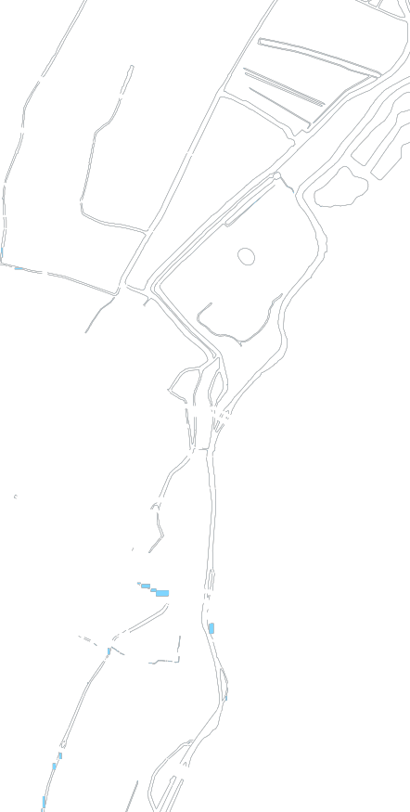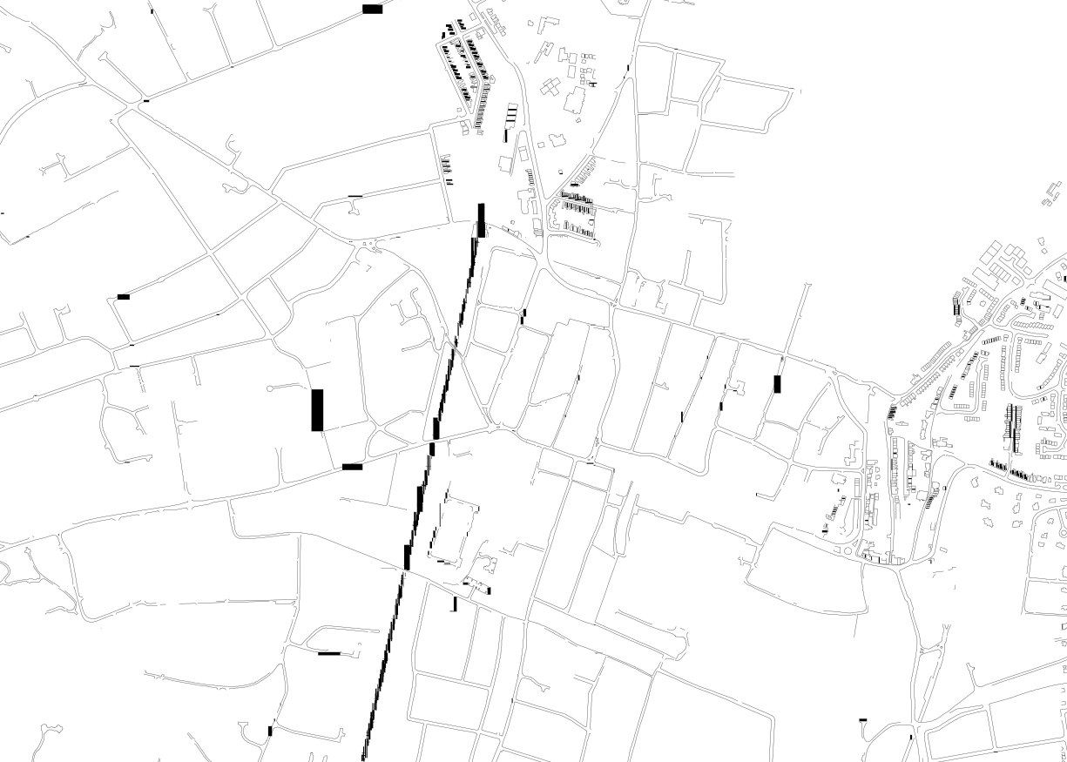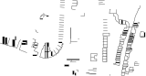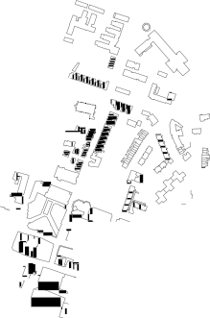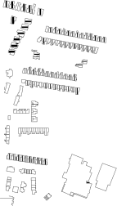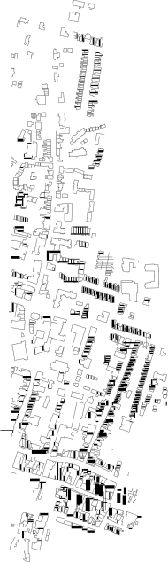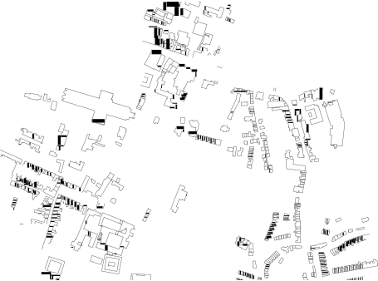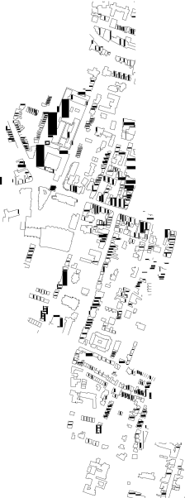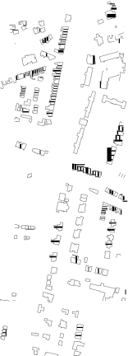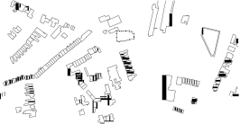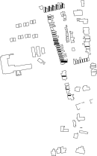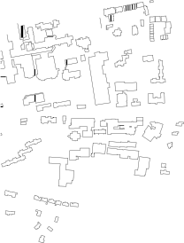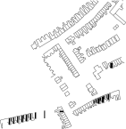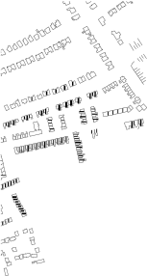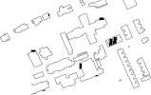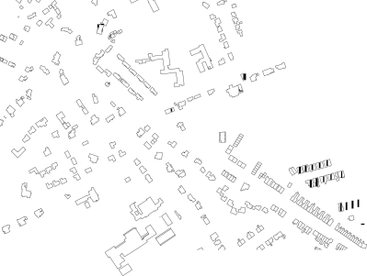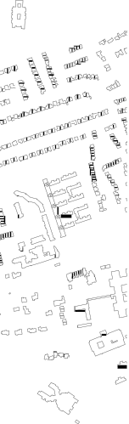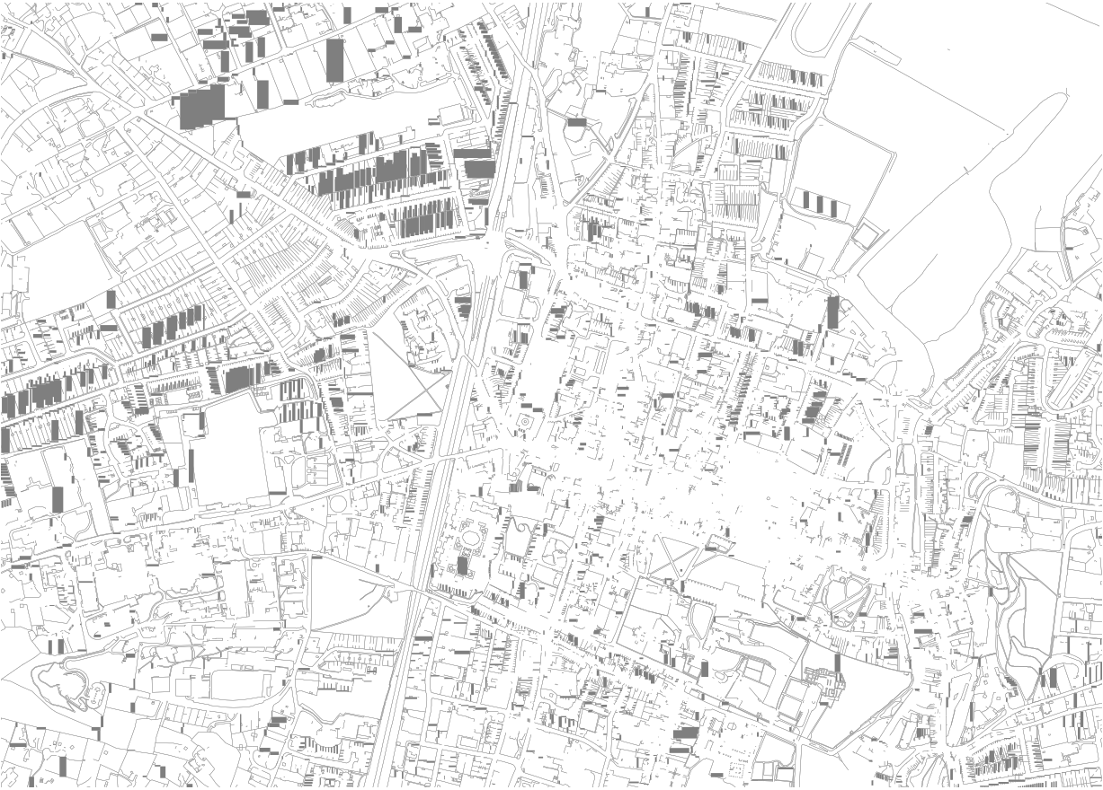

As part of the fourth round of Review and Assessment an Updating and Screening Assessment was undertaken in 2009. This report concluded that there continued to be exceedences of the NO2 objectives within the AQMA. Concentrations of PM10 remained within objective levels at all monitoring sites. The report also concluded that no new or significantly changed sources were identified and as such there was no requirement for a Detailed Assessment to be undertaken.

The 2010 Progress Report concluded that there were continued to be exceedences of the annual mean objective for NO2 within the current AQMA. Concentrations of PM10 remained within the objective levels and as such it was decided to revoke the AQMA with respect to the 24-hour objective for PM10.

**Figure 1-1 AQMA Boundary**

130500°N

130250°N

130000°N

129750°N

129500°N

129250°N

129000°N

**2 New Monitoring Data**

**2.1 Summary of Monitoring Undertaken**

**2.1.1 Automatic Monitoring Sites**

Winchester City Council operate two automatic monitoring stations, these are a roadside site located at Echo Offices, St Georges Street and an urban background site located at Godson House, Friarsgate.

Carbon Monoxide monitoring and monitoring of PM10 using Osiris ceased in 2009 and no new sites have been commissioned.

Figure 2.1 shows the location of the automatic monitoring sites, whilst Table 2.1 provides the details of the automatic monitoring sites.

Figure 2-1 Automatic Monitoring Station Locations

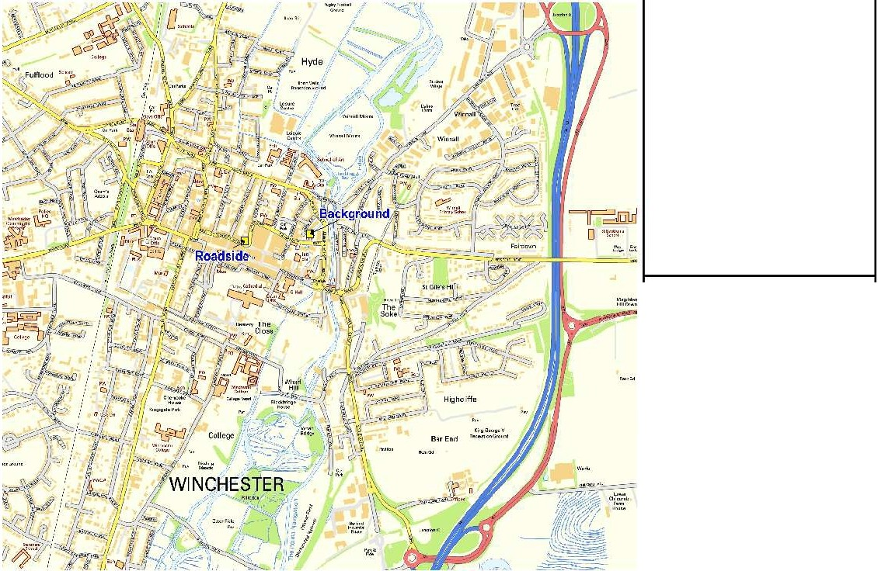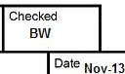

AkOuallty

.

I

BrandOnHouse

. 180BoroughHighStreet

**1**.**:**.**1**.**1**..**1·**,**1**,**¥**,,**·**,**•**.**•**.**•**,

londonSE11LB

Telephone:02076810 700

Facsimlle: 0207 6610 741

Location Winchester District Council

Title Automatic Monitoring locations

By SM Scale

Job No.

N.T.S.

Fig. No.

Approved

BW

7351442

2.1

**Table 2-1 Details of Automatic Monitoring Sites**

|  |  |  |  |  |  |  |  |  |  |
| --- | --- | --- | --- | --- | --- | --- | --- | --- | --- |
| **Site ID** | **Site Type** | **X OS Grid**  **Reference** | **Y OS Grid**  **Reference** | **Inlet Height (m)** | **Pollutants**  **Monitored** | **In**  **AQMA?** | **Relevant**  **Exposure?** | **Distance to Kerb of Nearest Road**  **(m)** | **Does this Location Represent Worst- Case Exposure?** |
| Echo  Offices | Roadside | 448215 | 129510 | 2.65 | NO2, PM10 | Yes | No | 2.75 | Yes |
| Godson  House | Urban  Background | 448509 | 129539 | 2.80 | NO2, PM10 | Yes | No | N/A | No |

**Bureau Veritas Air Quality Winchester City Council**

**2.1.2 Non-Automatic Monitoring Sites**

Winchester City Council undertook passive monitoring using diffusion tubes at 30 locations in

2012, with 22 located within Winchester City Centre and a further 8 located across the district. There has been no change from the 2011 monitoring program.

Details of the monitoring locations are shown in Table 2.2 and Table 2.3. The monitoring locations within Winchester City are shown in Figure 2. 2.

Diffusion tubes in 2012 were prepared and analysed by Gradko International. The tube preparation method is 20% TEA in water. Gradko International participates in the Workplace Analysis Scheme for Proficiency (WASP) for NO2 diffusion tube analysis. This provides strict performance criteria for participating laboratories to meet, thereby ensuring NO2 concentrations reported are of a high calibre. WASP data rounds 116 through to 119 (January to December 2012) Gradko have scored 100%, meaning that all of resulted submitted are deemed to be satisfactory based upon the z-score of < ± 2.

A bias adjustment factor has been applied to the data, which is an estimate of the difference between diffusion tube concentrations and continuous monitoring, the latter assumed to be a more accurate method of monitoring. The technical guidance document LAQM.TG (09) provides guidance with regard to the application of a bias adjustment factor to correct diffusion tubes. Triplicate co-location studies can be used to determine a local bias factor based on the comparison of diffusion tube results with data from NOx / NO2 continuous analysers. Alternatively, the national database of diffusion tube co-location surveys provides bias factors for the relevant laboratory and preparation method.

Winchester City Council has a set of diffusion tubes collocated with the roadside automatic analyser on St Georges Street. The local bias correction factor for this site is 1.06. The national bias factor for this laboratory and preparation method was 0.97 (V_07_13). Data capture for the continuous analyser and the diffusion tubes were excellent for the monitoring periods. As such it has been decided to use the local factor for bias correction for years 2011 and 2012.

For previous data, years 2008 to 2011, the bias adjustment factors have been taken from the

Council’s previous LAQM annual reports. The factors used were 1.02 (2008), 1.13 (2009),

1.03 (2010), and 1.02 (2011).

LAQM Progress Report 2013

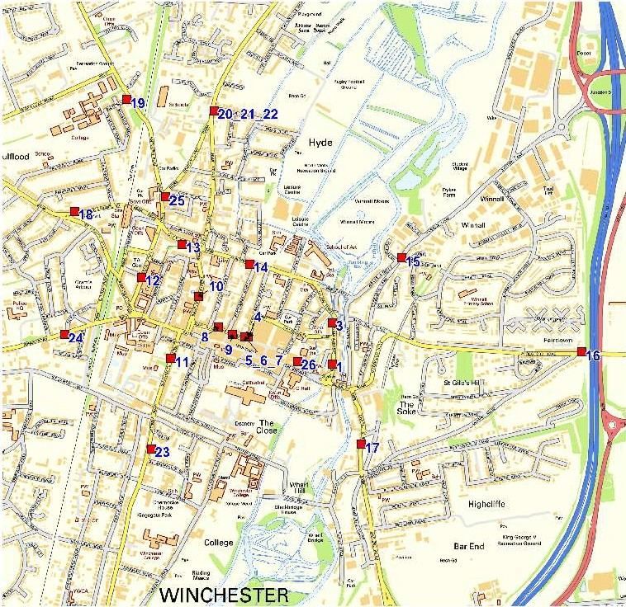AkOuaUty

BrandonHouse

160BoroughHighStreet londonSE11LB Telephone:02076810 700

Facsimlle:0207 6610 741

Location Winchester District Council

Title City Study Diffusion Tube locations

By SM

Approved

BW

Scale Date Nov-13

N.T.S.



Job No.

73.51442

Fig. No.

2.2

|  |  |  |  |  |  |  |  |  |  |  |
| --- | --- | --- | --- | --- | --- | --- | --- | --- | --- | --- |
| **Site Name** | **Site Type** | **X OS Grid**  **Reference** | **Y OS Grid**  **Reference** | **Site Height (m)** | **Pollutants**  **Monitored** | **In**  **AQMA?** | **Is Monitoring Co-located with a Continuous Analyser (Y/N)** | **Relevant Exposure?** (m) from monitoring site to relevant exposure | **Distance to Kerb of Nearest Road**  **(m)** | **Does this Location Represent Worst- Case Exposure?** |
| Site 1, 10  Eastgate St | UC | 448563 | 129391 | 1.70 | NO2 | Y | N | Y (0.1m) | 5.55 | Y |
| Site 2, Greyfriars | UC | 448566 | 129560 | 1.75 | NO2 | Y | N | Y (0.1m) | 9.7 | Y |
| Site 3, Friarsgate | RS | 448566 | 129560 | 1.75 | NO2 | Y | N | Y (4.6m) | 4.25 | Y |
| Site 4, Upper  Brook St | UC | 448227 | 129504 | 2.45 | NO2 | Y | N | Y (9.2m) | 8.0 | Y |
| Site 5, Roadside  Monitor | RS | 448213 | 129504 | 1.70 | NO2 | Y | Y | N | 3.1 | N |
| Site 6, Roadside  Monitor | RS | 448213 | 129504 | 1.70 | NO2 | Y | Y | N | 3.1 | N |
| Site 7, Roadside  Monitor | RS | 448213 | 129504 | 1.70 | NO2 | Y | Y | N | 3.1 | N |
| Site 8, St  Georges St TC | RS | 448106 | 129541 | 2.45 | NO2 | Y | N | Y (0.1m) | 4.05 | Y |
| Site 9, St  Georges St Lad | RS | 448163 | 129512 | 2.40 | NO2 | Y | N | N | 3.6 | N |

|  |  |  |  |  |  |  |  |  |  |  |
| --- | --- | --- | --- | --- | --- | --- | --- | --- | --- | --- |
| **Site Name** | **Site Type** | **X OS Grid**  **Reference** | **Y OS Grid**  **Reference** | **Site Height (m)** | **Pollutants**  **Monitored** | **In**  **AQMA?** | **Is Monitoring Co-located with a Continuous Analyser (Y/N)** | **Relevant Exposure?** (m) from monitoring site to relevant exposure | **Distance to Kerb of Nearest Road**  **(m)** | **Does this Location Represent Worst- Case Exposure?** |
| Site 10, Jewry St  FK | RS | 448029 | 129666 | 2.35 | NO2 | Y | N | N | 4.05 | N |
| Site 11, Southgate St DV | RS | 447918 | 129413 | 2.60 | NO2 | Y | N | Y (0.1m) | 3.65 | Y |
| Site 12, Sussex  St | RS | 447804 | 129741 | 2.60 | NO2 | Y | N | Y (2.4m) | 3.6 | Y |
| Site 13, City  Road | UC | 447963 | 129875 | 3.00 | NO2 | Y | N | Y (0.1m) | 6.55 | N |
| Site 14, 74  Northwalls | RS | 448234 | 129794 | 2.65 | NO2 | Y | N | Y (10.2m) | 1.2 | Y |
| Site 15, Wales  St | RS | 448842 | 129820 | 2.45 | NO2 | Y | N | Y (0.1m) | 1.7 | Y |
| Site 16, Alresford Rd (M3) | Other (M3) | 449563 | 129439 | 1.50 | NO2 | N | N | N | N/A | N |
| Site 17, Chesil  St | RS | 448679 | 129068 | 2.60 | NO2 | Y | N | Y (0.1m) | 1.3 | Y |

|  |  |  |  |  |  |  |  |  |  |  |
| --- | --- | --- | --- | --- | --- | --- | --- | --- | --- | --- |
| **Site Name** | **Site Type** | **X OS Grid**  **Reference** | **Y OS Grid**  **Reference** | **Site Height (m)** | **Pollutants**  **Monitored** | **In**  **AQMA?** | **Is Monitoring Co-located with a Continuous Analyser (Y/N)** | **Relevant Exposure?** (m) from monitoring site to relevant exposure | **Distance to Kerb of Nearest Road**  **(m)** | **Does this Location Represent Worst- Case Exposure?** |
| Site 18, Stockbridge Rd | UC | 447534 | 130006 | 2.00 | NO2 | Y | N | Y (10m) | 5.4 | Y |
| Site 19, Andover  Rd | UC | 447745 | 130456 | 2.30 | NO2 | Y | N | Y (0.5m) | 6.5 | Y |
| Site 20, Worthy  Rd 1 | RS | 448092 | 130411 | 2.50 | NO2 | Y | N | Y (3.7m) | 2.2 | Y |
| Site 21, Worthy  Rd 2 | RS | 448092 | 130411 | 2.50 | NO2 | Y | N | Y (3.7m) | 2.2 | Y |
| Site 22, Worthy  Rd 3 | RS | 448092 | 130411 | 2.50 | NO2 | Y | N | Y (3.7m) | 2.2 | Y |
| Site 23, St Cross  Rd | RS | 447842 | 129050 | 2.20 | NO2 | Y | N | Y (6m) | 2.4 | Y |
| Site 24, Romsey  Road | RS | 447495 | 129511 | 2.50 | NO2 | Y | N | Y (0.8m) | 1.1 | Y |
| Site 25, Andover  Rd | RS | 447898 | 130065 | 2.15 | NO2 | Y | N | Y (0.6m) | 4.2 | Y |

|  |  |  |  |  |  |  |  |  |  |  |
| --- | --- | --- | --- | --- | --- | --- | --- | --- | --- | --- |
| **Site Name** | **Site Type** | **X OS Grid**  **Reference** | **Y OS Grid**  **Reference** | **Site Height (m)** | **Pollutants**  **Monitored** | **In**  **AQMA?** | **Is Monitoring Co-located with a Continuous Analyser (Y/N)** | **Relevant Exposure?** (m) from monitoring site to relevant exposure | **Distance to Kerb of Nearest Road**  **(m)** | **Does this Location Represent Worst- Case Exposure?** |
| Site 26, Bus  Station | Other (Bus) | 448427 | 129401 | 2.40 | NO2 | Y | N | N | N/A | N |

**Table 2-3 Details of Non- Automatic Monitoring Sites – District Study**

|  |  |  |  |  |  |  |  |  |  |  |
| --- | --- | --- | --- | --- | --- | --- | --- | --- | --- | --- |
| **Site Name** | **Site Type** | **X OS Grid**  **Reference** | **Y OS Grid**  **Reference** | **Site Height (m)** | **Pollutants**  **Monitored** | **In**  **AQMA?** | **Is**  **Monitoring Co-located with a Continuous Analyser (Y/N)** | **Relevant**  **Exposure?** (m) from monitoring site to relevant exposure | **Distance to Kerb of Nearest Road**  **(m)** | **Does this Location Represent Worst- Case Exposure?** |
| Site 1, High  Street, Twyford | RS | 448062 | 124372 | 1.8 | NO2 | N | N | N | 0.9 | N |
| Site 2, Southdown Road, Otterbourne | Other (M3) | 446690 | 124645 | 1.8 | NO2 | N | N | N | N/A | N |

|  |  |  |  |  |  |  |  |  |  |  |
| --- | --- | --- | --- | --- | --- | --- | --- | --- | --- | --- |
| **Site Name** | **Site Type** | **X OS Grid**  **Reference** | **Y OS Grid**  **Reference** | **Site Height (m)** | **Pollutants**  **Monitored** | **In**  **AQMA?** | **Is Monitoring Co-located with a Continuous Analyser (Y/N)** | **Relevant Exposure?** (m) from monitoring site to relevant exposure | **Distance to Kerb of Nearest Road**  **(m)** | **Does this Location Represent Worst- Case Exposure?** |
| Site 3, Church Green Close, Kings Worthy | Other (A34) | 449161 | 132291 | 1.8 | NO2 | N | N | N | N/A | N |
| Site 4, West St, New Alresford | RS | 458828 | 132707 | 1.8 | NO2 | N | N | N | Centre of  Road | N |
| Site 5, Hambledon Rd, Denmean | RS | 465915 | 112047 | 1.8 | NO2 | N | N | N | 1.2 | N |
| Site 6, Winchester Rd, Wickham | RS | 457305 | 111730 | 1.8 | NO2 | N | N | N | 0.8 | N |
| Site 7, Winchester Rd, Bishops Waltham | RS | 455331 | 117399 | 1.8 | NO2 | N | N | N | 1.0 | N |
| Site 8, Whiteley  Ln, Whiteley | Other  (M27) | 453638 | 182580 | 1.8 | NO2 | N | N | N | N/A | N |

**Bureau Veritas Air Quality Winchester City Council**

**2.2 Comparison of Monitoring Results with Air Quality**

**Objectives**

**2.2.1 Nitrogen Dioxide (NO2)**

There are two Air Quality Objectives for nitrogen dioxide, namely:

the annual mean of 40µg/m3, and

the 1-hour mean of 200µg/m3 not to be exceeded more than 18 times a year.

**Automatic Monitoring Data**

The Council monitored NO2 at two locations during 2012. Data capture at both sites was excellent for the year, therefore annualisation was not required.

The monitoring data can be seen in Table 2.4 and 2.5 below.

Results for 2012 indicate the 1-hour objective for NO2 continues to be met at the both the continuous monitoring locations. With regards to the annual mean objective, it continues to be met at the background location at Godson House. The roadside location at Echo Offices continues to show an exceedence of the annual mean objective.

Figure 2.3 shows the trend in NO2 concentration from 2008 through to 2012, this shows that both sites have shown similar trends in concentration, with the roadside site having a

consistently higher annual mean concentration.

LAQM Progress Report 2013 21

**Table 2-4 Results of Automatic Monitoring for NO2: Comparison with Annual Mean Objective**

|  |  |  |  |  |  |  |  |  |  |
| --- | --- | --- | --- | --- | --- | --- | --- | --- | --- |
| **Site ID** | **Site Type** | **Within**  **AQMA?** | **Valid Data Capture for Monitoring Period %** | **Valid Data**  **Capture 2012**  **%** | **Annual Mean Concentration (µg/m3)** | | | | |
| **2008** | **2009** | **2010** | **2011** | **2012** |
| Echo Offices | Roadside | Y | 95.8 | 95.8 | **47.8** | **48.0** | **50.0** | **46.2** | **45.9** |
| Godson  House | Urban  Background | Y | 99.1 | 99.1 | 27.4 | 26.0 | 27.0 | 25.1 | 26.0 |

**Figure 2-3 Trends in Annual Mean NO2 Concentrations Measured at Automatic Monitoring Sites**

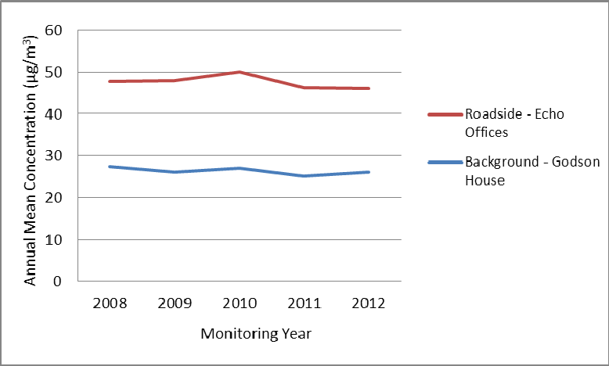Figure 2.3 shows the trend in annual mean NO2

concentrations at both monitoring sites between 2008 and

2012. From this it can be seen that both sites follow a similar trend, with the Roadside site showing consistently higher annual mean concentrations than the Background site over the monitoring period. Both sites showed an increase in

annual mean NO2 concentrations in 2010, before declining the following year. The 2012 result has shown a small increase in concentration at the background site, whilst the roadside site has shown a slight decrease from the 2011 concentrations.

**Table 2-5 Results of Automatic Monitoring for NO2: Comparison with 1-hour Mean Objective**

|  |  |  |  |  |  |  |  |  |  |
| --- | --- | --- | --- | --- | --- | --- | --- | --- | --- |
| **Site ID** | **Site Type** | **Within**  **AQMA?** | **Valid Data Capture for Monitoring Period %** | **Valid Data**  **Capture 2012**  **%** | **Number of Hourly Means > 200µg/m3** | | | | |
| **2008** | **2009** | **2010** | **2011** | **2012** |
| Echo Offices | Roadside | Y | 95.8 | 95.8 | 0 | 3 | 0 | 0 | 0 |
| Godson  House | Urban  Background | Y | 99.1 | 99.1 | 0 | 0 | 0 | 0 | 0 |

**Bureau Veritas Air Quality Winchester City Council**

**Diffusion Tube Monitoring Data**

The nitrogen dioxide diffusion tube data for 2012 are summarised in Table 2.6 and 2.7. The full dataset (monthly mean values) are included in Appendix A.

There were a number of sites where data capture was less than 75%, as such the results for these sites have been annualised. Details of annualisation can be found in Appendix A.

There were 14 locations in the Winchester City study area where the NO2 annual mean Air Quality Objective of 40µg/m3 was exceeded. All of the sites showing an exceedence are within the existing AQMA boundary, with the exception only of Site 16, Alresford Road (M3).

There is no relevant exposure at this monitoring location. It is the first year in which an exceedence of the objective has occurred in this monitoring location.

There were no sites within the District wide study area where the annual mean objective was exceeded.

There were three sites where the annual mean concentration was greater than 60µg/m3. An annual mean concentration of greater than 60µg/m3 shows a potential for an exceedence of the 1-hour objective. All three sites have shown annual mean concentrations of greater than

60µg/m3 in previous monitoring years. It is therefore recommended that a Detailed

Assessment be undertaken with respect the 1-Hour Objective for NO2.

LAQM Progress Report 2013 24

**Table 2-6 Results of NO2 Diffusion Tubes 2012 – City Study**

|  |  |  |  |  |  |  |
| --- | --- | --- | --- | --- | --- | --- |
| **Location** | **Site Type** | **Within**  **AQMA?** | **Triplicate or Co-located Tube** | **Full Calendar Year Data Capture 2012** | **Have Results been**  **Annualised?** | **2012 Annual Mean 3**  **Concentration (µg/m )**  **- Bias Adjustment factor = 1.06** |
| Site 1, 10  Eastgate St | UC | Y | N | 57% | Y | **41.5** |
| Site 2, Greyfriars | UC | Y | N | 100% | N | 38.2 |
| Site 3, Friarsgate | RS | Y | N | 100% | N | 32.2 |
| Site 4, Upper  Brook St | UC | Y | N | 86% | N | **47.4** |
| Site 5, 6, 7, Roadside Monitor | RS | Y | Y | 100% | N | **46.4** |
| Site 8, St  Georges St TC | RS | Y | N | 100% | N | **65.6** |
| Site 9, St  Georges St Lad | RS | Y | N | 100% | N | **67.5** |
| Site 10, Jewry St  FK | RS | Y | N | 100% | N | **53.7** |
| Site 11, Southgate St DV | RS | Y | N | 71% | Y | 38.3 |

|  |  |  |  |  |  |  |
| --- | --- | --- | --- | --- | --- | --- |
| **Location** | **Site Type** | **Within**  **AQMA?** | **Triplicate or Co-located Tube** | **Full Calendar Year Data Capture 2012** | **Have Results been**  **Annualised?** | **2012 Annual Mean 3**  **Concentration (µg/m )**  **- Bias Adjustment factor = 1.06** |
| Site 12, Sussex  St | RS | Y | N | 86% | N | **42.4** |
| Site 13, City  Road | UC | Y | N | 100% | N | **43.4** |
| Site 14, 74  Northwalls | RS | Y | N | 86% | N | **42.0** |
| Site 15, Wales  St | RS | Y | N | 57% | Y | 27.8 |
| Site 16, Alresford Rd (M3) | Other (M3) | N | N | 86% | N | **42.5** |
| Site 17, Chesil  St | RS | Y | N | 100% | N | **46.2** |
| Site 18, Stockbridge Rd | UC | Y | N | 100% | N | 34.0 |
| Site 19, Andover  Rd | UC | Y | N | 100% | N | 33.1 |

|  |  |  |  |  |  |  |
| --- | --- | --- | --- | --- | --- | --- |
| **Location** | **Site Type** | **Within**  **AQMA?** | **Triplicate or Co-located Tube** | **Full Calendar Year Data Capture 2012** | **Have Results been**  **Annualised?** | **2012 Annual Mean 3**  **Concentration (µg/m )**  **- Bias Adjustment factor = 1.06** |
| Site 20, 21, 22, Worthy Rd 1 | RS | Y | Y | 100% | N | 33.4 |
| Site 23, St Cross  Rd | RS | Y | N | 100% | N | 37.8 |
| Site 24, Romsey  Road | RS | Y | N | 100% | N | **66.8** |
| Site 25, Andover  Rd | RS | Y | N | 86% | N | **41.2** |
| Site 26, Bus  Station | Other (Bus) | Y | N | 100% | N | **44.6** |

Means should be “annualised” as in Box 3.2 of TG(09) ([http://laqm.defra.gov.uk/technical-guidance/index.html?d=page=38),](http://laqm.defra.gov.uk/technical-guidance/index.html?d=page%3D38)) if full calendar year data capture is less than 75%

In bold, exceedence of the NO2 annual mean AQS objective of 40µg/m3

Underlined, annual mean > 60µg/m3, indicating a potential exceedence of the NO2 hourly mean AQS objective

**Table 2-7 Results of NO2 Diffusion Tubes 2012 – District Study**

|  |  |  |  |  |  |  |
| --- | --- | --- | --- | --- | --- | --- |
| **Location** | **Site Type** | **Within**  **AQMA?** | **Triplicate or Co-located Tube** | **Full Calendar Year**  **Data Capture 2012** | **Have results been annualised** | **2012 Annual Mean Concentration (µg/m3) - Bias Adjustment factor**  **= 1.06** |
| Site 1, High  Street, Twyford | RS | N | N | 87.5% | N | 35.8 |
| Site 2, Southdown Road, Otterbourne | Other (M3) | N | N | 100% | N | 35.1 |
| Site 3, Church Green Close, Kings Worthy | Other (A34) | N | N | 100% | N | 31.8 |
| Site 4, West St, New Alresford | RS | N | N | 100% | N | 34.1 |
| Site 5, Hambledon Rd, Denmean | RS | N | N | 75% | N | 29.4 |
| Site 6, Winchester Rd, Wickham | RS | N | N | 100% | N | 34.5 |

|  |  |  |  |  |  |  |
| --- | --- | --- | --- | --- | --- | --- |
| **Location** | **Site Type** | **Within**  **AQMA?** | **Triplicate or Co-located Tube** | **Full Calendar Year**  **Data Capture 2012** | **Have results been annualised** | **2012 Annual Mean Concentration (µg/m3) - Bias Adjustment factor**  **= 1.06** |
| Site 7, Winchester Rd, Bishops Waltham | RS | N | N | 87.5% | N | 34.3 |
| Site 8, Whiteley  Ln, Whiteley | Other (M27) | N | N | 75% | N | 30.1 |

Means should be “annualised” as in Box 3.2 of TG(09) ([http://laqm.defra.gov.uk/technical-guidance/index.html?d=page=38),](http://laqm.defra.gov.uk/technical-guidance/index.html?d=page%3D38)) if full calendar year data capture is less than 75%

**Table 2-8 Results of NO2 Diffusion Tubes (2008 to 2012) – City Study**

|  |  |  |  |  |  |  |  |
| --- | --- | --- | --- | --- | --- | --- | --- |
| **Site ID** | **Site Type** | **Within**  **AQMA?** | **Annual Mean Concentration (µg/m3) - Adjusted for Bias** | | | | |
| **2008 (Bias Adjustment Factor = 1.02)** | **2009 (Bias Adjustment Factor = 1.13)** | **2010 (Bias Adjustment Factor = 1.03)** | **2011 (Bias Adjustment Factor = 1.02)** | **2012 (Bias Adjustment Factor 1.06)** |
| Site 1, 10  Eastgate St | UC | Y | 37.8 | **42.9** | 37.5 | **49.3** | **41.5** |
| Site 2, Greyfriars | UC | Y | 38.0 | **40.7** | 37.3 | 38.4 | 38.2 |
| Site 3, Friarsgate | RS | Y | 31.6 | 36.7 | 34.0 | 31.8 | 32.2 |
| Site 4, Upper Brook St | UC | Y | **47.4** | **44.0** | **41.8** | **40.6** | **47.4** |
| Site 5, 6, 7, Roadside Monitor | RS | Y | **45.8** | **47.6** | **47.2** | **46.9** | **46.4** |
| Site 8, St Georges St TC | RS | Y | **57.8** | **61.4** | **60.4** | **59.2** | **65.6** |
| Site 9, St Georges St Lad | RS | Y | **60.7** | **69.8** | **56.0** | **71.5** | **67.5** |

|  |  |  |  |  |  |  |  |
| --- | --- | --- | --- | --- | --- | --- | --- |
| **Site ID** | **Site Type** | **Within**  **AQMA?** | **Annual Mean Concentration (µg/m3) - Adjusted for Bias** | | | | |
| **2008 (Bias**  **Adjustment**  **Factor = 1.02)** | **2009 (Bias**  **Adjustment**  **Factor = 1.13)** | **2010 (Bias**  **Adjustment**  **Factor = 1.03)** | **2011 (Bias**  **Adjustment**  **Factor = 1.02)** | **2012 (Bias**  **Adjustment**  **Factor 1.06)** |
| Site 10, Jewry St FK | RS | Y | **55.2** | **59.5** | **52.9** | **68.7** | **53.7** |
| Site 11, Southgate St DV | RS | Y | **42.1** | **46.3** | **41.9** | **46.6** | 38.3 |
| Site 12, Sussex St | RS | Y | **43.9** | **46.3** | 39.8 | 38.5 | **42.4** |
| Site 13, City  Road | UC | Y | 38.8 | **45.8** | **40.1** | **41.4** | **43.4** |
| Site 14, 74  Northwalls | RS | Y | **44.9** | **49.0** | **46.1** | **45.5** | **42.0** |
| Site 15, Wales St | RS | Y | 33.1 | 38.5 | 35.6 | 31.7 | 27.8 |
| Site 16, Alresford Rd (M3) | Other (M3) | N | 38.3 | 39.7 | 35.1 | 37.4 | **42.5** |
| Site 17, Chesil St | RS | Y | **41.4** | **44.7** | **44.8** | **46.2** | **46.2** |

|  |  |  |  |  |  |  |  |
| --- | --- | --- | --- | --- | --- | --- | --- |
| **Site ID** | **Site Type** | **Within**  **AQMA?** | **Annual Mean Concentration (µg/m3) - Adjusted for Bias** | | | | |
| **2008 (Bias**  **Adjustment**  **Factor = 1.02)** | **2009 (Bias**  **Adjustment**  **Factor = 1.13)** | **2010 (Bias**  **Adjustment**  **Factor = 1.03)** | **2011 (Bias**  **Adjustment**  **Factor = 1.02)** | **2012 (Bias**  **Adjustment**  **Factor 1.06)** |
| Site 18, Stockbridge Rd | UC | Y | 25.7 | 28.6 | 28.8 | 27.6 | 34.0 |
| Site 19, Andover Rd | UC | Y | 33.8 | 36.0 | 32.7 | 34.8 | 33.1 |
| Site 20, 21,  22, Worthy  Rd 1 | RS | Y | 32.5 | 36.0 | 33.7 | 33.2 | 33.4 |
| Site 23, St  Cross Rd | RS | Y | 39.4 | **41.8** | 38.4 | 32.7 | 37.8 |
| Site 24, Romsey Road | RS | Y | **53.1** | **66.5** | **61.6** | **63.3** | **66.8** |
| Site 25, Andover Rd | RS | Y | 38.2 | **42.8** | 38.2 | **40.1** | **41.2** |
| Site 26, Bus  Station | Other (Bus) | Y | **41.8** | **44.8** | **43.3** | **43.1** | **44.6** |

In bold, exceedence of the NO2 annual mean AQS objective of 40µg/m3 Underlined, annual mean > 60µg/m3, indicating a potential exceedence of the NO2 hourly mean AQS objective

**Table 2-9 Results of NO2 Diffusion Tubes (2008 to 2012) – District Study**

|  |  |  |  |  |  |  |  |
| --- | --- | --- | --- | --- | --- | --- | --- |
| **Site ID** | **Site Type** | **Within**  **AQMA?** | **Annual Mean Concentration (µg/m3) - Adjusted for Bias** | | | | |
| **2008 (Bias Adjustment Factor = 1.02)** | **2009 (Bias Adjustment Factor = 1.13)** | **2010 (Bias Adjustment Factor = 1.03)** | **2011 (Bias Adjustment Factor = 1.02)** | **2012 (Bias Adjustment Factor 1.06)** |
| Site 1, High Street, Twyford | RS | N | 33.4 | 34.9 | 34.5 | 33.4 | 35.8 |
| Site 2, Southdown Road, Otterbourne | Other (M3) | N | 36.1 | 36.9 | 33.9 | 35.8 | 35.1 |
| Site 3, Church Green  Close, Kings  Worthy | Other (A34) | N | 34.2 | 31.3 | 28.5 | 27.8 | 31.8 |
| Site 4, West St, New Alresford | RS | N | 34.9 | 35.2 | 35.3 | 36.9 | 34.1 |

|  |  |  |  |  |  |  |  |
| --- | --- | --- | --- | --- | --- | --- | --- |
| **Site ID** | **Site Type** | **Within**  **AQMA?** | **Annual Mean Concentration (µg/m3) - Adjusted for Bias** | | | | |
| **2008 (Bias**  **Adjustment**  **Factor = 1.02)** | **2009 (Bias**  **Adjustment**  **Factor = 1.13)** | **2010 (Bias**  **Adjustment**  **Factor = 1.03)** | **2011 (Bias**  **Adjustment**  **Factor = 1.02)** | **2012 (Bias**  **Adjustment**  **Factor 1.06)** |
| Site 5, Hambledon Rd, Denmean | RS | N | 22.8 | 25.8 | 23.0 | 23.2 | 29.4 |
| Site 6, Winchester Rd, Wickham | RS | N | 34.0 | 37.6 | 34.0 | 34.2 | 34.5 |
| Site 7, Winchester Rd, Bishops Waltham | RS | N | 35.8 | 39.8 | 35.3 | 37.3 | 34.3 |
| Site 8, Whiteley Ln, Whiteley | Other (M27) | N | 31.8 | 34.6 | 31.9 | 25.9 | 30.1 |

**Figure 2-4 Trends in Annual Mean Nitrogen Dioxide Concentrations Measured at Diffusion Tube Monitoring Sites – City**

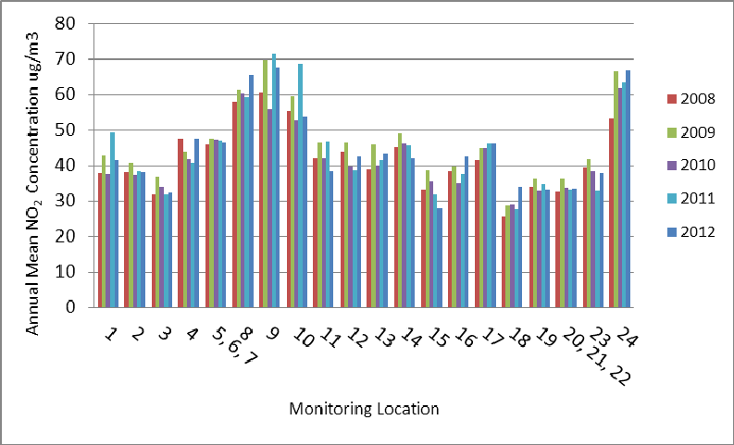

The above graph shows the trend in annual mean NO2 concentrations at the monitoring locations in the Winchester City survey area. This shows that over the past five years the annual mean concentrations at the monitoring locations have remained relatively stable. The 2012 result has continued this pattern as some sites show a small increase, whilst others have decreased slightly. In 2012 there were 16 locations in the City where the annual mean objective was exceeded.

**Wide**

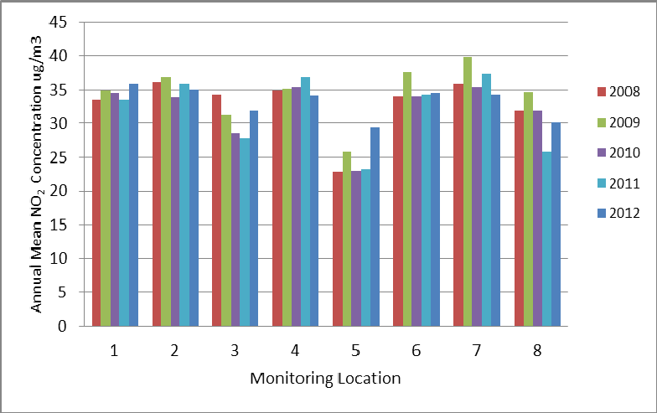

The above graph shows the trend in annual mean NO2 concentrations at the monitoring locations in the Winchester District survey area. This shows that over the past five years the annual mean concentrations at the monitoring locations have remained relatively stable. The 2012 result has continued this trend with the majority of sites showing a slight increase in annual mean concentration. In 2012 there were no locations in the district monitoring survey where the annual mean objective was exceeded.

**Bureau Veritas Air Quality Winchester City Council**

**2.2.2 Particulate Matter (PM10)**

There are two Air Quality Objectives for PM10, namely:

the annual mean of 40µg/m3; and

the 24-hour mean of 50µg/m3 not to be exceeded more than 35 times a year.

The Council undertook monitoring of PM10 using BAM analysers at two locations during

2012. Osiris dust and particles analysers were also installed at three locations in 2012. Results for the BAMs have been corrected to provide an indicative gravimetric equivalent using a factor of 0.83 by AQDM who conduct the data management for the Council. Data capture was greater than 90% at the both locations and as such there was no requirement for annualisation or presentation of the 90.4th percentile for the 24-hour objective.

The 2012 results show that the annual mean and the 24-hour mean continue to be met at both monitoring locations. The 2012 pollutant levels show a continued increase in annual mean concentrations at the roadside location, with the background remaining stable from the

2011 result. With regards to the 24-hour mean the number of days exceeding 50µg/m3 has

increased at the roadside location, whereas it has shown a decrease at the background site from 2011 results.

LAQM Progress Report 2013 37

**Table 2-10 Results of Automatic Monitoring for PM10: Comparison with Annual Mean Objective**

|  |  |  |  |  |  |  |  |  |  |  |
| --- | --- | --- | --- | --- | --- | --- | --- | --- | --- | --- |
| **Site ID** | **Site Type** | **Within**  **AQMA?** | **Valid Data Capture for Monitoring Period %** | **Valid Data**  **Capture**  **2012 %** | **Confirm Gravimetric Equivalent (Y or N/A)** | **Annual Mean Concentration (µg/m3)** | | | | |
| **2008** | **2009** | **2010** | **2011** | **2012** |
| Echo Offices | Roadside | Y | 98.4 | 98.4 | Y | 22 | 21 | 22 | 27 | 29 |
| Godson  House | Urban  Background | Y | 91.2 | 91.2 | Y | 18 | 18 | 17 | 20 | 20 |

**Figure 2-6Trends in Annual Mean PM10 Concentrations**

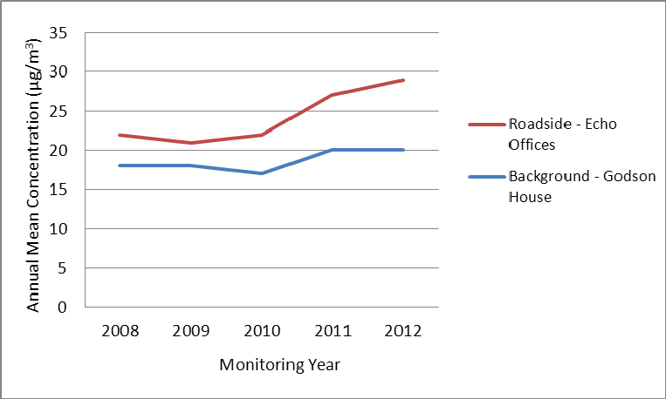Figure 2.6 shows the trend in annual mean PM10 concentration from 2008 through to 2012. This shows that annual mean concentrations were relatively stable between

2008 and 2010, with an increase observed at both monitoring locations in 2011. This increase in annual mean concentration has continued at the Roadside monitoring location, with the highest concentration recorded in 2012. The 2012 result for the background site has shown that concentrations have remained the same as those observed in 2011.

**Table 2-11 Results of Automatic Monitoring for PM10: Comparison with 24-hour Mean Objective**

|  |  |  |  |  |  |  |  |  |  |  |
| --- | --- | --- | --- | --- | --- | --- | --- | --- | --- | --- |
| **Site ID** | **Site Type** | **Within**  **AQMA?** | **Valid Data Capture for Monitoring Period % a** | **Valid Data**  **Capture**  **b**  **2012 %** | **Confirm Gravimetric Equivalent (Y or N/A)** | **Number of Daily Means > 50µg/m3** | | | | |
| **2008** | **2009** | **2010** | **2011** | **2012** |
| Echo Offices | Roadside | Y | 98.4 | 98.4 | Y | 9 | 3 | 4 | 9 | 16 |
| Godson House | Urban  Background | Y | 91.2 | 91.2 | Y | 5 | 1 | 1 | 3 | 1 |

**2.2.3 Sulphur Dioxide (SO2)**

Winchester City Council does not undertake any monitoring of Sulphur Dioxide.

**2.2.4 Benzene**

Winchester City Council does not undertake any monitoring of Benzene.

**2.2.5 Summary of Compliance with AQS Objectives**

The updated monitoring for NO2 in 2012 has shown that there are a number of diffusion tube locations within the existing AQMA where the annual mean continues to be exceeded. As such the AQMA should remain. In addition Site 16, Alresford Road (M3) also showed an exceedence of the annual mean objective. There is no relevant exposure at this monitoring location.

There were three sites where the annual mean concentration was greater than 60µg/m3. An annual mean concentration of greater than 60µg/m3 indicates the potential for exceedence of the 1-hour objective. It is therefore recommended that a Detailed Assessment be

undertaken with respect the 1-Hour Objective for NO2 for the St Georges Street and Romsey

Road areas.

With regards to PM10, the updated monitoring for 2012 shows that the AQS Objectives for

PM10 continue to be met at both monitoring locations within the City.

Winchester City Council has measured concentrations of NO2 above the 1-hour mean objective at relevant locations and **will need to proceed to a Detailed Assessment**, for St. Georges Street (TC and Lad) and Romsey Road.

**3 New Local Developments**

**3.1 Road Traffic Sources**

LAQM requires local authorities to consider the following:

Narrow congested streets with residential properties close to the kerb; Busy streets where people may spend one hour or more close to traffic; Roads with a high flow of buses and/or HGVs;

Junctions;

New roads constructed since the last Updating and Screening Assessment; Roads with significantly changed traffic flows; and

Bus or coach stations.

Winchester City Council have identified the following new developments which may impact upon road traffic sources within the district.

Barton Farm, Winchester – new homes, school, retail food store, community building and district energy centre;

Silver Hill redevelopment, Winchester – redevelopment of the Silver Hill area with new residential units, retail and office space, new bus station, public car park; and Whiteley Development Area – new housing development, schools and community facilities.

All of the above applications are currently at the planning stage with no works currently started. Further details of all three are included in Section 5. The developments will be considered in the next Updating and Screening Assessment

**3.2 Other Transport Sources**

LAQM requires local authorities to consider the following: Airports;

Locations where diesel or stream trains are regularly stationary for periods of 15 minutes or more, with relevant exposure within 15m;

Locations with a large number of movements of diesel locomotives and long term relevant exposure within 30m; and

Shipping ports.

Winchester City Council confirms that there are no new/newly identified non-road transport sources in the borough.

**3.3 Industrial Sources**

LAQM requires local authorities to consider the following: Industrial Installations: new or proposed;

Industrial installations: existing where emissions have increased substantially or relevant exposure introduced;

Major fuel storage depots; Petrol stations; and

Poultry farms.

Winchester City Council confirms that there are no new/newly identified industrial sources in the borough

**3.4 Commercial and Domestic Sources**

LAQM requires local authorities to consider the following: Biomass combustion plant – individual installations;

Areas where the combined impact of several biomass combustion sources may be relevant; and

Areas where domestic solid fuel burning may be relevant.

Winchester City Council confirms that there are no new/newly identified commercial or domestic sources in the borough.

**3.5 New Developments with Fugitive or Uncontrolled**

**Sources**

LAQM requires local authorities to consider the following: Landfill sites;

Quarries;

Unmade haulage roads on industrial sites; Waste transfer stations; and

Any other potential sources of fugitive particulate emissions.

Winchester City Council confirms that there are no new/newly identified fugitive or uncontrolled sources in the borough.

Winchester City Council has identified the following new or previously unidentified

local developments which may impact on air quality in the Local Authority area.

Barton Farm Development; Silver Hill Re-development; and

Whiteley Development.

These will be taken into consideration in the next Updating and Screening

Assessment

Winchester City Council confirms that all the following have been considered:

Road traffic sources; Other transport sources; Industrial sources;

Commercial and domestic sources; and

New developments with fugitive or uncontrolled sources.

**4 Local / Regional Air Quality Strategy**

Winchester City Council does not have a separate local air quality strategy, as air quality issues and actions are covered by the current Air Quality Action Plan for the Winchester City AQMA.

The Winchester Town Access Plan (July 2011) includes the following aims which link to improving air quality in the area:

Lead a transition to cycling, walking, public transport and low-carbon modes of travel, including low emission private and commercial vehicles; and

Reduce the negative effects of transport related carbon emissions on all neighbourhood’s including the town’s historic environment.

**5 Planning Applications**

There are three major planning developments which have been identified by Winchester City

Council.

**Barton Farm – Winchester**

The first is the Barton Farm development in Winchester. Outline planning approval has been provided for up to 2,000 new homes, a school, retail food store, community building, district energy centre, offices and a park and ride facility. The development will be completed in a number of phases, with the phase 1 reserved matters application having been submitted to Winchester City Council.

As part of the planning application an air quality assessment was undertaken using dispersion modelling to predict changes to PM10 and NO2 from changes to traffic flows and the energy centre. The results showed that the proposed development would cause moderate to small increases in NO2 concentrations at the majority of modelled receptors and a small increase with regards to PM10. The proposed development is predicted to have a moderate adverse impact at one receptor with minor adverse at a further thirteen locations with regards to NO2 concentrations.

The model results for 2023 where the development is fully operational has seen exceedences of the NO2 annual mean objective at nine receptor locations, with the development and at seven sites without the development. The annual mean objective is met at all locations within the development.

A framework travel plan has been prepared to support the development. With the aims being to reduce single occupancy vehicle use, increase the number of people using public transport and to increase the number of people walking and cycling.

In addition there are a number of proposed highways improvement works to mitigate the transportation impacts of the development. These include the following:

Diversion of Andover Road North at the junction with Harestock/Wellhouse Lane and the formation of a new signalised junction;

Formation of New Andover Road to the east of the current route and re-connection with Andover Road to the north of Park Road;

Easward extension of Stoney Lane to form a new junction with New Andover Road

New access road from New Andover Road to provide access to dwellings on Andover

Road North;

Southward diversion of Well House Lane to the west of Well House Farm to form a new signalised T junction with the New Andover Road and closure of Wellhouse Land to motorised traffic between the point of diversion and Andover Road North;

Closure of Andover Road to vehicular traffic in the vicinity of Henry Beaufort School; Creation of a pedestrian and cycle route along the route of Andover Road;

New public right of way across the site and new route linking the railway underpass to

Worthy Road; and

Improve and upgrade existing public rights of way.

The transport assessment of the Environmental Statement predicted that there would be increased traffic at the majority of modelled junctions. This has the potential to lead to increases in delays and queuing as thus reductions in air quality. The development contains many mitigation measures to reduce the impact upon traffic in the area; these include additional bus services, park and ride provision, reduction of speed limits and new footpath and cycle routes. These mitigation measures are forecast to reduce the impact of the development by one level of significance.

The Local Authority should review current and future monitoring locations to ensure the impact from the development are monitored at modelled receptor locations where there is the potential for future exceedences and at relevant receptors at locations considered in the transport assessment.

**Silver Hill Redevelopment**

This is a redevelopment area within central Winchester, including the bus station, Friarsgate medical centre, Kings Walk and Friarsgate cark park. The re-development of this area will include the following:

278 residential units; New retail space;

Office accommodation;

New bus station;

New public car park; and

Public space improvements, including the Broadway.

Further details of this re-development will be provided in the next Updating and Screening

Assessment.

**Whiteley Development Area**

Winchester City Council have identified an area to the north of Whiteley which would be suitable for new housing. The development would also include provision of new schools and community centres. The Environmental Impact Assessment for this development is currently being prepared. This development will be reviewed in the next Updating and Screening Assessment.

**6 Air Quality Planning Policies**

Winchester City Council has developed its Joint Core Strategy, adopted in March 2013. This document sets of the vision and strategic policies for growth and development up to 2031.

The following policies will influence air quality within the district:

**DS1 – Development Strategy and Principles**

The council will take a positive approach that reflects the presumptions in favour of sustainable development. The Council will work proactively to find solutions which mean proposals that accord with planning policies can be approved wherever possible and to ensure development that improves the economic, social and environmental conditions in the area.

**Policy WT1 – Development Strategy for Winchester Town**

Implementation of the Winchester Access Plan and the Winchester Air Quality Action Plan to ensure that transport provision and access to and within the Town provides opportunities for sustainable transport provision and reduces pollution and carbon emissions.

**7 Local Transport Plans and Strategies** Winchester City Council works together with Hampshire County Council on local transport issues including the implementation of Local Transport Plan (LTP) measures in the district.

The Local Transport Plan was formally adopted in 2011 and includes a Long Term Strategy document, 2011-2031 and Three-Year Implementation plans, currently covering the period April 2013 to April 2016.

The following are priorities listed in the LTP, which will influence air quality in the District:

**Main Priority 3:** Manage traffic to maximise the efficiency of exiting network capacity, improving journey time reliability and reducing emissions, thereby supporting the efficient and sustainable movement of people and goods.

**Policy Objective 2:** Work with District authorities to agree coherent policy approaches to parking to provide efficient and environmentally sustainable alternative means of access to town centres, with small scale park and ride being considered as well as major schemes.

**Policy Objective 4:** Work with bus and coach operators to grow bus travel

**Policy Objective 6:** Work with rail industry partners and community rail partnerships to deliver priorities for long-term rail investment.

**Policy Objective 10:** Contribute to achieving local targets for improving air quality and national carbon targets through transport measures, where possible and affordable.

**Policy Objective 11:** Reduce the need to travel through encouragement of a high speed broadband network

**Policy Objective12:** Invest in sustainable transport measures, including walking and cycling infrastructure, to provide alternatives to the car for local short journeys

Within Winchester the following specific measures have been listed as being progressed through future implementation plans:

Encourage well signed and suitability located parking;

Support the Quality Bus Partnership within Winchester and other towns;

Encourage employers and schools to develop and implement travel plans to improve access by all transport modes and encourage flexible working patterns;

Exploring the potential for ‘mini park and ride’ schemes; and

Invest in the development of walking and cycling routes in Winchester and the others towns.

**8 Climate Change Strategies**

Winchester City Council published its Climate Change Strategy document in 2007, titled ‘Live for the Future: Tacking Climate Change’. The document outlines the following as priorities for work:

**Buildings:** Winchester City Council will reduce CO2 emissions from its buildings and make the most of opportunities available to ensure low carbon development on its land.

**Transport:** Through the Air Quality Action Plan, Hampshire Local Transport Plan, Local Development Framework and Town Access Plan, promote the use of more sustainable modes of travel such as walking, cycling and public transport. Where there are limited alternatives to private car use, encourage the use of the cleanest fuels and lowest emission vehicles.

**Waste:** Reduce emissions from landfill by waste minimisation and recycling initiates

**Working with Businesses:** Work with the Hampshire Sustainable Business Forum to encourage businesses to develop greener ways of working, and to provide advice, information and signposting.

**Encourage Installation:** Encourage businesses and the community to install renewable energy technologies.

Winchester City Council also supports Winchester Action on Climate Change (WinACC). This is a collation of organisations and citizens with the aim to encourage and advise households and organisations within the district to reduce their carbon footprint.

**9 Implementation of Action Plans**

Winchester City Council has an Air Quality Action Plan detailing actions aimed at reducing emissions within the AQMA and the wider area.

The Air Quality Action Plan and its progress have been reviewed by a Councillor panel over the past year, Informal Scrutiny Group (ISG). In addition to the comments in Table 9, the below actions were recommended by the group.

It was recommended that the City Council continues to work with Hampshire County Council in the implementation of the Winchester Town Access Plan in the following area:

Ensure that measures implemented through the Local Sustainable Transport fund include a quantitative assessment of their likely impact on air quality

Recommended that the City Council work with the Winchester BID on potential schemes to implement the following:

Implement a local delivery service;

Provide a shared waste collection service; and

Introduction of a park and ride user voucher scheme.

|  |  |  |  |  |  |  |  |  |  |
| --- | --- | --- | --- | --- | --- | --- | --- | --- | --- |
| **No.** | **Measure** | **Lead**  **Authority** | **Implemen- tation Phase** | **Indicator** | **Target Annual Emission Reduction in the AQMA** | **Progress to Date** | **Progress in Last 12**  **Months** | **Estimated Completion Date** | **Comments Relating to Emission Reductions** |
| 1 | We will work with the  County  Council to provide an additional  Park & Ride facility to the south of  Winchester. | HCC | 2005/6-2011 |  |  | **Complete**. Second Park and  Ride Site opened 19 April 2010 ahead of original schedule.  864 spaces in new P&R.  ISG recommended priority being given for the opportunities for an additional Park and Ride site to serve the northern approaches  of Winchester City. | | - | Will reduce emissions in  AQMA, especially as all  buses are Euro V  compliant |
| 2 | We will ensure that the buses on  the Park & Ride service are  increasingly environmentally  friendly, making  allowance for  economic and technical considerations. | WCC | 2005/6-2011 |  |  | **Complete** (see action 1). All new buses are Euro V compliant (equating to nearly half the NOx emissions of Euro IV). Opening times of both  sites extended into the  evenings to increase patronage  (e.g. hospital staff and evening visitors to town centre). | | - | First P&R site buses  now at  capacity. Survey undertaken in October  2007  on journey habits etc, but no  monitoring since then. Likely to have had  some  impact on emissions reductions in the AQMA  in  the time of operation. |

|  |  |  |  |  |  |  |  |  |  |
| --- | --- | --- | --- | --- | --- | --- | --- | --- | --- |
| **No.** | **Measure** | **Lead**  **Authority** | **Implemen- tation Phase** | **Indicator** | **Target Annual Emission Reduction in the AQMA** | **Progress to Date** | **Progress in Last 12**  **Months** | **Estimated Completion Date** | **Comments Relating to Emission Reductions** |
| 3 | We will review the loading  restrictions in the town centre and  on the main approach roads to the city | HCC & WCC | 2010/2011 |  |  | Loading  restrictions complete in High Street and semi pedestrian areas (complete April 2009). Enhancement scheme in the square – access restrictions to be finalised in next 6  months. | Meeting of the ISG confirmed that priority given for congestion relief in areas such as St Georges St. | April 2011 | Potentially significant emissions reductions in St Georges Street where there are major air quality issues and HGV parking restricts traffic movements throughout the day |
| 4 | We will work with the County Council to replace the Real-Time Information systems at bus stops in and around the city and implement Variable Message Signing (VMS) for the town centre car parks. | HCC & WCC | 2007/2008 |  |  | **Complete** October 2008.  50/50 funding from HCC and WCC. Review of car parking signage undertaken at the same time to reflect the parking strategy to encourage use of peripheral car parks. RTI systems on bus stops implemented, but company went into administration. | | - | VMS likely to reduce vehicle mileage round Winchester City Centre and hence reduce emissions. No monitoring undertaken on impact of VMS on behaviour |
| 5 | We will support the  County Council  (a MIRACLES project) in the implementation and use of Variable Message Signing (VMS) on approach routes to the Town, informing  travellers of journey conditions. | HCC – MIRACLES  WCC |  |  |  | **Complete**. VMS now on main approaches, which provides traffic information about diversions etc and re: information on spaces within 11 car parks in the city. | | - | VMS on approach roads may reduce vehicle mileage round Winchester City Centre and hence reduce emissions. No monitoring undertaken on impact of VMS on behaviour. |

|  |  |  |  |  |  |  |  |  |  |
| --- | --- | --- | --- | --- | --- | --- | --- | --- | --- |
| **No.** | **Measure** | **Lead**  **Authority** | **Implemen- tation Phase** | **Indicator** | **Target Annual Emission Reduction in the AQMA** | **Progress to Date** | **Progress in Last 12**  **Months** | **Estimated Completion Date** | **Comments Relating to Emission Reductions** |
| 6 | We will work with the County Council to carry out an investigation of possible traffic management options and with the Highways Agency on possible measures on the Trunk Road network. The objective being to reduce town centre  congestion and therefore improve air quality. | HCC, WCC and Highways Agency | Ongoing through LTP3 | Amount of unnecessary cross-town  traffic |  | Road network and traffic management study commissioned within WTAP stage 2 traffic management study commissioned  – due to be completed in next 6 months | ISG  recommended that priority be given to assessing the air quality impacts of introducing at  20mph zone across the city. Also the completion of  a traffic management study to identify additional schemes to support the WTAP. Robust data on traffic profiles to be  investgated to inform whether a Low Emissions  Zone is viable. | Unclear at this stage |  |

|  |  |  |  |  |  |  |  |  |  |
| --- | --- | --- | --- | --- | --- | --- | --- | --- | --- |
| **No.** | **Measure** | **Lead**  **Authority** | **Implemen- tation Phase** | **Indicator** | **Target Annual Emission Reduction in the AQMA** | **Progress to Date** | **Progress in Last 12**  **Months** | **Estimated Completion Date** | **Comments Relating to Emission Reductions** |
| 7 | We will develop our own Walking and Cycling strategy and we will continue to work with the County Council on the development and implementation of facilities for cyclists and pedestrians and to support the MIRACLES Bikeabout initiative. This will include working with both the County Council and the Primary Care Trust to promote walking and cycling as a healthy alternative to car based travel. | HCC & WCC  PCT | Implementation through to  2011 and  beyond | County wide LTP3 indicator (Cycling trips) |  | Winchester  Walking and Cycling Strategy produced  2005/6. Bikeabout scheme now being run by  WCC (rather  than HCC). 35 bikes at 2 locations in  the city. 4 new mountain  bikes recently purchased.  Cycle working  group have list of schemes which will attract developer contributions | Provision of additional secure cycle stands within Winchester City centre car parks.  Investigate the feasibility of introducing cycle contra- flows within Winchester City. | Ongoing through WTAP  – walking and  Cycling strategies to be implemented in Action Plan | Modal shift to walking and cycling will reduce emissions within the AQMA. Countywide target for cycling moving in right direction, but unclear what specific impact this might have in Winchester |
| 8 | We will apply for Central  Government powers to allow us to take action against vehicles which  exceed vehicle emission  standards. Long term usage of these powers  to be assessed following an initial MIRACLES trial  project. | HCC – MIRACLES WCC | n/a |  |  | As reported in last Progress Report, **not being taken forward**. Work undertaken as part of the MIRACLES project suggested that there are very few gross polluters and hence this isn’t a cost effective measure. Therefore powers not applied for. | | n/a | n/a |

|  |  |  |  |  |  |  |  |  |  |
| --- | --- | --- | --- | --- | --- | --- | --- | --- | --- |
| **No.** | **Measure** | **Lead**  **Authority** | **Implemen- tation Phase** | **Indicator** | **Target Annual Emission Reduction in the AQMA** | **Progress to Date** | **Progress in Last 12**  **Months** | **Estimated Completion Date** | **Comments Relating to Emission Reductions** |
| 9 | We will continue to support and encourage the use of an integrated Public Transport system with special emphasis  on Quality Bus  Partnerships to improve buses including a reduction in their emissions to the latest standards.  We will bring forward measures to enhance public transport opportunities within the city. | HCC WCC PT  Operators | Ongoing through LTP3 | LTP indicators: BVPI102 Bus transport patronage, BVPI104 bus satisfaction and LTP5 Bus punctuality. |  | Quality Bus  Partnership on route 1 and 5 implemented as part of MIRACLES. Frequency of Routes increased  to 10 minutes. All buses Euro IVs on QBP routes. Improvements to Romsey Road. 3 x long distance services (X64,  69 and 86) converted to low floor with Euro III in April 2010 |  | Sept 2010 for improvements for rural routes (bus stops and infrastructure) | Very new bus fleet in Winchester which is likely to provide significant emissions improvements in comparison  with an ‘average’ fleet. For example, a Euro IV  bus is half of the NOx  emissions of Euro II vehicle, a Euro V is a quarter the NOx emissions of a Euro I  bus. |

|  |  |  |  |  |  |  |  |  |  |
| --- | --- | --- | --- | --- | --- | --- | --- | --- | --- |
| **No.** | **Measure** | **Lead**  **Authority** | **Implemen- tation Phase** | **Indicator** | **Target Annual Emission Reduction in the AQMA** | **Progress to Date** | **Progress in Last 12**  **Months** | **Estimated Completion Date** | **Comments Relating to Emission Reductions** |
| 10 | We will continue to manage parking  in the city through the Controlled Parking Zones, appropriate  charging levels,  enforcement and parking availability. | WCC | Up to 2011 | Completion of Review of CPZs |  | Most of city Now covered with CPZs and moved outwards to cover residential parking | Car parking  price structure to be continued to be linked with distance from the town  centre and that air quality impacts being  a demonstrable consideration built into the pricing structure. | Ongoing – Reviewed Annually | Use of parking charges, enforcement etc, in conjunction with public transport improvements such as the new P&R should encourage more people onto public transport, which in  turn will reduce emissions in the AQMA |
| 11 | We will keep our parking policies, availability and charges under review to maximise the use of existing and future Park  & Ride facilities. We will continue to offer parking  discounts to “cleaner”  vehicles to encourage their use over other vehicles (a MIRACLES initiative). | WCC |  |  |  | **Complete**. 75% discount for  ‘A’ rated vehicles on an annual season ticket for parking/ P&R and 50% discount for ‘B’ rated vehicles. Also discounts to large employers who bulk  purchase parking spaces at the  P&R. P&R season tickets now available to ensure comparability with city centre parking.  Car parking charges have been reviewed in 09/10 and 10/11 to encourage use of Park and  Ride  The ISG recommended that the car park season ticket and  residents parking pricing  structure should continue to encourage the use of low emission vehicles. | | - | See action 10. Cleaner buses on the P&R routes will  also add to reductions in emissions in the AQMA. |

|  |  |  |  |  |  |  |  |  |  |
| --- | --- | --- | --- | --- | --- | --- | --- | --- | --- |
| **No.** | **Measure** | **Lead**  **Authority** | **Implemen- tation Phase** | **Indicator** | **Target Annual Emission Reduction in the AQMA** | **Progress to Date** | **Progress in Last 12**  **Months** | **Estimated Completion Date** | **Comments Relating to Emission Reductions** |
| 12 | We will use cleaner and alternative fuelled vehicles within our own fleet where such options are a viable alternative. We will support the promotion of cleaner vehicle technologies and cleaner fuels. | WCC / HCC | Ongoing | Proportion of alternatively fuelled vehicles in the WCC fleet |  | 6 electric  charging points  in P&R car  park with 3 to install in city centre.  WCC lease cars have CO2 limits  on vehicles (170g/km), with a slightly higher allowance for cars below  130g/km. | The ISG also recommended tha a report be produced identifying opportunities for the provision of electric charging  points within WCC car parks. | Ongoing | Emissions reductions likely to be minimal within the AQMA as low proportion of vehicles affected, but step in the right direction |
| 13 | We will take action to increase public awareness of the existence and impacts of poor air quality. We  will work with the County Council to develop a strategy for the dissemination of Air Quality Information. | WCC / HCC | Ongoing | Completion of a strategy for the dissemination of Air Quality Information. |  | Dissemination of information on  the web has improved – annual summary reports on line, with data being provided to those who ask. County based forecast system contract not renewed. Public information  boards re: real time information being decommissioned.  Potential air quality alert  system in future | | Ongoing | No emissions reductions likely in relation to provision of air quality information,  other than where a modal shift is achieved |

|  |  |  |  |  |  |  |  |  |  |
| --- | --- | --- | --- | --- | --- | --- | --- | --- | --- |
| **No.** | **Measure** | **Lead**  **Authority** | **Implemen- tation Phase** | **Indicator** | **Target Annual Emission Reduction in the AQMA** | **Progress to Date** | **Progress in Last 12**  **Months** | **Estimated Completion Date** | **Comments Relating to Emission Reductions** |
| 14 | We will ensure that all  existing and forthcoming plans, policies and strategies affecting the City take due account of air quality issues and the AQMA. Special regard will be paid to air quality issues in the preparation of the next Local Transport Plan for Hampshire. | WCC / HCC | Ongoing |  |  | Ongoing action. LTP3 will still ensure that air quality is included. First draft on whole strategy will take place June to Sept 2010. | | March 2011 for LTP3. Ongoing in terms of planning and LDF process | Not possible to quantify over future years, but potentially significant emissions reductions in the AQMA |
| 15 | We will ensure that new developments and transport schemes take account of their effects on Air Quality and the  Air Quality Management  Area. | WCC | Ongoing | Numbers of developments which successfully considered air quality (and implemented mitigation |  | Air Quality recognised in Core Strategy and in saved Local Plan policies. In planning terms,  air quality seen as a sustainable transport issue. 2 planning applications pending which  may have air quality issues – Barton Farm (2000 properties planned on the outskirts of Winchester) and Silverhill (city centre development involving bus station and demolishing office blocks etc) | | Ongoing | Impact on concentrations  within the AQMA can be assessed through the planning system |

|  |  |  |  |  |  |  |  |  |  |
| --- | --- | --- | --- | --- | --- | --- | --- | --- | --- |
| **No.** | **Measure** | **Lead**  **Authority** | **Implemen- tation Phase** | **Indicator** | **Target Annual Emission Reduction in the AQMA** | **Progress to Date** | **Progress in Last 12**  **Months** | **Estimated Completion Date** | **Comments Relating to Emission Reductions** |
| 16 | We will encourage  businesses and other organisations to implement Travel Plans and promote more sustainable travel to their staff. This will include the requirement for Travel Plans though the planning process. Winchester City and Hampshire County  Councils will continue to develop their own travel plans. | WCC / HCC | Ongoing | Adoption of WCC Travel Plan and monitoring of staff travel patterns |  | Majority of large employers now have TPs on Voluntary  basis. Need to be reviewed  periodically |  | 2011 for WCC Travel Plan | Impact on emissions and concentrations potentially large if commuting reduced, which could also impact on congestion. Hospital implementing measures (e.g. 4 out of 5 day parking/ shuttle buses etc). Prison undertaking staff survey and trying  to promote smarter choices |
| 17 | We will continue to support the Hampshire CarShare scheme and the introduction of Car Clubs | WCC / HCC | ongoing |  |  | Carshare  scheme  has ongoing support  from HCC. Car clubs supported in principle, but not proactively WTAP includes  an action to investigate car clubs further |  | 2011 for WTAP  investigation | Potential emissions reductions if car clubs took off. Unlikely at the moment as initial attempt to set up a car club in Winchester failed. |

|  |  |  |  |  |  |  |  |  |  |
| --- | --- | --- | --- | --- | --- | --- | --- | --- | --- |
| **No.** | **Measure** | **Lead**  **Authority** | **Implemen- tation Phase** | **Indicator** | **Target Annual Emission Reduction in the AQMA** | **Progress to Date** | **Progress in Last 12**  **Months** | **Estimated Completion Date** | **Comments Relating to Emission Reductions** |
| 18 | We will continue working with the County Council and local schools to increase the number of schools with travel plans | WCC / HCC | ongoing | Walking to school rates gradually increasing (32%) |  | 86.6% of schools in Hants have school travel plans |  | March 2011 (end of LTP2) | Potential emissions reductions at certain times of the day in localised areas around schools |
| 19 | We will review the taxi licensing regime to assess whether to include additional conditions aimed  at reducing vehicle emissions | WCC | ongoing | Regime to be reviewed again in year  2011/12 |  | Taxi licensing conditions under review, but not in relation to emissions conditions.  Currently, Hackney cabs need to be less than 2 years old (at  the time of licensing), private hire cabs need to be in  excellent condition. Compliance test with MOT emissions standards on registering and re-licensing every year | | ongoing | Marginal emissions improvements due to relatively new taxi fleet (especially Hackney cabs) |

|  |  |  |  |  |  |  |  |  |  |
| --- | --- | --- | --- | --- | --- | --- | --- | --- | --- |
| **No.** | **Measure** | **Lead**  **Authority** | **Implemen- tation Phase** | **Indicator** | **Target Annual Emission Reduction in the AQMA** | **Progress to Date** | **Progress in Last 12**  **Months** | **Estimated Completion Date** | **Comments Relating to Emission Reductions** |
| 20 | We will support the County Council in its aim to achieve traffic reduction by  encouraging sustainable travel and reducing the need to travel by car. | WCC / HCC | ongoing | Monitoring of traffic being undertaken through LTP and WTAP process |  | This action covers all the work which is done within the LTP and WTAP which all aims to reduce traffic and encourage sustainable travel. | | ongoing | Emissions reductions and reductions in concentrations  could be large if significant traffic reduction within the City Centre. |
| 21 | We will monitor the performance of the  action plan and reassess the necessity &  feasibility of introducing additional measures if these are shown to be necessary to meet the air quality objectives | WCC / HCC | ongoing | Air quality concentrations in Winchester City Centre |  | This report  forms part of the monitoring of the action plan.  Following the outcomes of this report, WCC will assess the need for additional measures  and potentially for a full  review  of the action plan | ISG recommended that the  current AQAP be updated to include the outcomes of the ISG process with the aim of providing a clear direction for air quality management. | Ongoing | n/a |

**10 Conclusions and Proposed Actions**

**10.1 Conclusions from New Monitoring Data**

The updated monitoring for NO2 in 2012 has shown that there are a number of diffusion tube locations within the existing AQMA where the annual mean continues to be exceeded. As such the AQMA should remain. In addition Site 16, Alresford Road (M3) also showed an exceedence of the annual mean objective. There is no relevant exposure at this monitoring location.

There were three sites where the annual mean concentration was greater than 60µg/m3. An annual mean concentration of greater than 60µg/m3 indicates the potential for exceedence of the 1-hour objective. It is therefore recommended that a Detailed Assessment be

undertaken with respect the 1-Hour Objective for NO2 for the St Georges Street and Romsey

Road areas.

With regards to PM10, the updated monitoring for 2012 shows that the AQS Objectives for

PM10 continue to be met at both monitoring locations within the City.

**10.2 Conclusions relating to New Local Developments** Winchester City Council have reviewed new local developments and have identified three housing developments which will require further review in the next updating and screening assessment.

The air quality assessments for one of the developments, Barton Farm, has been reviewed in this assessment. The model results predicted that there were a number of sites both without and with the development where the annual mean objective for NO2 would be exceeded. In addition the transport assessment stated that due to the development there would be increased traffic at the majority of modelled junctions.

It is therefore recommended that the Council should review current and future monitoring locations to ensure the impact from the development are monitored at modelled receptor locations where there is the potential for future exceedences and at relevant receptors at locations considered in the air quality and transport assessment.

**10.3 Proposed Actions**

Proposed actions arising from the 2013 Annual Progress Report are as follows:

Continue NO2 diffusion tube monitoring in the district to identify future changes in pollutant concentrations;

Undertake a Detailed Assessment with regards to the hourly objective for NO2 for the

St Georges Street and Romsey Road areas;

Review the current NO2 diffusion tube monitoring locations to ensure that the area surrounding the Barton Farm developed has monitoring in place at those receptors identified as having the potential to exceed the annula mean objective for NO2; and

Proceed to a Progress Report in 2014.

**11 References**

Local Air Quality Management Technical Guidance LAQM.TG(09). February 2009. Published by Defra in partnership with the Scottish Government, Welsh Assembly Government and Department of the Environment Northern Ireland

Winchester City Council 2011 Annual Progress Report

Winchester City Council Updating and Screening Assessment 2009

Winchester City Council Air Quality Action Plan

Air Quality Action Plan Progress Report 2010-2011

Live for the Future Tacking Climate Change Framework (December 2007) Hampshire Local Transport Plan 2011-2031 (Reviewed April 2013) Winchester District Local Plan Part 1 Joint Core Strategy (March 2013) Winchester Town Access Plan (July 2011)

Land at Barton Farm, Winchester, Environmental Statement

Barton Farm Winchester, Framework Travel Plan (November 2009)

**Appendices**

Appendix A: Quality Assurance *I* Quality Control (QAIQC) Data

Appendix 8: Updating and Screening Assessment Additional Information

**Appendix A: QA:QC Data**

**Diffusion Tube Bias Adjustment Factors**

The diffusion tubes are supplied and analysed by Gradko International utilising the 20% Triethanolamine (TEA) in water preparation method.

The bias adjustment factor for 2011 for this preparation method is 0.90 (based on 41 studies, version 07_13) as derived from the national bias adjustment calculator.

The bias adjustment factor for 2012 for this preparation method is 0.97 (based on 34 studies, version 07_13) as derived from the national bias adjustment calculator.

**Factor from Local Co-location Studies (if available)**

Winchester City Council undertake a colocation study with the roadside continuous monitors.

The local bias adjustment factor for this site for 2011 is 1.02

|  |  |  |  |  |  |
| --- | --- | --- | --- | --- | --- |
| Location | Diffusion Tube  Data capture | Continuous Monitor Data Capture | Diffusion Tube Annual Mean  (µg/m3) | Continuous Monitor Annual Mean (µg/m3) | Ratio |
| Roadside | 100% | 99% | 46 | 48 | 1.02 |

The local bias adjustment factor for this site for 2012 is 1.06.

|  |  |  |  |  |  |
| --- | --- | --- | --- | --- | --- |
| Location | Diffusion Tube  Data capture | Continuous Monitor Data Capture | Diffusion Tube Annual Mean  (µg/m3) | Continuous Monitor Annual Mean (µg/m3) | Ratio |
| Roadside | 100% | 98% | 43 | 46 | 1.06 |

**Discussion of Choice of Factor to Use**

It is recommended where possible to use a local bias adjustment factor. Data capture for the continuous analyser and the diffusion tubes were excellent for the monitoring periods. As such it has been decided to use the local factor for bias correction for years 2011 and 2012.

**PM Monitoring Adjustment**

Winchester City Council employees Air Quality Data Management (AQDM) to provide ratified and corrected particulate results. The particulate results are adjusted using 0.83333 for

indicative gravimetric equivalent. This adjustment is completed by AQDM prior to being reported.

**Short-term to Long-term Data adjustment**

Data capture was limited at two of the city survey sites during 2011 therefore the results have been annualised.

|  |  |  |  |  |
| --- | --- | --- | --- | --- |
| Site | Annualisation Factor  Portsmouth | Annualisation Factor Reading New Town | Annualisation Factor  Southampton | Average Annualisation Factor |
| Site 1 | 1.113 | 1.123 | 1.279 | 1.171 |
| Site 10 | 1.029 | 1.041 | 1.230 | 1.100 |

Data capture was limited at one of the District survey sites during 2011 therefore the result

has been annualised.

|  |  |  |  |  |
| --- | --- | --- | --- | --- |
| Site | Annualisation Factor  Portsmouth | Annualisation Factor Reading New Town | Annualisation Factor  Southampton | Average Annualisation Factor |
| Site 8 | 0.877 | 0.889 | 0.719 | 0.828 |

Data capture was limited at three of the city survey sites during 2011 therefore the results have been annualised. Data capture was above 75% at all sites across the District survey in

2012, therefore no annualisation was required.

|  |  |  |  |  |
| --- | --- | --- | --- | --- |
| Site | Annualisation Factor  Portsmouth | Annualisation Factor Reading New Town | Annualisation Factor  Southampton | Average Annualisation Factor |
| Site 1 | 0.951 | 0.967 | 1.051 | 0.990 |
| Site 11 | 0.809 | 0.845 | 0.792 | 0.816 |
| Site 15 | 0.815 | 0.849 | 0.760 | 0.808 |

Data capture at all continuous monitoring locations for 2011 and 2012 was greater than the threshold and as such annualisation was not required.

**QA/QC of Diffusion Tube Monitoring**

Gradko International Ltd is a UKAS accredited laboratory and participates in the Workplace Analysis Scheme for Proficiency (WASP) for NO2 diffusion tube analysis and the Annual Field Inter-Comparison Exercise. These provide strict performance criteria for participating laboratories to meet, thereby ensuring NO2 concentrations reported are of a high calibre. The lab follows the procedures set out in the Harmonisation Practical Guidance. In the latest available WASP results, rounds 112 through to 114 (January to September 2011) Gradko

International Ltd have scored 100% in rounds, with 37.5% being scored in round 115 (October to December. For WASP rounds 116 through to 119 (January to December 2012) Gradko International Ltd have scored 100% in all rounds. The percentage score reflects the results deemed to be satisfactory based upon the z-score of < ± 2. The tube precision for the NO2 Annual Field Inter-comparison at Marylebone Road was rated as ‘Good’ for both 2011 and 2012.

**QA/QC of Automatic Monitoring**

Nitrogen dioxide is monitored continuously by means of a chemiluminescent analyser. PM10 concentrations at the Echo Offices and Godson House sites are monitoring by an unheated Met One BAM 1020 analyser.

The data collected from these sites are subject to verification and ratification process that follows procedures detailed in the AEA Handbook and Defra technical guidance. This includes:

Nightly automatic internal zero and span checks (IZS) to the gas analysers;

Fortnightly calibration of gas analysers to traceable primary gas standards by

Winchester City Council staff;

Six monthly servicing by original equipment provider (Enviro Technology);

Data ratification provided by an independent third party (Air Quality Consultants); All gasses used for calibration have been independently certified (AEA).

|  |  |  |  |  |  |  |  |  |  |
| --- | --- | --- | --- | --- | --- | --- | --- | --- | --- |
| Site ID | 23/12/10  -  27/01/11 | 27/01/11  -  02/03/11 | 02/03/11  -  04/03/11 | 04/04/11  -  12/05/11 | 12/05/11  -  21/06/11 | 21/06/11  -  03/08/11 | 03/08/11  -  21/09/11 | 21/09/11  -  16/11/11 | 16/11/11  -  13/01/12 |
| Site 1, 10  Eastgate St | 45.5 | 41.6 |  | 42.7 | 37.1 | 39.5 |  |  |  |
| Site 2, Greyfriars | 38.6 | 39.0 | 44.0 | 38.1 | 39.0 | 34.9 | 37.6 | 33.8 | 33.6 |
| Site 3, Friarsgate | 37.1 | 38.1 | 39.4 | 32.1 | 24.9 | 26.5 | 28.5 | 19.4 | 34.2 |
| Site 4, Upper Brook St | 42.8 | 47.9 | 46.6 | 31.8 | 40.4 | 36.7 | 37.2 | 35.0 | 39.8 |
| Site 5, Roadside Monitor | 49.2 | 54.0 | 56.1 | 50.6 | 46.9 | 45.6 | 41.1 | 32.1 | 37.2 |
| Site 6, Roadside Monitor | 53.3 | 52.2 | 58.6 | 49.7 | 45.1 | 45.7 | 41.5 | 39.6 | 29.9 |
| Site 7, Roadside Monitor | 48.1 | 56.1 | 56.7 | 50.4 | 44.2 | 44.2 | 40.2 | 37.5 | 36.0 |
| Site 8, St Georges St TC | 61.3 | 60.5 | 64.6 | 57.7 | 60.4 | 61.6 | 56.1 | 51.3 | 48.5 |
| Site 9, St Georges St Lad | 56.1 | 67.5 | 63.6 | 79.6 | 72.0 | 67.6 | 70.3 | 81.6 | 72.4 |
| Site 10, Jewry St FK | 57.4 | 65.7 | 69.9 | 54.6 | 59.8 | 60.3 |  |  |  |
| Site 11, Southgate | 46.8 | 44.5 | 87.7 | 29.8 | 39.9 | 42.4 | 39.2 | 38.8 | 41.8 |

|  |  |  |  |  |  |  |  |  |  |
| --- | --- | --- | --- | --- | --- | --- | --- | --- | --- |
| St DV |  |  |  |  |  |  |  |  |  |
| Site 12, Sussex St | 48.2 | 44.2 | 42.9 | 37.9 | 31.4 | 38.0 | 36.3 | 32.1 | 28.7 |
| Site 13, City Road | 40.0 | 48.5 | 49.5 | 32.2 | 43.0 | 34.0 | 43.3 | 31.1 | 43.9 |
| Site 14, 74  Northwalls | 42.3 | 54.3 | 48.8 | 37.2 | 43.8 | 41.3 | 44.6 | 44.6 | 44.7 |
| Site 15, Wales St | 37.2 | 42.9 | 45.5 |  | 27.7 | 27.9 | 29.4 | 5.4 | 32.7 |
| Site 16, Alresford Rd (M3) | 40.9 | 41.2 | 46.3 |  | 30.5 | 38.9 | 29.6 | 35.8 | 30.0 |
| Site 17, Chesil St | 43.5 | 53.0 | 50.6 | 51.2 | 40.3 | 39.8 | 41.6 | 54.7 | 33.2 |
| Site 18, Stockbridge Rd | 33.8 |  | 37.1 | 31.5 | 18.2 | 21.1 | 21.2 | 28.7 | 25.0 |
| Site 19, Andover Rd | 36.7 | 35.7 | 46.6 | 40.0 |  | 24.0 |  | 32.4 | 23.2 |
| Site 20, Worthy Rd  1 | 35.0 | 38.5 | 39.1 | 32.5 | 27.8 | 29.7 | 27.5 | 26.2 | 34.8 |
| Site 21, Worthy Rd  2 | 37.3 | 41.3 | 38.3 | 31.9 | 28.9 | 29.9 | 31.7 | 27.4 | 32.1 |
| Site 22, Worthy Rd  3 | 35.3 | 37.1 | 36.5 | 28.7 | 28.6 | 29.2 | 29.2 | 24.3 | 39.2 |
| Site 23, St  Cross Rd | 42.0 | 47.8 | 49.6 | 34.2 | 30.6 | 34.5 | 30.7 | 32.8 | 51.3 |
| Site 24, Romsey Road | 56.2 | 69.9 | 75.4 | 59.8 | 62.8 | 61.3 | 54.4 | 55.8 | 62.5 |
| Site 25, Andover Rd | 43.3 | 46.5 |  | 40.2 | 33.8 | 33.5 |  | 33.2 | 45.2 |

|  |  |  |  |  |  |  |  |  |  |
| --- | --- | --- | --- | --- | --- | --- | --- | --- | --- |
| Site 26,  Bus Station |  | 49.8 | 44.8 | 56.5 | 38.7 | 37.0 | 37.2 | 32.9 | 41.3 |

**Monthly Diffusion Tube Results City Centre – 2012**

|  |  |  |  |  |  |  |  |
| --- | --- | --- | --- | --- | --- | --- | --- |
| Site ID | 13/01/12-  21/02/12 | 21/02/12-  02/04/12 | 02/04/12-  18/05/12 | 18/05/12-  09/08/12 | 09/08/12 -  23/10/12 | 23/10/12 -  04/12/12 | 04/12/12 -  30/01/13 |
| Site 1, 10 Eastgate St | 37.9 | 36.3 |  | 30.1 |  | 53.8 |  |
| Site 2, Greyfriars | 31.5 | 40.2 | 32.1 | 30.3 | 34.6 | 42.3 | 41.1 |
| Site 3, Friarsgate | 28.5 | 35.5 | 22.7 | 20.9 | 26.1 | 42.1 | 36.8 |
| Site 4, Upper Brook St | 48.4 | 55.3 | 37.7 | 30.4 |  | 50.8 | 45.8 |
| Site 5, Roadside Monitor | 39.1 | 50.9 | 44.0 | 32.8 | 38.3 | 48.3 | 48.2 |
| Site 6, Roadside Monitor | 50.5 | 54.1 | 39.9 | 27.6 | 39.0 | 52.2 | 39.8 |
| Site 7, Roadside Monitor | 46.1 | 52.8 | 41.0 | 33.3 | 37.8 | 53.1 | 49.5 |
| Site 8, St Georges St TC | 76.1 | 73.5 | 53.1 | 45.1 | 53.8 | 71.1 | 60.5 |
| Site 9, St Georges St Lad | 56.8 | 68.7 | 59.9 | 58.9 | 63.8 | 72.7 | 64.9 |
| Site 10, Jewry St FK | 49.3 | 56.1 | 47.8 | 40.8 | 46.4 | 61.3 | 52.8 |
| Site 11, Southgate St DV | 32.3 | 50.6 | 41.1 |  |  | 50.1 | 47.5 |
| Site 12, Sussex St |  | 48.3 | 38.9 | 28.7 | 30.7 | 49.4 | 44.0 |
| Site 13, City Road | 35.6 | 42.8 | 39.8 | 40.2 | 39.7 | 44.3 | 44.3 |
| Site 14, 74 Northwalls | 32.3 | 51.2 | 38.9 |  | 31.6 | 42.2 | 41.5 |
| Site 15, Wales St | 23.0 | 36.1 | 30.3 |  |  |  | 40.5 |
| Site 16, Alresford Rd (M3) | 48.4 | 42.5 | 36.8 |  | 31.1 | 42.4 | 39.6 |
| Site 17, Chesil St | 31.8 | 49.4 | 40.1 | 38.2 | 41.3 | 54.2 | 50.1 |
| Site 18, Stockbridge Rd | 31.7 | 33.0 | 20.5 | 17.1 | 20.2 | 35.1 | 30.6 |
| Site 19, Andover Rd | 36.4 | 37.3 | 24.5 | 23.6 | 29.7 | 40.6 | 32.5 |
| Site 20, Worthy Rd 1 | 29.6 | 40.0 | 21.6 | 24.7 | 27.2 | 36.4 | 39.1 |
| Site 21, Worthy Rd 2 | 25.6 | 36.6 | 27.4 | 25.3 | 27.7 | 39.3 | 34.3 |
| Site 22, Worthy Rd 3 | 32.8 | 39.3 | 26.5 | 26.0 | 26.4 | 37.1 | 38.9 |
| Site 23, St Cross Rd | 30.9 | 48.2 | 27.7 | 23.0 | 32.2 | 44.5 | 43.1 |
| Site 24, Romsey Road | 58.8 | 73.4 | 54.9 | 49.0 | 67.1 | 72.4 | 65.8 |
| Site 25, Andover Rd | 31.8 | 44.5 |  | 31.6 | 33.2 | 48.8 | 43.4 |
| Site 26, Bus Station | 62.9 | 42.7 | 33.3 | 31.4 | 34.5 | 48.4 | 41.5 |

**Monthly Diffusion Tube Results District Wide – 2011**

|  |  |  |  |  |  |  |  |  |  |
| --- | --- | --- | --- | --- | --- | --- | --- | --- | --- |
| Site ID | 23/12/10  -  27/01/11 | 27/01/10  -  03/03/11 | 03/03/11  -  06/04/11 | 06/04/11  -  11/05/11 | 11/05/11  -  14/06/11 | 14/06/11  -  28/07/11 | 28/07/11  -  15/09/11 | 15/09/11  -  28/10/11 | 28/10/11  -  06/01/12 |
| Site 1 |  | 43.1 | 36.2 | 34.5 | 24.4 | 29.3 | 30.0 | 31.9 |  |
| Site 2 | 39.5 | 32.5 | 37.8 | 33.4 | 37.1 | 31.0 | 49.5 | 31.0 | 23.9 |
| Site 3 | 31.0 | 32.6 | 32.5 | 24.2 | 24.9 | 23.9 | 26.4 | 28.8 | 29.7 |
| Site 4 | 38.6 | 43.2 |  | 34.2 | 33.5 | 34.3 | 32.3 | 36.9 |  |
| Site 5 | 24.1 | 27.6 | 27.4 |  | 20.2 | 15.6 | 18.3 |  | 26.1 |
| Site 6 | 35.0 | 38.8 | 33.0 | 35.2 | 28.8 | 30.9 | 32.7 | 33.5 |  |
| Site 7 | 37.4 | 39.4 | 42.5 | 45.1 | 30.0 | 30.2 | 33.0 | 38.9 | 32.9 |
| Site 8 | 30.3 | 29.7 |  |  |  |  |  | 34.5 | 28.3 |

**Monthly Diffusion Tube Results District Wide – 2012**

|  |  |  |  |  |  |  |  |  |
| --- | --- | --- | --- | --- | --- | --- | --- | --- |
| Site ID | 06/01/12 -  17/02/12 | 17/02/12  -  29/03/12 | 29/03/12  -  24/05/12 | 24/05/12  -  27/06/12 | 27/06/12  -  09/08/12 | 09/08/12  -  17/10/12 | 17/10/12  -  28/11/12 | 15/09/11 -  28/10/11 |
| Site 1 | 30.6 | 47.4 | 27.0 |  | 27.2 | 27.1 | 39.9 | 37.2 |
| Site 2 | 44.9 | 34.5 | 33.9 | 24.1 | 26.8 | 30.6 | 29.8 | 40.4 |
| Site 3 | 35.5 | 46.0 | 20.5 | 23.5 | 22.6 | 26.0 | 32.6 | 33.5 |
| Site 4 | 42.3 | 27.5 | 29.2 | 18.4 | 25.8 | 29.9 | 39.2 | 45.3 |
| Site 5 | 31.9 | 42.0 | 17.1 |  |  | 16.8 | 27.3 | 31.4 |
| Site 6 | 35.2 | 39.1 | 27.9 | 27.0 | 27.5 | 26.9 | 38.0 | 38.9 |
| Site 7 | 30.3 |  | 27.8 | 24.3 | 33.4 | 33.8 | 37.8 | 39.6 |
| Site 8 | 29.8 | 37.1 | 23.8 | 26.3 |  | 21.3 | 32.2 |  |

**Appendix B: USA Additional Information**

**Updating and Screening Assessment – Additional Information**

Winchester City Council did not complete an Updating and Screening Assessment report in

2012. Information which would have been included in this report, which does form part of the

Annual Progress Report is presented in the below Annex.

**Road Traffic Sources**

**Narrow Congested Streets with Residential Properties**

**Close to the Kerb**

Technical Guidance TG(09) defines narrow congested streets to have the following:

Daily traffic flow (AADT) of around 5,000 vehicles per day;

Congested street is one that has slow moving traffic that is frequently stopping and starting throughout the day; and/or

A narrow street is one with residential properties within 2 m of the kerb and buildings on both sides of the road

Winchester City Council confirms that there have been no newly identified narrow streets with a vehicle flow of greater than 5,000 vehicles per day.

Winchester City Council confirms that there are no new/newly identified congested streets with a flow above 5,000 vehicles per day and residential properties close to the kerb, that have not been adequately considered in previous rounds of Review and Assessment.

**Busy Streets Where People May Spend 1-hour or More**

**Close to Traffic**

There will be some street locations where individuals may regularly spend 1-hour or more close to busy traffic. For example, streets with many shops and streets with outdoor cafes and bars. The assessment considers areas not assessed adequately in previous rounds of

review and assessment for the nitrogen dioxide objectives.

Winchester City Council confirms that there are no new/newly identified busy streets where people may spend 1 hour or more close to traffic.

**Roads with a High Flow of Buses and/or HGVs.**

A road with a high flow of buses or HGVs would be one where the proportion of these vehicles would be greater than 20%.

Winchester City Council confirms that there are no new/newly identified roads with high flows of buses/HDVs.

**Junctions**

The Technical Guidance TG(09) states that if a junction requires assessment the following criteria will be met.

‘Busy’ Junctions are those with more than 10,000 vehicles per day; and

Relevant exposure within 10 m of the kerb

Winchester City Council has not identified any new junctions that have not been adequately considered in previous rounds.

Winchester City Council confirms that there are no new/newly identified busy junctions/busy roads.

**New Roads Constructed or Proposed Since the Last Round of Review and Assessment**

The new development, Barton Farm in Winchester, includes the plan for the diversion of Andover Road North and the formation of New Andover Road together with junction improvement works.

An air quality assessment has been completed for the development, including the new road proposed. Further details regarding the assessment can be found in the main body of this

report.

Winchester City Council has assessed new/proposed roads meeting the criteria in Section A.5 of Box 5.3 in TG(09), and concluded that it will not be necessary to proceed to a Detailed Assessment.

**Roads with Significantly Changed Traffic Flows**

Roads with significantly changed traffic flow (since the last round of review and assessment)

should take into account the following:

Daily traffic flow is 10,000 vehicles per day or more; and

The increase in traffic flow is 25% or more

Winchester City Council confirms that there are no new/newly identified roads with significantly changed traffic flows.

**Bus and Coach Stations**

The assessment considers both nitrogen dioxide and PM10 emissions at bus stations that are not enclosed with >2500 movements per day.

Winchester City Council confirms that there are no relevant bus stations in the Local

Authority Area.

**Other Transport Sources**

**Airports**

Winchester City Council confirms that there are no airports in the Local Authority area.

**Railways (Diesel and Steam Trains)**

The assessment for stationary trains considers sulphur dioxide emissions, while the assessment for moving diesel trains considers nitrogen dioxide emissions.

**Stationary Trains**

Winchester City Council confirms that there are no locations where diesel or steam trains are regularly stationary for periods of 15 minutes or more, with potential for relevant exposure within 15m.

**Moving Trains**

Rail lines with a heavy traffic of diesel passenger trains are listed in the Technical Guidance

TG (09).

Winchester City Council confirms that there are no locations with a large number of movements of diesel locomotives, and potential long-term relevant exposure within 30m.

**Ports (Shipping)**

The assessment for shipping considers SO2 emissions at busy ports with between 5,000 and

15,000 movements per year and relevant exposure within 250 meters.

Winchester City Council confirms that there are no ports or shipping that meet the specified criteria within the Local Authority area.

**Industrial Sources**

**Industrial Installations**

The assessment of industrial installations considers all of the regulated pollutants, although those most at risk of requiring further work are sulphur dioxide, NO2, PM10 and benzene

**New or Proposed Installations for which an Air Quality Assessment has been**

**Carried Out**

Winchester City Council has assessed new/proposed industrial installations, and concluded that it will not be necessary to proceed to a Detailed Assessment.

**Existing Installations where Emissions have Increased Substantially or New**

**Relevant Exposure has been Introduced**

Winchester City Council confirms that there are no industrial installations with substantially increased emissions relevant to the AQS or new relevant exposure in their vicinity within its area or nearby in a neighbouring authority**.**

**New or Significantly Changed Installations with No Previous Air Quality**

**Assessment**

Winchester City Council confirms that there are no new or proposed industrial installations for which planning approval has been granted within its area or nearby in a neighbouring authority.

**Major Fuel (Petrol) Storage Depots**

This assessment considers Benzene, with respect to the 2010 objective.

There are no major fuel (petrol) storage depots within the Local Authority area.

**Petrol Stations**

The specified criteria for petrol stations requiring assessment as stated in the Technical

Guidance TG (09) is a petrol station with the following:

Annual throughput of more than 2,000m3 of petrol per annum

A busy road nearby, with more than 30,000 vehicles per day

Winchester City Council confirms that there are no petrol stations meeting the specified criteria**.**

**Poultry Farms**

Studies have been conducted by the Environment Agency, Department for Environment Northern Ireland and a local authority. From the studies the following guidance has been produced as to assessment of poultry farms.

Farms housing in excess of:

o 400,000 birds if mechanically ventilated

o 200,000 birds if naturally ventilated

o 100,000 birds for any turnkey unit

Relevant exposure within 100m of the poultry units.

Winchester City Council confirms that there are no poultry farms meeting the specified criteria.

**Commercial and Domestic Sources**

**Biomass Combustion – Individual Installations**

The assessment considers both PM10 and NO2 objectives.

Winchester City Council confirms that there are no biomass combustion plant in the Local

Authority area which meet the required criteria

**Biomass Combustion – Combined Impacts**

Winchester City Council confirms that there are no biomass combustion plant in the Local

Authority area which meet the required criteria

**Domestic Solid-Fuel Burning**

The assessment considers sulphur dioxide emissions (only) from significant areas of residential properties that use solid fuel to heat their houses. ‘Significant’ areas are those of about 500m x 500m with more than 50 houses burning coal/smokeless fuel as their primary

source of heating.

Winchester City Council confirms that there are no areas of significant domestic fuel use in the Local Authority area.

**Fugitive or Uncontrolled Sources**

The assessment of fugitive and uncontrolled sources considers the PM10 objectives. This included consideration to quarries, landfill sites, opencast coal mining, waste transfer sites, and materials handling (i.e. ports, major construction sites). Only locations not covered by previous rounds of review and assessment, or where there is new relevant exposure, require consideration. In the case of proposed new sources, these are only required to be

considered if planning approval has been granted.

Winchester City Council confirms that there are no potential sources of fugitive particulate matter emissions in the Local Authority area.