Anti-social Behaviour Satisfaction Survey 2020

Introduction

Each year Winchester Community Safety Partnership (CSP) directs the City Councils ASB lead to undertake an anti-social behaviour satisfaction survey.

Tackling anti-social behaviour remains a statutory duty for CSPs and whilst we can show some sucess it’s important to note that the subject is complex and often requires a much broader partnership approach to tackle the issues. For example what might initially be reported as a single ASB concern, upon investigation flags a number of contributory factors e.g. mental health.
In order to ensure we continue to evaluate the current process and meet the needs of those reporting ASB concerns, we asked residents, and those who have reported through “Your Winchester “ in the past year January – December 2020 to complete the survey.

We also took the opportunity to consult with businesses in areas that have experienced Anti-social Behaviour asking them to participate in the survey alongside residents who live in locations identified as hotspots. Hot spots are agreed using the level of reports received through Community Safety or external Partners and are changeable according to the number of reports coming in.

Scope and Methodology

This consultation was published on Citizen Space and sent as an electronic link to residents who reported an incident of anti-social behaviour in the previous 12 months alongside businesses and residents in areas that have previously experienced ASB. The results have been split in the report to enable the reader to see the separate responses. The consultation was open between the 19th November and 10th December 2020

Results

The survey was sent to 151 individuals which resulted in 35 responses (23.1%). The following graphs and free text tables represent the collated responses.

Response Headlines - ASB previously reported by Your Winchester online app

- 80% reported ASB to Winchester City Council compared to 52% Hampshire Constabulary
- 76% of reports received were reported online compared to 40% phone and 44% email

Response Headlines – ASB/Hotspot Locations

- Type of ASB reported Alcohol related ASB 60%, drug dealing 50%, drug paraphernalia 50%, begging 60%, illegal encampments 70%
- 30% gave a score of between 9 -10 being extremely satisfied with the advice given by Community Safety.
- 30% would contact the CS and NS Services again if issues arose compared to 10% who replied no.
- 60% were not aware of the Community Safety Partnership compared to 40% who were aware of the CSP.
- 90% stated that ASB should be a priority for the Community Safety Partnership compared to 10% who did not know about the Community Safety Partnership.
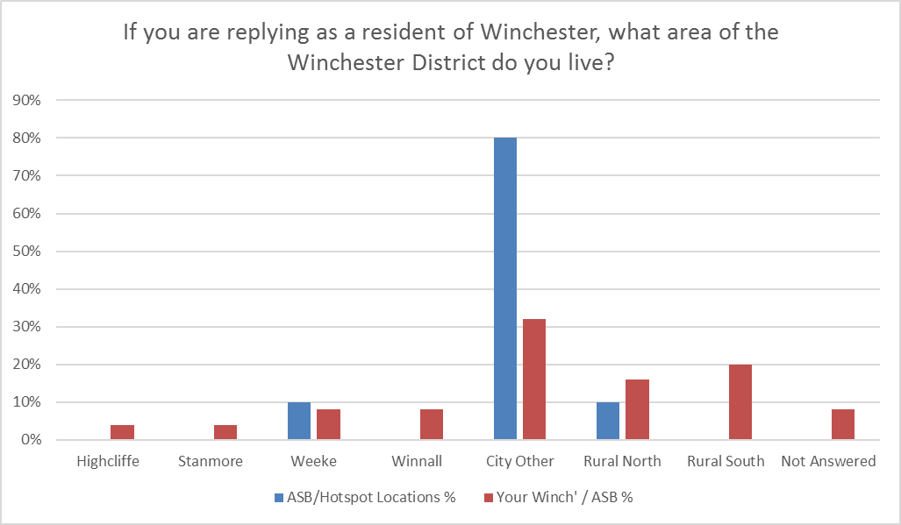

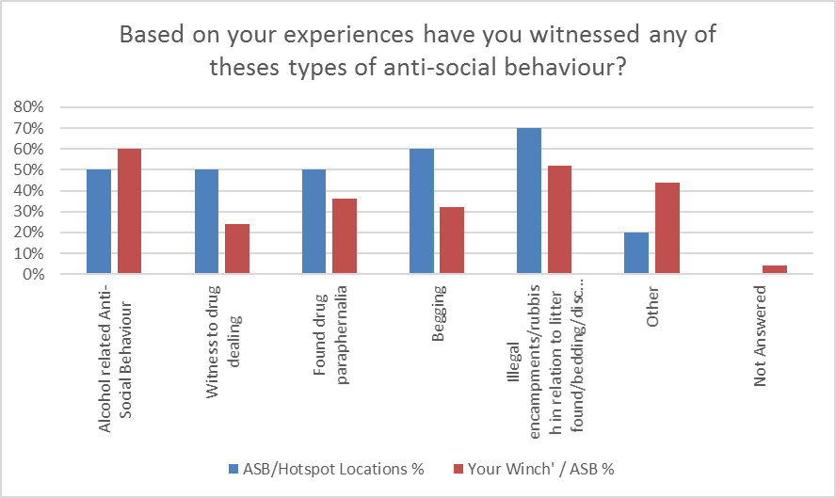

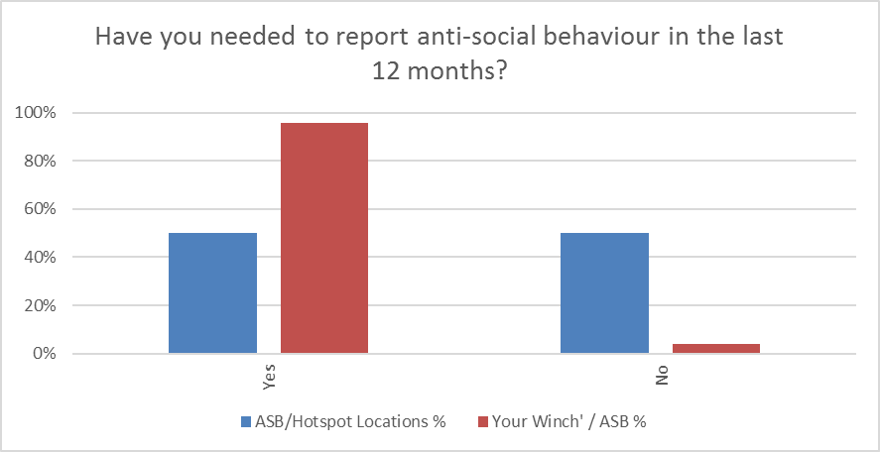

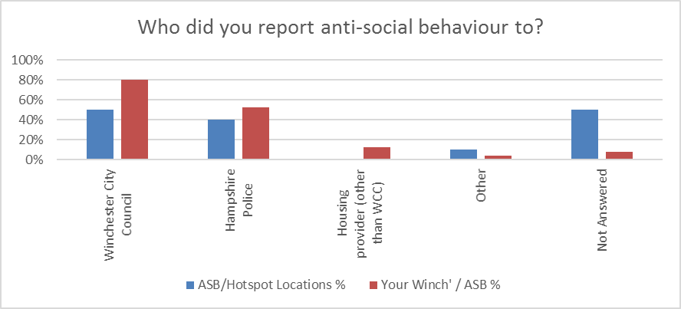

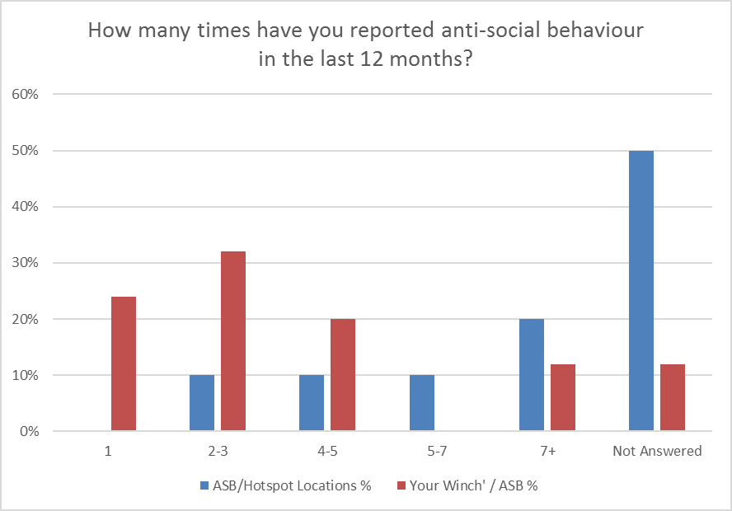

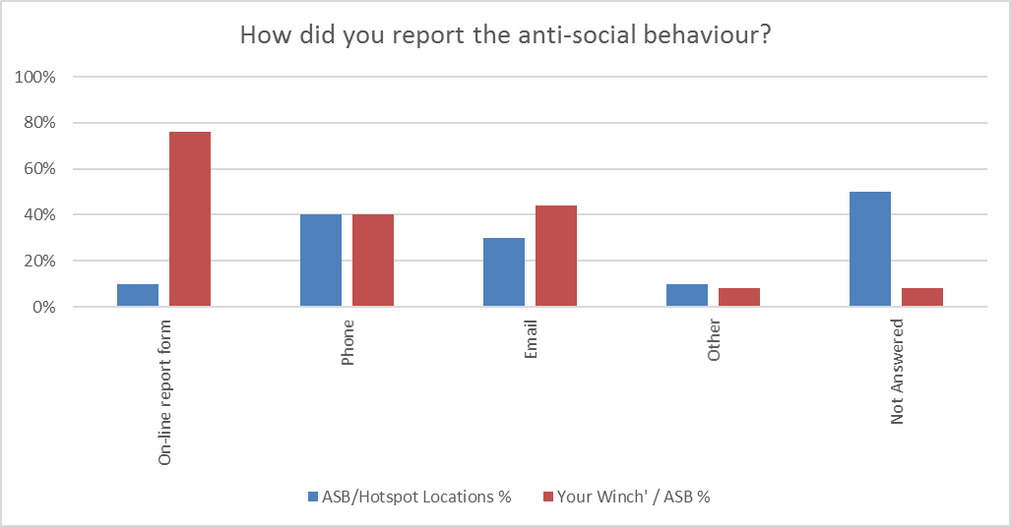
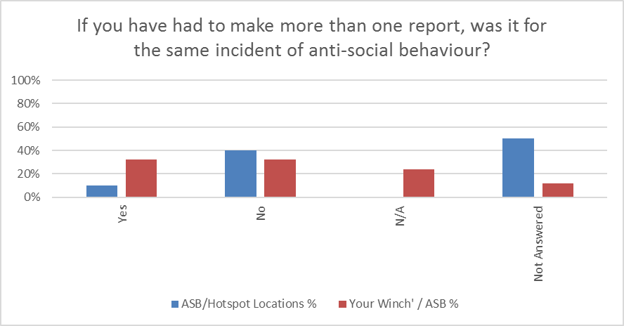
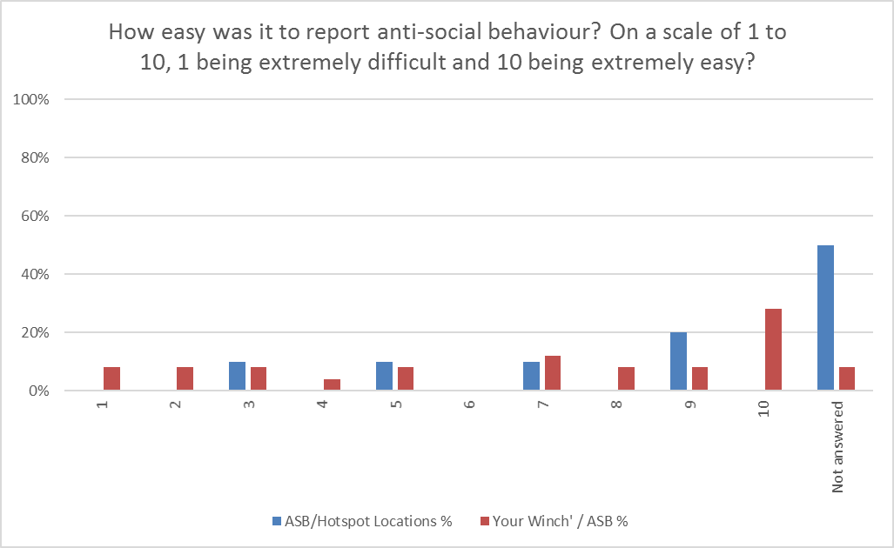

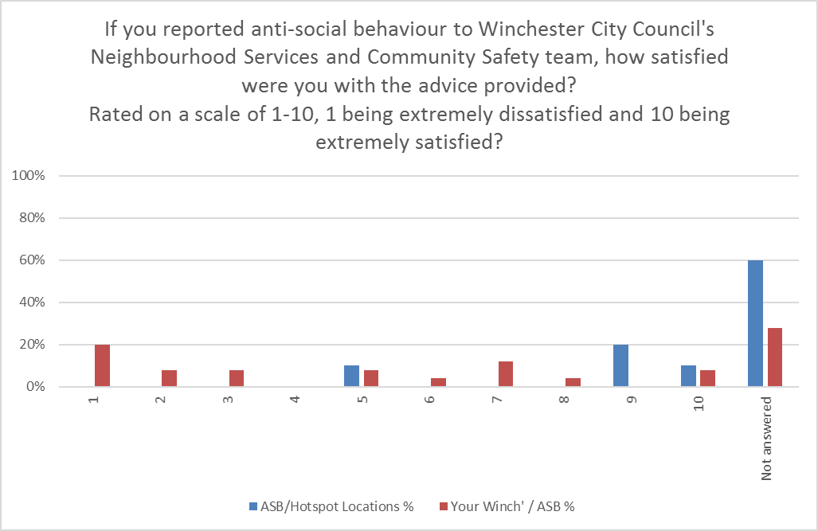

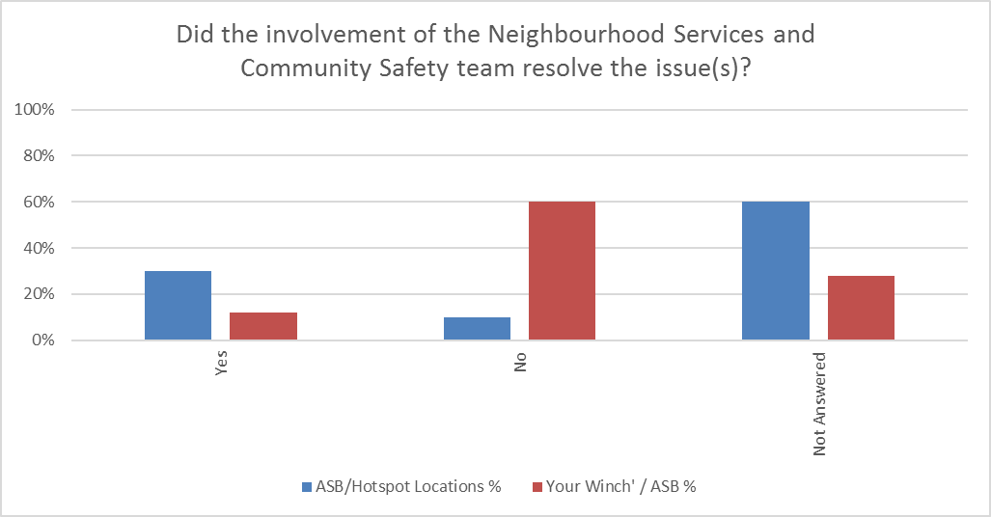

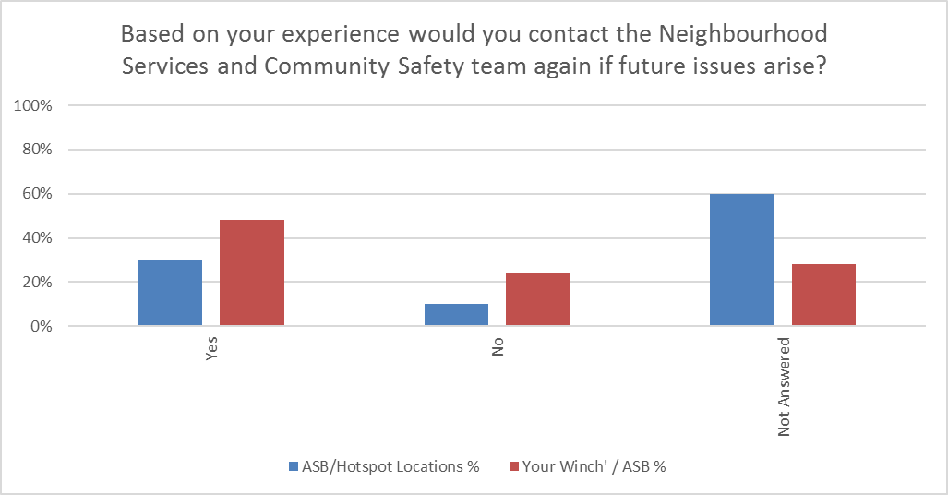

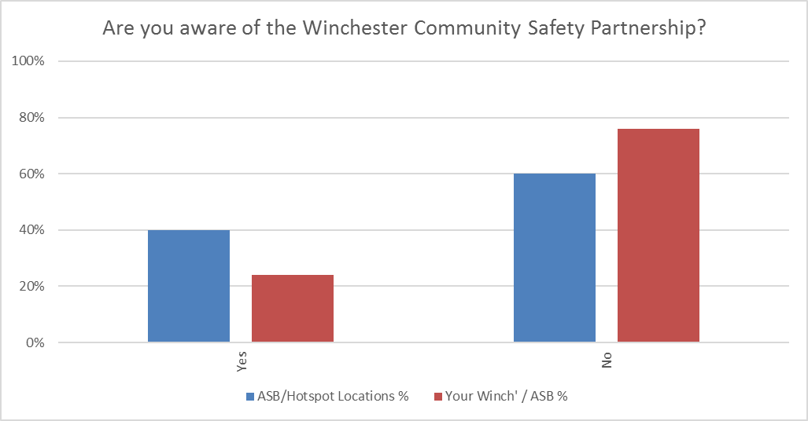
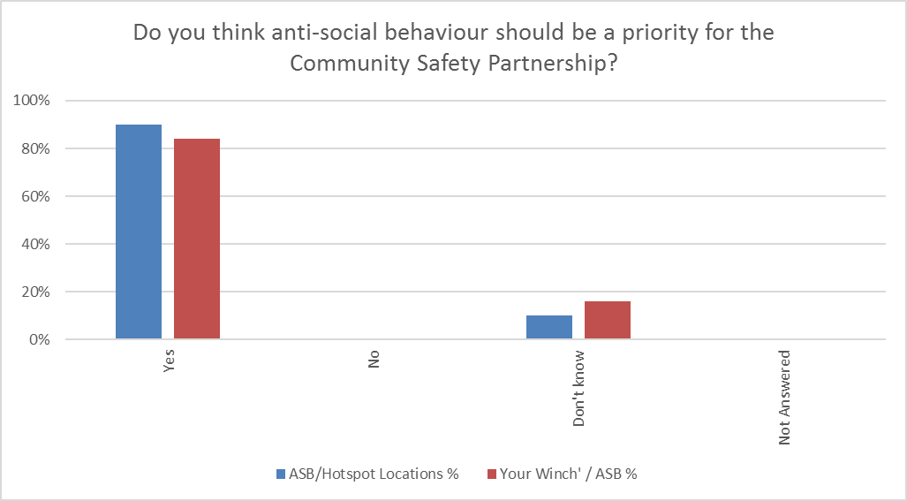

Responses captured from the surveys

THEME | YOUR WINCH /RESPONSES | OUR RESPONSE
Drugs/Alcohol | When in and around town, there are a lot of less fortunate people around by the old ice cream shop opposite Sainsbury’s, they are constantly swearing, drinking alcohol and I’ve even seen them drug dealing. The bid team can only do so much and they are allowed to annoy local shoppers. | We strive to improve the service and awareness of how to report Anti-social Behaviour and will look at identifying how we can work more closely with those affected.
Anti-social Behaviour | We were walking our dog on a public footpath and the farmer took a dislike to this and drove his tractor at us, alongside screaming, shouting and making threats. We all had to take action to move out the way to avoid being run over. My wife refuses to even walk on that route anymore because she was so traumatized. | The customer verbally abused by the farmer was advised to report the incident to 101 whilst Community Safety also made Hampshire County Council aware as they manage the footpaths. It’s important this kind of behaviour is always reported to the Police.
Graffiti | WCC do not respond to requests to remove graffiti or fly posting and provide very poor value for money. If council cannot or won’t manage the situation they should employ full time private contractors to clean comm’s cabinets as well. | Winchester City Council always respond to requests and aim to remove racist or obscene graffiti within 24 hrs of a complaint unfortunately in this case the graffiti was on Network Rail land so not able to be removed by us – the graffiti was reported to Network Rail on 3 x separate occasions and the customer updated.
Vulnerable persons | I think when people are very vulnerable living in accommodation extra care needs to be put in place. | There is always support put in place for those who are more vulnerable living in supported accommodation but it is sometimes difficult for those needing support to engage with the many support services. As a partnership we endeavour to signpost to services and encourage cross service support.

A core group of multi-agency partners (the most relevant) will meet bi-monthly to share, collate information and action plan for those identified as being key individuals causing anti-social behaviour or those who are coming to the attention of partners as victims of anti-social behaviour.
The aim of the Panel is to reduce ASB across the district whilst ensuring that there are joint working arrangements in place to respond to concerns about individuals, hot spot locations and the impact some individuals can have on local communities, businesses and those visiting Winchester.

THEME | ASB/HOTSPOT LOCATIONS | OUR RESPONSE
Drugs/Alcohol | I feel that hostels like West View are targeted by drug dealers coming down from London and from local dealers. I regularly see drug deals going on (particularly at dusk) and occasionally people injecting  I am in regular contact with Neighbourhood Services and they always come out to collect drug paraphernalia and to deal with litter. I do feel I can talk with them and ask for advice. I'd like to thank them for their help. | We are aware that some cases require a broader partnership approach. This may manifest itself in a referral being made to another service e.g. Two Saints who now manage WVH, Drug Inclusion Services, and Intel sent to Police and to ask they investigate further.
Drugs/Alcohol | Always helpful and can generally deal with the problem.  Drug use is more difficult because the perpetrators move on very quickly. | As stated above this is core work for the community safety partnership and drug related issues are managed through Operation Fortress and other multi-agency meetings.
Anti-social Behaviour | I have been very frustrated over the last 18months at the increase in anti -social behavior right outside our shop in Middle Brook Street. We have daily aggression, drunkenness, fighting, appalling language and this has increased during COVID lockdowns where restrictions are not being adhered to. We see drinking on the street from 10am onwards on a daily basis. We have had regular visits from ambulance crews to deal with fighting or collapses presumably due to substance abuse. we then witness ALL the security resources of Winchester - Bid Rangers, PCSO’s, police and the ambulance crew themselves all trying to operate safely to treat one person. These people clearly have needs for substance control, work and socialisation. Surely there is a way to deal with this group and also save money on all the resources they take up. I have often said, if you want to shop lift in the city Centre, do it while all the resources are dealing with this particular group as all the resource goes there! I really hope that there is a more productive way forward for this group, to have more purpose and direction for their lives and to be productive members of society rather than a drain on resources gone on for over a year and has been compounded by COVID. | Winchester has a strong partnership ethos and the city council prides itself on collaborative working arrangements with our communities and partner agencies. However we will review our communication channels to ensure that those affected are made aware of the joined up work being undertaken and how and who to report too. This particular area in the city centre has now been referred to the Anti-social Behaviour Panel
Anti-social Behaviour | In our area (Kings Walk) it is particularly rife and also extremely damaging to our business. We have a number of children who enter through the kings Walk alley way so their safety comes in to question.  We have had parents remove children from our services as they felt unsafe.  We have also had incidences where these people behaving anti-socially, entering our building and disrupting sessions. We feel very unsafe within Kings Walk - particularly at night when most of our classes and sessions run. CCTV being installed and linked to the police etc...Would be of huge benefit. | There is a multi-agency group in place that is focusing their efforts on the city centre and the area around King Walk, CCTV is one of the topics being discussed with external partners and our colleagues. Hampshire Constabulary are also key partners within the Community Safety Partnership and work with us to tackle some of the issues reported about ASB.
Anti-social Behaviour | ASB is often subjective - my boisterous teens are someone else's threatening behaviour,  I do worry that minor issues are being exaggerated while issues such as drug dealing are being given insufficient attention. | All ASB is taken seriously and dealt with on a case by case basis. This is core work for the community safety partnership and drug related issues are managed through Operation Fortress and other multi-agency meetings.
Good News | Since the takeover of West View from A2Dominium to 2Saints the difference has been an improvement. There seems to be far more people living there but they seem to be older and living not quite such chaotic lives. Yes, there is drug taking going on with occasional gatherings under the arch and dealing through the windows at the back. The main ring leader seems to have gone although most of the familiar faces are still about, but their lives seem more contained within their boundaries not spilling out all over us. I think it might be helpful for the residents of the sheltered accommodation to know that you do keep a regular check on the area as I did not know this until recently. I still think there is the opportunity of a drug rat run between Aylene House on Hyde Street and WestView which is hard on both residents and ex- convicts trying to start again. | Good news that there has been an improvement in the area. Over the past few years we have run meetings with the residents, fliered all flats with “how to Report ASB”, posters have been put up in communal areas again advising how to report ASB. We will continue to keep residents informed and encourage better reporting from residents when there are issues whilst continuing to work with relevant partners to deal with the any issues.
Neighbour issues | Our situation was quite complicated as we were/are being targeted by our neighbour. The police looked at our gathered evidence and told us it was a civil case, so we went to the council Neighbourhood team. It seems as the victims of harassment and fly tipping of rubbish & glass into our garden, we have no choice but to try to ignore it or spend a lot of money we don’t have spare. The team at Winchester council were very helpful but unfortunately we have just had to put up with the anti-social behaviour. | Wherever possible we would try and support residents within the district, unfortunately in some civil cases it rests with the individuals to take their own action alongside other investigation taking place around criminal activity.
How to report | Find the reporting section of Winchester Councils website very easily and the Anti-social form was simple to fill in. The only issue I came across was the video evidence I uploaded via this form didn’t make it over to the council so I had to email them separately.  The app made it easy to get in contact with someone through email  Online App has been very easy to use until the last update in early November when it stopped working, calling 101 hasn't worked well as the calls often do not get answered. | Winchester City Council app can only accept jpeg’s for videos and there is a limited size – I will feedback these comments to our IT department although it would appear that reporting online is still the most popular way of reporting issues.  101 is Hampshire Constabulary and not Winchester City Council – we will share this comment with the Police.
Knowledge of service | If the neighboured services team is the Rangers then the service is good but they’re limited to what they can offer and there is no support in the evenings. Being a venue that’s tucked away with no CCTV this is particularly unnerving.  If the NST is not the Rangers then no, we haven’t contacted them as didn’t know they were available. | We will continue to take a proactive approach to all concerns by working with partner agencies, including the Police and Bid Rangers.  Once COVID restrictions have been lifted I will be visiting this particular location and advising how to report ASB and engage with the Community Safety Partnership.

OUTCOMES

- We are aware that some cases require a broader partnership approach. This may require a referral being made to another service e.g. Housing Tenancy, Outreach Team, Environmental Health or other relevant agencies such as the Police or other social landlords.
- Winchester has a strong partnership ethos and the city council prides itself on collaborative working arrangements with our communities and partner agencies. We will review our communication channels to ensure that those contacting us are made aware of the joined up work being undertaken. Hampshire Constabulary are key partners within the Community Safety Partnership and work with us to tackle some of the issues reported about ASB.
- The Neighbourhood Service Team have 5 patrolling officers who identify hot spot locations through partnership working, they undertake proactive patrols on a regular basis.
- It is important that all ASB concerns are reported in a timely fashion using the Winchester City Council app or via 101 to ensure we are made aware of the issues and as appropriate put in place partnership action/support/patrol activity where it’s needed.
- Due to the low response rate we will review whether the current consultation method is the most appropriate, although we saw an increase this year compared to responses in 2019 the response rate is still disappointing. We are currently investigating the use of other digital tools to improve collaboration and participation in the future.
- The current Anti-social Behaviour “Report It” leaflet to be shared more prominently on the Winchester City Council website to reach a wider audience and raise awareness across the Winchester district about the role of the Community Safety Partnership.
- We will identify ways of improving the current communication with Head Teachers and pupils once the COVID restrictions are lifted i.e. regular virtual meetings, attendance in school, greater collaboration around school campaigns/projects.

YOUR WINCHESTER is the Winchester City Council online reporting service that is available 24 hours a day, 7 days a week, 365 days a year to report service requests, general enquiries, or report issues such as Anti-social Behaviour – www.winchester.gov.uk
A core group of multi-agency partners (the most relevant) will meet bi-monthly to share, collate information and action plan for those identified as being key individuals causing anti-social behaviour or those who are coming to the attention of partners as victims of anti-social behaviour
Operation Fortress – a multi-agency meeting designed to discuss county lines (transient drug dealing) and other drug related issues.

