# **WINCHESTER CITY COUNCIL GRANT SCHEME**

# **Green Business Grants**

# **ELIGIBILITY POLICY**

# **November 2023**

## **Introduction**

Is your business looking to reduce its energy costs and consumption or need help with increasing renewable energy generation or lowering carbon emissions through transport?

It’s also a priority for Winchester City Council to reduce carbon emissions so we are launching a new green project grant that will reduce your carbon footprint and running costs in line with our recommendations in the [Green Economic Development Strategy](https://www.winchester.gov.uk/business/green-economic-development-strategy) and [Carbon Neutrality Action Plan.](https://www.winchester.gov.uk/climate-change-and-energy/carbon-neutrality-action-plan)

[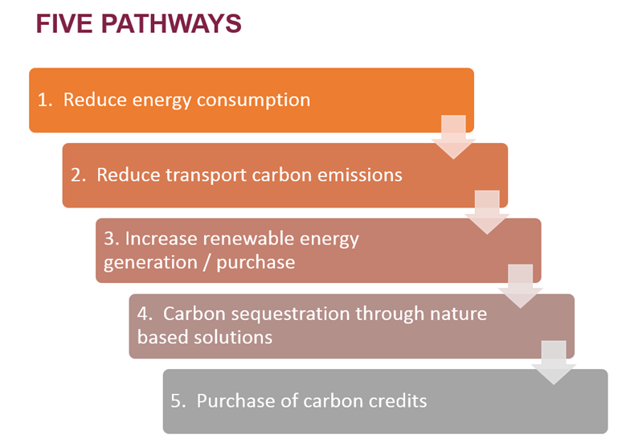](https://www.winchester.gov.uk/climate-change-and-energy/carbon-neutrality-action-plan)

The latest Carbon Neutrality Action Plan, adopted in September 2023, sets out five pathways for carbon reduction.

The council will make available £45,000 which will be allocated to businesses in grants of between **£5,000 and £10,000** and they are required to secure a minimum of 50% of the total project cost in match funding from other sources.

For help and advice please contact our Economy Team at [ecodev@winchester.gov.uk](mailto:ecodev@winchester.gov.uk).

**Am I eligible?**

**You must:**

* be a business based in and operating from within the Winchester District. Please see our [Ward Map](https://www.winchester.gov.uk/councillors-committees/ward-map) for more information.
* A landlord whose commercial, office, industrial warehouse etc. premises is located in the Winchester
* be able to provide a least 50% match funding for your project
* be a legal entity such as a limited company, limited liability partnership or cooperative or Community Interest Company
* be small business that does not employ more than 50 people
* have an independent energy or carbon assessment by a qualified assessor that recommends the project that you are applying for a grant for. Please refer to the Winchester City Council supported [carbon audit service](https://www.visitwinchester.co.uk/low-carbon-assessments/) if you would like to arrange an assessment of your business
* have all necessary insurances, polices and permissions in place, including [planning permission](https://www.winchester.gov.uk/planning/planning-applications/extensions-to-private-houses), to enable you to deliver this project
* have a project that can be delivered by 28 February 2024
* actively trading on 30 November 2023 not in administration, insolvent or has had a striking off notice made

**What can I use the grant for?**

Your project should deliver carbon emissions savings for your business, for example from energy savings, water savings and/or direct reductions in emissions, measured as tonnes of carbon dioxide equivalent (tCO2e).

Outcomes and impacts of funded projects will need to demonstrate they can deliver on one or more of the five pathways set out in the Winchester District Carbon Neutrality Action Plan (revised Sept 2023):

|  |  |  |
| --- | --- | --- |
| **Carbon Neutrality Action Plan Pathways** | **Potential Outcomes & Impacts** | **Potential Project Activity** |
| 1. Reduce energy consumption | Retrofitting energy efficiencies (saving) measures | Insultation and glazing improvements  Replacing a gas boiler with an air source heat pump  Replacing lighting with LED alternatives  Installing energy management systems and monitors |
| 1. Reduce transport carbon emissions | Active travel to reduce the need to use the car.  Increase use of low emission vehicles.  Contribute to cleaner air. | Electric bike schemes including shared community e-bikes, bike racks and shelters and repair workshops  EV charging points  Car clubs and car sharing |
| 1. Increase renewable energy generation / purchase | Increase energy supply resilience.  Reduce energy costs | Solar photovoltaic panels and batteries |
| 1. Carbon sequestration through nature-based solutions | Increase bio-diversity.  Safeguard and enhance our district’s natural habitats.  Protect against extreme climate events. | Tree planting schemes  Rewilding projects  Flood defences |
| 1. Support creation of local carbon credits | Help the Winchester district be carbon neutral by 2030 | Projects that work towards creating carbon credits or offsetting schemes within the Winchester district. |

You can apply for a grant of between **£5,000 to £10,000** per business to cover up to or 50% of your eligible costs.

**What type of expenditure is eligible is?**

Grants can be used for:

* capital and revenue
* scoping studies / design work to enable capital investment
* pilots – trying some new to test out concepts
* innovation – project where you want to do something new
* behaviour change campaigns for staff that lead to action

**Additional considerations**

Liability and ongoing costs for any equipment purchased or asset improved must be met by the applicant organisation. The council will not take on any liability as a consequence of grants awarded.

Contributions to a large-scale project will only be considered if this grant would help secure other sources of funding / investment.

All necessary permissions (e.g. planning / building; landlord / owner), where appropriate, must be in place before an application will be considered.

Only one grant from this funding scheme will be given to an organisation in any one financial year.

The grants will be allocated on a first-come, first-serve basis for applications that meet the criteria.

Applicants should obtain three quotes for items of expenditure above £2,500

**Ineligible expenditure**

We are unable to provide grant funding for:

* activities that will increase your production and overall carbon emissions but at a lower carbon intensity per item produced
* individuals
* staff costs
* general running costs of a vehicle
* vehicles
* replacement or ‘like for like’ equipment or items
* retrospective funding of activities/projects
* repeat projects
* websites
* projects that have received funding in previous years via this scheme or from other council or government funds such as the [Rural England Prosperity Fund](https://www.winchester.gov.uk/business/uk-shared-prosperity-fund).
* planning fees or permits

**How will my application be assessed?**

This is a competitive fund and each application will be assessed against the grant eligibility and criteria, and scored using the grant scoring matrix below.

|  |  |  |
| --- | --- | --- |
| Criteria | Aspect of evulation | Weighting |
| Project need | Clear evidence of need for project (provided through carbon audit/assessment)  Demonstration of delivery on one or more of the five pathways set out in the Winchester District Carbon Neutrality Action Plan  The EPC rating of the property will be taken into consideration  Amount of carbon emissions reduction resulting from project (measured in tCO2e) | 50% |
| Deliverablity | Project can be delivered by 28 February 2024.  No permissions required  Permissions already in place  Evidence that measures are in place to evulatate the success of the project against the Carbon Neutrality Plan pathways | 30% |
| Grant | A clear description of how the money will be spent on eligible activities  Evidence that 50% match funding in place  Provision of three quotes | 20% |

**Grant award process**

Grants are awarded on a first-come, first-served basis, with decisions according to the grant eligibility and criteria around every four weeks. Decisions are made by Winchester City Council’s Economy Team in consultation with the Sustainability Team.

There is no obligation for Winchester City Council to fund eligible bids. We may decide to close the grant round early or prioritise grant awards if the programme is oversubscribed.

It is likely to take four weeks from your application to the grant award decision. This can vary based on the volume of applications we receive and the frequency of approval meetings. Please allow for this when making plans to start or complete your project.

All decisions will be communicated by email to businesses. There is no right of appeal.

**How is the grant paid?**

The grant is paid in arrears once the project is completed and is, in effect, cashback on your project spend. You must be able to cashflow the project while it is in progress – we do not pay grant upfront nor do we pay grants in instalments while the project is in progress.

We aim to pay grants within 28 days of receiving all the information we need to process your claim. We will notify you when your claim has been processed and when to expect the grant to reach your bank account.

All payments of grant will be made by a BACS transfer to the organisations nominated business bank account, as confirmed in the on-line declaration. Please ensure that your bank details on the on-line form are correct to minimise delays in payment.

Grant income received by an organisation is taxable therefore will be subject to tax.

Only organisations which make an overall profit once grant income is included will be subject to tax.

**Grant terms and conditions**

1. All grant recipients are expected to enter into a grant agreement with Winchester City Council which includes the following terms:
2. Any spend by the business prior to formal notification from the council, will make the business ineligible for funding.
3. All funding must be spent by 28 February 2024.
4. Winchester City Council reserves the right to fund less than the amount requested in the application form.
5. Businesses must not change the use of the grant award and must spend the grant on the purpose for which it was approved unless agreed otherwise in writing by the Economy Team at Winchester City Council.
6. All grant recipients will be required to publicise the support of Winchester City Council including the use of the appropriate council logo on publicity material. Guidance on this will be sent to successful applicants.
7. All grant recipients will be required to explain how they used their grant within one months of spending the grant. The business must submit to the council a short statement of project completion, to confirm and evidence that the money was spent on the approved purpose, or the council may seek to reclaim its funding.
8. Payment of the grant by the council will be made once the project is completed and appropriate evidence has been submitted.
9. if grant funding is used inappropriately, is not used, or the applicant fails to respect the conditions attached to the grant, the council may demand reimbursement of any funds already paid out, or take other measures to recoup the funds.
10. Funding decisions are delegated to Corporate Head of Economy and Community. The council’s decisions with regards to funding are discretionary and no appeals process is available.

## **Subsidy control**

In accepting funding the business shall comply with all [Subsidy Control](https://www.gov.uk/government/collections/subsidy-control-regime) rules and shall ensure that all requirements for all such rules shall we met.

## **Managing the risk of fraud**

Winchester City Council will not accept deliberate manipulation and fraud. Any organisation caught falsifying their records to gain additional grant money could face prosecution and any funding issued will be recovered, as may any grants paid in error. All applications will be subject to checks and verification.

Applicants will be required, as part of the declaration process, to declare that they understand that if they knowingly and dishonestly provide false or misleading information in communication with the Council including verbal communication they will be committing a criminal offence contrary to the Fraud Act 2006 and could be subject to a criminal investigation and criminal proceedings may be taken against them.

**Data Protection Statement**

Any personal data you supply on this application form will only be used for purposes in connection with the Winchester City Council Grant Scheme.  
  
In line with our transparency reporting procedures, we would however, publish a list on our website ([www.winchester.gov.uk/business](http://www.winchester.gov.uk/business) of organisations to which we have awarded grants.

The Council's data protection and privacy policy was detailed upon registration of this system.  Should you require a refresh of this information please see links below:

* [Winchester City Council - Privacy Policy](http://www.winchester.gov.uk/about/privacy-policy)
* [Winchester City Council - Data Protection and Privacy protocol](http://www.winchester.gov.uk/about/data-protection-privacy)”