**WINCHESTER DISTRICT TEN YEAR**

**GREEN ECONOMIC DEVELOPMENT STRATEGY**

**ACTION PLAN 2024 – 2027**

**Revised September 2024**

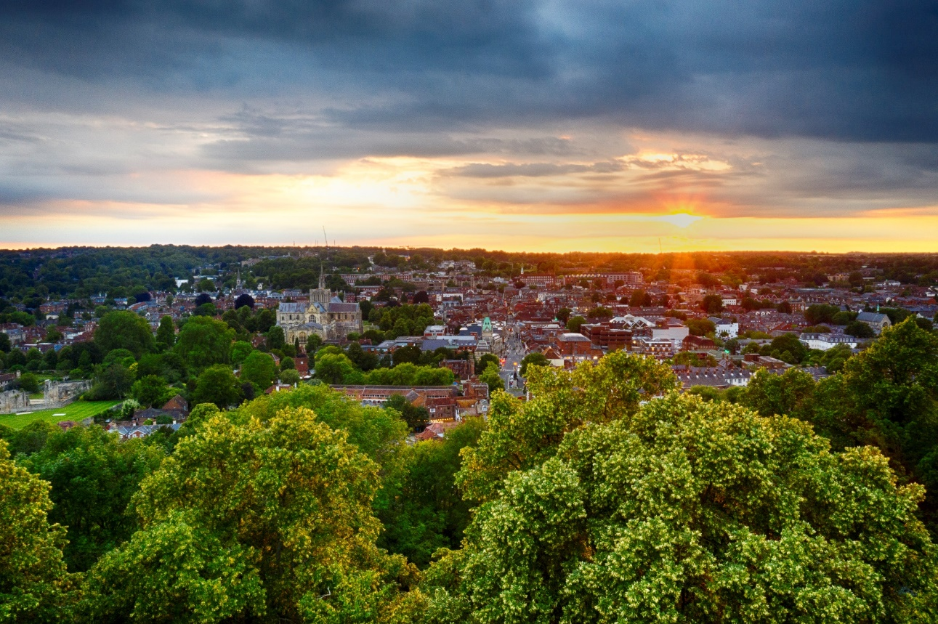

**Connected strategies and plans**

The GEDS remains closely connected with several other strategies across the council. This interdependency is illustrated below and reflected in the action plan.

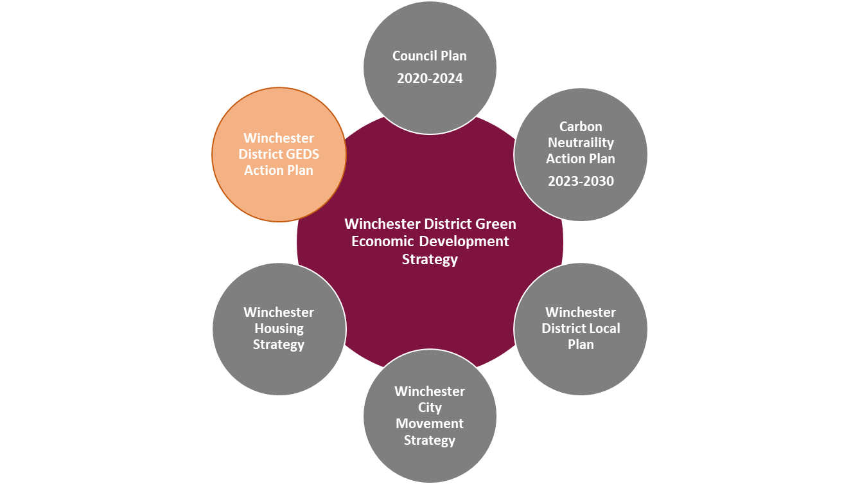The Winchester [Green Economic Development Strategy](https://www.winchester.gov.uk/business/green-economic-development-strategy) sets out a framework and overall direction to influence the development of the district’s economy, positioning it as a sustainable place in which to live, work, learn and visit. The Carbon Neutrality Action Plan (CNAP) sets out the council’s approach to carbon neutrality. [Carbon Neutrality Action Plan - Winchester City Council](https://www.winchester.gov.uk/climate-change-and-energy/carbon-neutrality-action-plan) This 2024 2027 Action Plan recognises the interdependency between the GEDS and the CNAP. It will take the effort, commitment, and action of a wide group of individuals, businesses and organisations to achieve the aims and objectives set out in these plans. Therefore the 2024 - 2027 GEDS Action Plan and revised governance structure aims to facilitate this. (see section 10.1)

**The GEDS Policy Themes**

The six policy themes outlined in the GEDS demonstrates the connectivity shown above and the action plan outlined below illustrates the work being done across the council.

The policy themes outlined in the GEDS remain relevant and have therefore been considered in the development of the 2024-2027 GEDS Action Plan.

**Commitment to carbon neutrality**

Since the GEDS and the 2022 2024 Action Plan was written Winchester City Council has reaffirmed its commitment to its carbon neutrality targets with the revision of Winchester District Carbon Neutrality Action Plan (CNAP). This CNAP outlines the work of the council and its role in supporting, working in partnership, and championing changes needed across the district to reduce carbon emissions to meet the aim for the district to be carbon neutral by 2030.

The CNAP builds on the carbon neutrality roadmap setting out how the council, alongside its partners, organisations, and local businesses, could work towards reaching carbon neutrality, including the nature and scale of interventions needed. The roadmap recognised that alongside the council’s efforts, contributions would be needed from the district’s businesses, institutions, and residents.

As such the 2024 – 20207 GEDS Action Plan recognises the five pathways outlined in the CNAP which focus efforts and prioritise actions and interventions needed for the district and the council to be net zero.

Priority interventions

To provide focus for delivery of the CNAP, three interventions have been identified as contributing nearly 75% of the emissions reduction modelled.

Supporting interventions

To support these priority interventions and to address the key issues for the district, supporting and complementary activity will also be progressed.

|  |  |
| --- | --- |
| **Commercial & Industrial**  Business investment in energy efficiency & generation aligned with actions in the Winchester District Green Economic Development Strategy with a potential total carbon saving by 2030 of 113 ktCO2e. | **Transport**  Active travel and decarbonising passenger vehicles initiatives has the potential for 107 ktrCO2e by 2030. This are of work will require policy and investment at both county and national level. |
|  |  |

|  |  |  |  |  |
| --- | --- | --- | --- | --- |
| Approach / Lever | **1. Reduce energy consumptions** | **3. Increase renewable energy generation** | **2. Reduce transport carbon emissions** | |
| **Business Retrofit programmes** | **Roof top solar** | **Active travel / reduce car use** | **Low carbon bus & taxis** |
| **Deliver** | Green Business support programme.  Explore development of a business / sector peer to peer mentoring programme | Investigate further sites for PV installation based on Biffa and Marwell model | District LCWIP will bring forward plan for improved cycling and walking routes across district.  Local Plan requires new developments in the district to consider mobility hubs. | Park & Ride bus fleet new contract to include low carbon fuel options |
| **Collaborate** | Work with Sustainable Business Network, Hampshire Chamber of Commerce etc. to deliver advice and guidance.  Progress Green Skills Academy to upskill tradespeople. |  | Electric Car Clubs – investigate capacity to roll out across market towns.  Work with HCC on Local Transport Plan 4 & implications for Winchester district | Work with HCC on bus services including its Enhanced Bus Partnership Plan; liaise with operators to discuss opportunities |
| **Enable** | UK Shared Prosperity Rural Fund and Green Project Fund  Apply for government (and other) funding to support programmes  Signpost to Innovate UK for funding for businesses to test innovative ideas. | Business support programme to guide and advice on options.  Case studies on models that have been used.  Facilitate access to external grants. | Delivery Hubs – working with Solent Transport on a potential hub for the city centre. |  |
| **Influence** | Business-focused workshops to understand specific barriers to decarbonisation and energy efficiency measures.  Signpost to Energy Saving Trust (EST) who provides case studies, energy efficiency resources and runs events to help businesses make informed choices, including supply chain advice. | Commercial properties that are rented will require co-ordination between landlord, renter and supplier to install solar PV. | Campaigns, events and information to change behaviours |  |

**Delivery Approach and Levers**

The GEDS and the CNAP established four levers to support their delivery. The 2024 – 2027 GEDS Action Plan has been set out against the approach / levers available to the council.

Three-year prioritisation chart

Principles of delivery and prioritisation:

* Projects which result in direct and measurable carbon savings, such as the solar for business programme, below
* Delivery of projects that have been externally funded, such as those through the UKSP, as well as those that can be funded through external funding applications.

|  |  |  |
| --- | --- | --- |
| 2024 -25 | 2025-26 | 2026-27 |
| Solar for business:   1. Identify opportunities to replicate the business model used at Biffa/Marwell whereby the council installs solar PV on a business’ premises and sells the energy at a discounted rate.  * Develop business case and project plan for the delivery of a programme of solar PV installations on business rooftops across the district  1. Increase number of solar PV installations on commercial properties.  * Use the Local Energy Net Zero Accelerator (LENZA) tool to identify and map buildings that are potentially suitable * Install 8MW of solar PV on commercial properties across Winchester district, 3.5MW on industrial property. 400 panels = 160kWp (mid-size) = 50 installations   Target 7 per annum midsize installations. | Solar for business:   1. Delivery of solar PV installations as described 2. Enabling interventions to increase solar on commercial properties  * Install 8MW of solar PV on commercial properties across Winchester district, 3.5MW on industrial property. 400 panels = 160kWp (mid-size) = 50 installations .Target 7 per annum midsize installations | Solar for business:   1. Delivery of solar PV installations as described 2. Enabling interventions to increase solar on commercial properties  * Install 8MW of solar PV on commercial properties across Winchester district, 3.5MW on industrial property. 400 panels = 160kWp (mid-size) = 50 installations. Target 7 per annum midsize installations |

**The GEDS Action Plan 2024 – 2027**

**Delivery (and investment)**

|  | **Action** | **GEDS Theme** | **CNAP Pathway** | **Long term aim** | **Lead Team** |
| --- | --- | --- | --- | --- | --- |
| Innovative Business & Economy | Produced digital sector inward investment prospectus | IB4 - Co-ordinate a digital cluster programme |  | Explore opportunities for building the digital / green technology offer in the district | Economy |
| Deliver a programme of low carbon assessments / business audits to identify measures that will reduce carbon emissions. | IB5 - Co-ordinate a single business carbon reduction and responsible management programme  Co­ordinate green energy initiatives | 1. Reduce energy consumption   * Business retrofit programme | A single district-wide brand and shop-window for this activity which sign-posts businesses to the relevant partner will reduce duplication and confusion. | Economy |
| Deliver a green business grants fund to reduce energy consumption and transport emissions and increase renewable energy regeneration | G17 - Co­ordinate green  energy initiatives | 1. Reduce energy consumption   * Business retrofit programme | A stronger, greener, more sustainable local economy  (Council Plan 2020 to 2025) | Economy |
| Technical advice note produced with accompanying publicity and action plan including:   * Comprehensive communications and stakeholder plan to include working with BID, chambers of commerce, Business South and landlords * Familiarisation with internal teams such as planning, business rates, tourism and culture * Provide a signposting service to landlords | IB7 - Encourage repurposing retail space |  | Opportunity to re-shape large retail space into more accessible and flexible customer-facing and workshop space for independent businesses | Economy |
| Delivery a mentoring scheme revised following feedback from pilot in 2023.  - potential to focus on a green(ing) business peer to peer support to support CNAP action  - explore the appetite with businesses for a green business conference at the end of the programme. | CCVE5 - Co­ordinate the  establishment and  operation of a  creativity-themed  business cluster  network | 1. Reduce energy consumption   * Business retrofit programme   3. Increase renewable energy generation / purchase   * Roof top solar | Existing businesses are supported (Council Plan 2020 to 2025) | Economy |
| Vacant property register and pop-up spaces promoted to cultural and creative sectors | IB7 - Encourage repurposing retail space |  | Work with businesses, local universities and colleges to position Winchester as a  centre for digital, creative and knowledge based industries  (Council Plan 2020 to 2025) | Tourism & Culture |
| Skills & competitiveness | Deliver a Digital Growth Factory which includes a digital productivity programme for SMES supported by UK Shared Prosperity Funding 2024/2025 | IB4 - Co-ordinate a digital cluster programme |  | Explore opportunities for building the digital / green technology offer in the district | Economy |
| Secure employment and skills plans for major developments that encourage developers to develop green skills. Monitor and report on skills and job outcomes | SFE1 - Co­ordinate development  of a low carbon offsite and  Sustainable Construction  Skills Academy  Type; Investment/delivery | 1. Reduce energy consumption 2. Increase renewable energy generation | A stronger, greener, more sustainable local economy  (Council Plan 2020 to 2025) | Economy |
| Deliver Digital Skills programme for residents (UK Shared Prosperity 2024/2025 funded project) | IB4 - Co-ordinate a digital cluster programme |  | Work with partners to help disadvantaged groups  access work  (Council Plan 2020 to 2025) | Economy |
| Jobs and Opportunities Fair  Deliver Jobs and Opportunities Fair | Skills and Competitiveness |  | Existing businesses are supported  (Council Plan 2020 to 2025) | Economy |
| Culture, creative and visitor economy | Implement the district-wide  Cultural Strategy 2024-2030   * Establish and mobilise Task and Finish groups to tackle agreed action plan * Undertake governance options analysis to formalise stakeholder group * Audit current cultural infrastructure including festivals and events spaces * Produce event toolkit and associated Event Management guidance * Undertake consumer marketing activity including production of a public art trail leaflet | CCVE1 – Grow opportunities for the creative and cultural sector |  | Delivery of creative and cultural spaces for residents and businesses, start-up space, skills hubs, creative exhibitions and events. | Tourism & Culture |
| Deliver a Sustainable Tourism strategy   * Development of evidence base * Development of vision, priorities, and actions * Sector testing * Draft strategy * Strategy endorsement | CCVE2 - Deliver an overarching and coordinated vision to make Winchester District a national leader in this sector. | 1. Reduce energy consumption  2. Reduce transport carbon emissions   1. Active travel / reduce car use | Improve connectivity and co-ordination across the district including maximising local supply chains, support tourism businesses to be more sustainable and maximise their growth potential. | Tourism & Culture |
|  | West of Waterlooville Public Art Programme   1. Produce Public Art Strategy and manage delivery of phase one action plan 2. Commission resident artist to deliver agreed public art interventions 3. Form community arts panel 4. Deliver community arts events | CCVE1 -  to grow  opportunities for the  creative and cultural  sector |  | Attractive public spaces where people feel safe and secure  A wide range of physical and cultural activities for all ages and abilities  (Council Plan 2020 to 2025) | Tourism & Culture |
|  | City Street Markets – new operating policy which involves traders’ sustainable credentials being considered as part of the application process | IB5 - Co-ordinate a single business carbon reduction and responsible management programme | 1. Reduce energy consumption  2. Reduce transport carbon emissions | A stronger, greener, more sustainable local economy  (Council Plan 2020 to 2025) | Economy |
| Connected, public & electric transport | Deliver a plan for the next phase of EV charging infrastructure strategy | T1 - Review the district wide EV strategy and commitments made in the Carbon Neutrality Action Plan and consider focusing on urban and rural as well as grid capacity and energy storage. | 2. Reduce transport carbon emissions | Develop a district wide statement on the approach to supporting EV infrastructure delivery to support transition to low carbon vehicles – domestic, commercial and public. | Transport |
| Deliver a feasibility for electric vehicle car club scheme | T6 - Develop a rental scheme for electric vehicles, in partnership with a rental provider. | 2. Reduce transport carbon emissions   1. Active travel / reduce car use | The Winchester district is carbon neutral by 2030 | Sustainability |
| Affordable, low carbon housing | New Homes: Development of 6 Passivhaus units at Southbrook Cottages in Micheldever  Passivhaus Units at Winnall  North Whiteley - completion of 7 Association for Environment Conscious Building (AECB) homes to WCC. | HC1 - Encourage low or zero carbon regeneration site testbed and development | 1. Reduce energy consumption   1. Domestic energy efficiency & renewable heating measures | To build supply chain capacity and show that the district is embracing innovation, a test-bed can be developed. | Housing |
| Social Housing Decarbonisation Funding is targeting 369 properties over 2 years and currently rolling this out. There have been 380 retrofit ready energy assessments. | HC2 - Deliver a significant retrofit campaign | 1. Reduce energy consumption   1. Domestic energy efficiency & renewable heating measures | Zero carbon exemplar development | Housing |

**Partnership & Collaboration**

We will collaborate, facilitate, and coordinate action by stakeholders. We will work with, and in, partnerships; working groups; networks and forums.

|  | **Action** | **GEDS Theme** | **CNAP Pathway** | **Long term aim** | **Lead Team:** |
| --- | --- | --- | --- | --- | --- |
| Innovative Business & Economy | Greener Futures Partnership | IB5 – Co-ordinate a single business carbon reduction and responsible management programme | 1. Reduce energy consumption 2. Reduce carbon transport emissions 3. Increase renewable energy regeneration | The Winchester district will be carbon neutral by 2030 | Sustainability & Economy |
| Sustainable Business Network  Themed programme of four events per annum focus on Carbon Neutrality Action Plan interventions | IB5 – Co-ordinate a single business carbon reduction and responsible management programme | 1. Reduce energy consumption 2. Reduce carbon transport emissions 3. Increase renewable energy regeneration | A stronger, greener, more sustainable local economy  (Council Plan 2020 to 2025) | Economy |
| Skills & competitiveness | Deliver a retrofit skills improvement programme in partnership with Hampshire County Council and the Retrofit Academy via UK Shared Prosperity Funding | SFE1 - Co-ordinate development of a low carbon offsite and Sustainable Construction Skills Academy | 1. Reduce energy consumption 2. Increase renewable energy regeneration | There is an opportunity to create a physical ‘academy’, as a way of seeding the growth of this sector. | Economy |
| Hampshire Rural Forum Skills Needs and Training Sub Group   * Meeting skills needs * Future farming and land management, energy solutions, tackling carbon emissions | IB3 - Co-ordinate innovation and knowledge-sharing in the rural and land-based economy. |  | Deliver innovation support and knowledge-sharing to agricultural businesses across the district. | Economy |
| Culture, creative and visitor economy | Cultural Network Group  Skills development including creative growth programme working on business planning and finance | CCVE1 - Collaborate to create a creative hub  CCVE5 - Co-ordinate the establishment and operation of a creativity-themed business cluster network |  | Support the district’s creative and cultural industries by delivering creative and cultural space for its residents and businesses. | Tourism & Culture |
| Green infrastructure, bio-diversity and renewable energy generation | Participate in the DEFRA Test and trail initiative through the Hampshire Environmental Land Management Scheme Board | GI6 - Collaborate with rural land-based businesses and the South Downs National Park Authority to increase biodiversity | 4. Carbon sequestration through nature-based solutions | Assist rural SMEs to access central Government Environmental Land Management (ELM) funding (formerly CAP) to enhance biodiversity | Natural Environment and Economy |
| Connected, public & electric transport | Active Travel Schemes  Hyde Church Lane modal filter.  Parchment Street Contraflow.  Permitting cycling on pedestrianized part of Middle Brook Street  Romsey Road puffin crossing near Clifton Terrace.  Worthy Road / Worthy Lane Active Travel Corridor. | T4 - Collaborate HCC on the Movement Strategy | 2. Reduce transport carbon emissions   * Improve active travel and public transport options | The Winchester district will be carbon neutral by 2030 | Transport |
| Micro-consolidation Trial  Consolidation of ‘last mile’ / ‘first mile’ / ‘only mile’ deliveries in Winchester city  Identification and use of public and private sector ‘last mile’ logistics site |  | 2. Reduce transport carbon emissions   * Decarbonise freight vehicles | The Winchester district will be carbon neutral by 2030 | Transport |
| HCC awarded £7.2m of BSIP+ funding (split over the two financial years 23/24 & 24/25) to sustain local bus services and encourage increased use of local buses. BSIP+ report on methodology being reviewed before distribution of funds to operators for supported services and pump priming. | T3 - Collaborate with HCC on Bus Improvement Plan | 2. Reduce transport carbon emissions   * Improve active travel and public transport options | Ensure a WCC voice in the HCC Bus Improvement Plan, together with a commitment to financial support where necessary to better connect rural and city across the district. | Transport |
| Affordable, low carbon housing | Working with Warmer Homes Consortium to deliver the target for WCC - 122 properties.  Launch and promotion of Great British Insulation Scheme and Connected for Warmth. | HC2 - Deliver a significant retrofit campaign | 1. Reduce energy consumption   * Housing retrofit programmes | Actively promote the Warmer Homes Local Authority Delivery (LAD) programme for non-Council housing residents. | Housing |

**Enabling** - policy & grants

We will use levers which enable business and communities to act including strategies, policies and grants.

|  | **Action** | **GEDS Theme** | **CNAP Pathway** | **Long term aim** | **Lead Team:** |
| --- | --- | --- | --- | --- | --- |
| Innovative Business & Economy | Implement the district-wide  Cultural Strategy 2024-2030 (as above)  Deliver a Sustainable Tourism strategy (as above) | CCVE1 – Grow opportunities for the creative and cultural sector  CCVE2 - Deliver an overarching and coordinated vision to make the Winchester District a national leader in this sector. |  | Delivery of creative and cultural spaces for residents and businesses, start-up space, skills hubs, creative exhibitions and events.  Improve connectivity and co-ordination across the district including maximising local supply chains, support tourism businesses to be more sustainable and maximise their growth potential. | Tourism & Culture |
| Skills & competitiveness | Sparsholt College to build and install three low carbon technology training bays supported by UK Shared Prosperity Funding 2024/2025 | SFE2 - Co-ordinate development of a rural innovation hub for energy efficiency and generation | 1. Reduce energy consumption   * Housing retrofit programmes | Across the UK there is currently a prohibitive skills and supply chain shortage for installation of energy efficiency and generation projects | Economy |
| Green infrastructure, biodiversity & renewable energy | Local Natural Recovery Strategy |  | 4. Carbon sequestration through nature-based solutions |  | Natural Environment |
| Draft and have approved a strategic / district wide approach to renewable energy generation.  Develop a Local Area Energy Plan. | GI7  Co-ordinate green energy initiatives | 3. Increase renewable energy generation / purchase   * Utility scale energy generation * Community Energy Schemes | Build or invest in large scale renewable generation projects. | Sustainability |
| Project grant to WinACC for Community Solar Support Scheme; advising and assisting local community groups to install solar PV from UK Share Prosperity Fund | GI7 - Co-ordinate green energy initiatives | 3. Increase renewable energy generation / purchase   * Roof top solar * Community Energy Schemes | Initiatives to develop solar energy using roofs (domestic, commercial, community) and appropriate rural / community schemes | Sustainability |
| Go Greener Faster – council project grants to support community and voluntary sector organisations improve their energy efficiency and reduce carbon emissions | GI7 - Co-ordinate green energy initiatives | 1. Reduce energy consumption   * Business retrofit programme   3. Increase renewable energy generation / purchase   * Roof top solar * Community Energy Schemes |  | Community |
| Co-ordinate Rural England Prosperity Funding Programme including encouraging applications for Net Zero Infrastructure.  Project grants for business, parish councils and community organisation to fund installation of Solar PV (and other energy efficiency measures) and environmental performance. | GI8 - Co-ordinate renewable energy and energy efficiency innovation and skills programme  GI7 - Co-ordinate green energy initiatives | 1. Reduce energy consumption   * Business retrofit programme   3. Increase renewable energy generation / purchase   * Roof top solar * Community Energy Schemes | Skills and training partner opportunities arising from renewable energy and energy efficiency projects. | Economy |

**Research, feasibility and influence** –Long-term, strategic activity

We will building evidence bases for and appraise future interventions. We will promote and inform with communications and campaigns; hold and attend events and workshops; lobby for change.

We need to:

* Support, contribute to and influence to maximise the potential and opportunity arising from long-term delivery projects such as Central Winchester Regeneration and other major development areas at St John Moore Barracks, Bushfield.
* Act to capitalise on opportunity if when they arises, pulled together delivery partners and seeking funding
* work with stakeholders to understand the opportunities and potential for growth and transition
* research and consider feasibility of projects
* contribute to the development of emerging strategies such as Local Plan, Local Nature Recovery Strategy, new policy such as bio-diversity net gain for developments.

|  |  |  |
| --- | --- | --- |
| Co-ordinate flexible, affordable grow on/small SME space | IB6 - Deliver flexible,  affordable grow on/small  SME space | Establish a pilot for a rural business hub to support start-ups and provide move on space, together with access to business support. |
| Collaborate to transform major developments into exemplar sustainable schemes. | HC3 -  1. Reduce energy consumption | Residential housing is aligned with aims to be zero carbon and with more offsite construction. New and existing developments to have better digital connectivity. New live-workspace and smart-city solutions as part of a multi-faceted mixed use town centre offer. |
| Encourage increased housing supply | HC4 –  1. Reduce energy consumption | Development is aligned to the evidence base for the local plan with a focus on aims around zero carbon and the need to address fuel and transport poverty, the just transition (affordability of decarbonised homes), and 20-minute communities. |
| Deliver green infrastructure and ecosystem services in built-up areas. | GI1 –  4. Nature based solutions | Deliver proven green infrastructure and ecosystem services in the city and town centres. This includes exemplar projects in Council-controlled housing and commercial sites and using planning policy / development management to deliver this in private sector developments. |
| Co-ordinate local food producers and landowners to enhance biodiversity | GI2 –  4. Nature based solutions | Support local food producers and landowners to enhance biodiversity and capture the value of natural capital assets for the district. |
| Collaborate with water supply companies on measures for surface water management | GI4 –  4. Nature based solutions | Nature-based solutions such as tree planting and flood meadow refurbishment and protection are important and sustainable interventions for protecting and managing flooding. |
| Deliver urban heat mitigation measures. | GI5 –  4. Nature based solutions | Nature-based solutions such as tree planting and soft landscaping are important and sustainable interventions for mitigating urban heat |
| Co-ordinate development of a Regional Green Growth Institute | GI9 –  1. Reduce energy consumption | ‘Green Growth Institute’– in essence a hub for developing ideas which ensure growth takes full account of environmental and social considerations. |
| Deliver new park and ride capacity to the north of the city. | T2 –  2. Reduce transport carbon emissions | new park and ride/stride to the North of the City centre will provide a new option for commuters, visitors, and shoppers approaching from that direction. |
| Co-ordinate a high-profile EV fleet commitment | T5 –  2. Reduce transport carbon emissions | Co-ordinate anchor institutions and public bodies across the district to switch to zero carbon fleets. |

**Performance measures and indicators**

| **Skills & competitiveness**  **Outcome / Performance Indicator** | **Current data** |
| --- | --- |
| **Higher Skills and Productivity**  Qualifications  Source NOMIS. | |  |  |  |  |  |  |  |  | | --- | --- | --- | --- | --- | --- | --- | --- | |  | Total: All usual residents aged 16 years and over | No qualifications | Level 1 and entry level qualifications | Level 2 qualifications | Level 3 qualifications | Level 4 qualifications | Other qualifications | |  | **number** | **%** | **%** | **%** | **%** | **%** | **%** | | **Winchester** | 104,750 | 11.1 | 7.0 | 12.4 | 18.6 | 44.9 | 2.0 | | Hampshire | 1,151,127 | 14.7 | 10.0 | 14.5 | 18.2 | 34.2 | 2.6 | | South East | 7,554,580 | 15.4 | 9.8 | 13.9 | 17.4 | 35.8 | 2.7 | | England | 46,006,955 | 18.1 | 9.7 | 13.3 | 16.9 | 33.9 | 2.8 | |

| **Innovative Business & Economy**  **Outcome / Performance Indicator** | **Current data** |
| --- | --- |
| **Increased business density & diversity**  Number of district enterprises by sector.  *Source: ONS - UK business, activity, size and location; 2023* |  |
| **Job Density**  The ratio of total jobs to population aged 16-64.  *(Source. NOMIS)* | **1.28**  **(Year 2021)** |
| **Business density**    Number of businesses per 10,000 people.  *(Source LG Inform from ONS NOMIS data)* | |  |  |  |  | | --- | --- | --- | --- | | **District** | **2020** | **2021** | **2022** | | **Winchester** | **705** | **697** | **684** | | Basingstoke & Deane | 505 | 495 | 460 | | East Hampshire | 580 | 567 | 566 | | Eastleigh | 568 | 511 | 463 | | Fareham | 468 | 464 | 460 | | Havant | 410 | 419 | 409 | | Test Valley | 596 | 551 | 521 | |
| **Reduced socio-economic and spatial inequality.**  Resident Earnings vrs Workplace earnings  Gender pay gap and full time and part time  *Source NOMIS* | |  |  |  |  | | --- | --- | --- | --- | | **Gross Weekly Pay (2023)** | **Residents** | **Workforce** | **Gap** | | Full-Time Workers | £789.4 | £682.6 | -£106.8 | | Male Full-Time Workers | £854.3 | £757.3 | -£97 | | Female Full-Time Workers | £652 | £609.6 | -£42.4 | | Gender earnings gap | £202.3 | £147.7 |  | |

| **Net CO2 emissions reduced to zero**  **Outcome / Performance Indicator** | **Current data** |
| --- | --- |
| Co2e Carbon emission (as reported in the CNAP)  *Source*  *Department for Energy Security and Net Zero (DESNZ) emission data* | In 2021 total missions for Winchester district were just under 840 ktCo2e   |  |  |  | | --- | --- | --- | | Source | 2021 (kt CO2e) | % of net total emissions | | Transport | 400.6 | 47.7% | | Domestic | 199.0 | 23.7% | | Industry | 78.6 | 9.4% | | Commercial | 32.0 | 3.8% | | Public Sector | 38.7 | 4.6% | | LULUCF | -39.4 | -4.7% | | Agriculture | 112.7 | 13.4% | | Waste | 17.5 | 2.1% | | **Total** | **839.6** | **100.0%** | |
|
|
| **More local renewable energy**  Renewable energy generation as share of energy consumption  Source: | 15.6%  2021- latest data available |
| **Increased biodiversity and green infrastructure**  To follow |  |

| **Greener Transport & less congestion**  Performance Indicator | Current |
| --- | --- |
| Low emission vehicle ownership district  (Source ONS data) | |  |  | | --- | --- | | **Fuel All Vehicles** | Q4 2023 | | Battery electric | 2,108 | | Other fuels | 132 | | Plug-in hybrid electric (diesel) | 29 | | Plug-in hybrid electric (petrol) | 986 | | **Total LEV** | **3,255** | | **Share of all vehicles** | **0.04%** | |

| **Affordable, low carbon housing**  Outcome & Performance Indicator | **Current data** |
| --- | --- |
| **More affordable, sustainable, and flexible housing stock**  Homes achieving energy efficiency rating of C or above | A graph of a number of people  Description automatically generated65% Percent of all homes achieving energy efficiency rating of C or above (2022/23)  National data for the district |
| **Reduced socio-economic and spatial inequality**  Cost of housing  *(Source ONS: Housing affordability in England and Wales: 2022)* | Affordability ratio 13.5 in 2022  Median house price £466,500 in 2022 |