Statement of Common Ground
Between
Winchester City Council and Havant Borough Council

October 2024

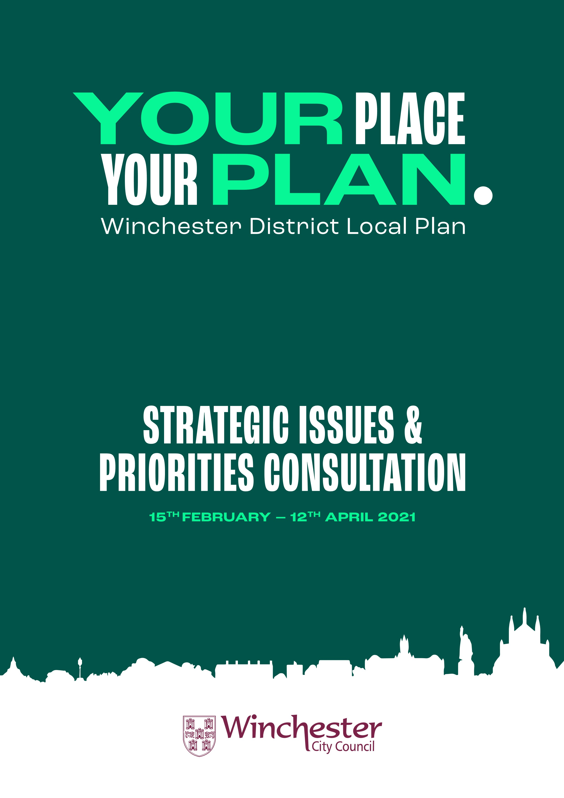

CONTENTS
- Introduction
- Legislation
- Statement of Common Ground

- Introduction
A Statement of Common Ground (to be referred to throughout as SoCG), of which concerns strategic cross-boundary matters, is a written record of the progress made by strategic plan-making authorities (and other prescribed bodies) during the process of (non-exhaustive) producing or reviewing a local plan. It documents the effective co-operation between the parties and outlines matters that are common ground (agreed) and areas of disagreement. Introduced by the 2018 National Planning Policy Framework, strategic policy making authorities are required to produce, maintain, and keep up to date a SoCG to highlight the agreements on cross-boundary strategic issues.
This SoCG is used to demonstrate that the respective authorities (Winchester City Council and Havant Borough Council) have cooperated on cross-boundary matters; and that the plan has been prepared in a positive and effective manner, therefore meeting the soundness test. The document assists in presenting evidence that plans are deliverable over the plan period and based on effective joint working across local authority boundaries. Furthermore, it is also part of the evidence required for local planning authorities to demonstrate that they have complied with the legal compliance of the Duty to Cooperate.
This SoCG has been prepared following discussions between Winchester City Council and Havant Borough Council following the publication of the Proposed Submission Local Plan (Regulation 19). It was prepared and signed during the 6 week public consultation on the Regulation 19 Winchester City Council Local Plan which commenced on 29th August 2024. It documents the outcomes of co-operation to date in preparing the local plan in order to inform and shape a positively prepared and justified strategy. In doing so it addresses, has been produced in accordance with, and takes account of the requirements set out in the current National Planning Policy Framework (NPPF), Planning Practice Guidance (PPG), relevant planning acts, and any other applicable information.
This document therefore sets out the position regarding points of common ground on relevant strategic cross-boundary matters and can be read as a standalone document.
- Legislation
The “Duty to Cooperate” was introduced by Section 33A of the Planning and Compulsory Purchase Act (2004) from Section 110 of the Localism Act (2011) as a strategic planning mechanism to replace regional spatial strategies. It places a legal duty on Local Planning Authorities, County Councils and prescribed public bodies to engage constructively, actively, and on an ongoing basis to maximise the effectiveness of local plan and marine plan preparation in the context of strategic cross boundary matters.
Strategic matters regarding plan-making refers to: “sustainable development or use of land that has or would have a significant impact on at least two planning areas, including (in particular) sustainable development or use of land for or in connection with infrastructure that is strategic and has or would have a significant impact on at least two planning areas.” (Section 33A, (4)(a))
Additionally, paragraph 20 of the NPPF outlines the strategic policies that a local plan should address, resolve, and where necessary, make provision for, these being:
- “Housing (including affordable housing), employment, retail, leisure and other commercial development;
- The provision of infrastructure for transport, telecommunications, security, waste management, water supply, wastewater, flood risk and coastal change management, and the provision of minerals and energy (including heat);
- Community facilities (such as health, education and cultural infrastructure); and
- Conservation and enhancement of the natural, built and historic environment, including landscapes and green infrastructure, and planning measures to address climate change mitigation and adaptation.”
Paragraphs 24 – 27 of the NPPF recognises this duty and considers effective, joint working between relevant bodies as integral to a positive and well-prepared strategy. Paragraph 26 also identifies joint working as helping to determine additional infrastructure, and whether development needs that cannot be wholly met within a particular plan area could be met elsewhere. PPG paragraphs 029 – 033, and 075 provide further information on meeting the Duty to Cooperate, explains the differences between the Duty to Cooperate and a SoCG, illustrates how the Duty to Cooperate is considered during examination, and how the Duty to Cooperate should be addressed during plan review.
Further to this, two of the four “tests of soundness” of Local Plans (NPPF Paragraph 35) directly relate to the Duty to Cooperate, specifically:
- “Positively prepared – providing a strategy which, as a minimum, seeks to meet the area’s objectively assessed needs; and is informed by agreements with other authorities, so that unmet need from neighbouring areas is accommodated where it is practical to do so and is consistent with achieving sustainable development;
- Effective – deliverable over the plan period, and based on effective joint working on cross-boundary strategic matters that have been dealt with rather than deferred, as evidenced by the statement of common ground”
In regard to the production of a SoCG, paragraph 27 of the NPPF specifically states:
“In order to demonstrate effective and on-going joint working, strategic policy making authorities should prepare and maintain one or more statements of common ground, documenting the cross-boundary matters being addressed and progress in cooperating to address these. These should be produced using the approach set out in national planning guidance and be made publicly available throughout the plan-making process to provide transparency.”
The Plan Making chapter of the PPG and in particular the Maintaining Effective Cooperation section (paragraphs 009 – 028) provides additional information and guidance on how authorities should (non-exhaustive): produce a SoCG, what cross-boundary matters should be included, carrying out effective cooperation, activities documented, functional geographical area, and preparation and publication.
- Statements of Common Ground
This section comprises of the matters that Winchester City Council and Havant Borough Council have entered into in support of Winchester Proposed Submisison Local Plan (Regulation 19). This statement demonstrates the current understanding of points of common ground and areas of disagreement for relevant strategic cross-boundary matters.

- List of Parties involved:
Winchester City Council and Havant Borough Council.

- Signatories:
Both parties agree that this interim SoCG is an accurate representation of matters discussed and issues agreed upon, or where there are areas of disagreement, this statement documents the issue, and that both parties confirm their respective position.

It is agreed that these discussions will inform the Winchester City Council Local Plan and the emerging Havant Borough Council Building a Better Future Plan. Both parties will continue to work collaboratively to meet the Duty to Cooperate obligations and will both continue to work proactively on the key strategic cross boundary issues identified in this document.

For Winchester City Council the Statement of Common Ground is signed by Julie Pinnock, Corporate Head of Planning and Regulatory Services.

For Havant Borough Council this Statement of Common Ground is signed by Alex Robinson, Executive Head of Place.
Signed: 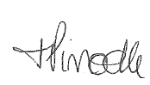 Signed: 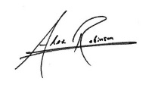

Name: Julie Pinnock Name: Alex Robinson

Position: Corporate Head of Planning & Position: Executive Head of Place
Regulatory Service

Winchester City Council Havant Borough Council

- Strategic Geography & Plan-Making History
This section will outline the strategic geographical relationship between the authorities demonstrating the geographical positioning, identifying key geographic factors and planning designations that influence policies within the emerging plans, recognising primary travel routes and the historic planning strategy of the combined area.

The section will also provide a brief update of the plan-making process to date and anticipated timeline for adoption.

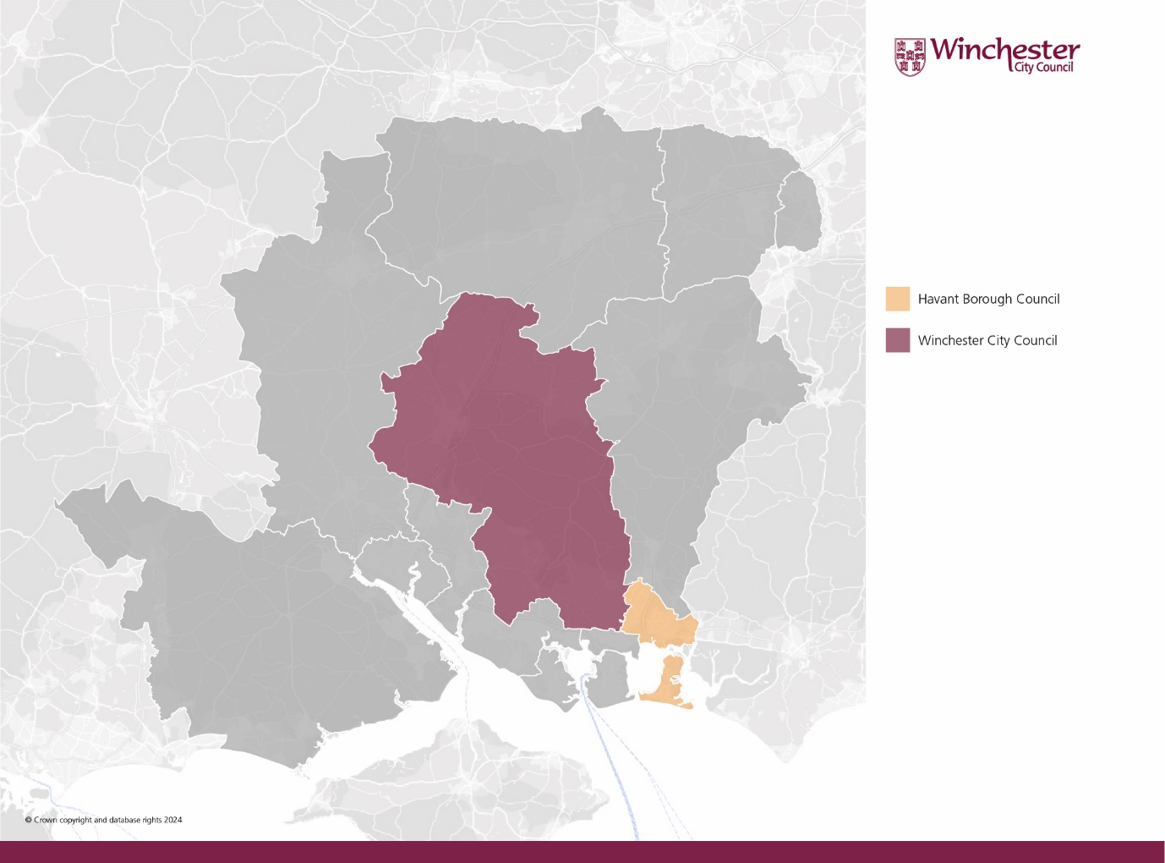
Map demonstrating the strategic geographical relationship between Winchester and Havant

Havant is situated to the south-east of the Winchester administrative area with East Hampshire district to the north and Portsmouth city to the south-west. The strategic road network does not pass through from one area to the other; however, the A27 that runs through the Havant borough merges into the M27 of which allows access into the Winchester district to the south. The borough town of Waterlooville physically adjoins the boundary of Winchester and forms part of a Strategic Urban Extension in the existing adopted Winchester City Council Local Plan and the Winchester City Council Proposed Submission Local Plan (Regulation 19). The South Downs National Park planning designation areas affects Winchester City but not Havant Borough. A large area of the Winchester district comprises the park, and whilst the park does not venture into the Havant Borough, its proximity is considered as part of the plan-making exercises. Both authorities are within the county of Hampshire and are both involved in the Partnership for South Hampshire with a number of other authorities.

Winchester City Council:

The existing WCC Local Plan Part 1 (JCS with the SDNPA) was adopted during March 2013 with the Local Plan Part 2 Housing and Employment allocations adopted during April 2017 and Gypsy, Traveller & Travelling Showpersons Development Plan Document (Traveller DPD) adopted in 2019, forming the Development Plan as a whole. Work on the emerging plan began during 2018 with a Strategic Issues and Priorities consultation taking place Feb – April 2021 followed by a draft plan Regulation 18 consultation occurring during Nov – Dec 2022.

Subsequent to the two Regulation 18 consultations, a six week public consultation on the Winchester City Council Proposed Submission Local Plan started on the 29th August 2024. Following this, it is anticipated that the Local Plan will be submitted to the Inspectorate by November 2024 with the Examination will be in early in the New Year. Once adopted it will replace the existing development plan.

Havant Borough Council:

The existing Havant Borough Local Plan (the Core Strategy – Local Plan part 1) was adopted on 1 March 2011 followed by the Allocations Plan (Local Plan part 2) that was adopted 23 July 2014. The Core Strategy sets out the strategic direction and broad distribution of development for the Borough, whilst the Allocations Plan identifies sites for specific uses including housing, employment, retail, recreation and green infrastructure up to 2026.

Following the withdrawal of a previous Local Plan from examination in March 2022, the Council has commenced work on a new Local Plan. In Autumn 2022, the Council carried out a Regulation 18 consultation focused on key issues. The Council intends to carry out a further Regulation 18 consultation on a Draft Local Plan under Regulation 18, before moving to the Pre-Submission (Regulation 19) stage.

- Strategic Matters
This section sets out where agreement has been reached on cross-border strategic matters, or where further work to reach common ground is required. Duty to Cooperate meetings have taken place over the course of the Local Plan review to discuss and resolve matters presented as part of the plan preparation, details of which and minutes documenting the outcome of the meeting(s).

At the time of preparing this Statement of Common Ground, both authorities agree the following are matters of strategic, cross-bondary importance:

- Meeting identified housing needs within the district and unmet housing needs, both from Havant Borough and the wider sub-region;
- Meeting the identified need for Gypsy, Traveller and Travelling Showpeople accommodation within the district and wider unmet needs;
- Meeting identified employment needs within the district and unmet housing needs Major Development Area at West of Waterlooville; and
- Continued work as part of the Partnership for South Hampshire.

The following demonstrates areas of common ground and/or details of disagreement or where further work is required, and will be updated as the plan moves to submission and examination:

Housing

Winchester City Council:

The Winchester City Council Proposed Submission Local Plan (Regulation 19) aims to deliver sufficient land to meet the housing need for the Local Plan area. In assessing the housing requirement for the plan-period (2020 – 2040), the amount of existing pipeline development is taken into consideration. The Standard Method output in the current NPPF (December 2023) has established an overall need for Winchester District over the plan-period of 13,565 dwellings; the Standard Method is updated on an annual basis with the first 4 years from 2020 resulting in yearly needs for 685, 666, 707 and 691 dwellings (2,749 total). The remaining 16 years of the plan-period (2024-2040) equates to 676 dwellings per annum i.e., 10,816, totalling 13,565 dwellings.

It remains WCCs intention to meet the Standard Method housing need of the Local Plan area. In addition to this the plan makes provision for an ‘unmet needs allowance’ to help with meeting the (currently undefined) unmet needs of neighbouring authorities in accordance with the Partnership for South Hampshire’s 2023 ‘Spatial Position Statement’.

The below table illustrates the overall position in terms of housing need and supply for the Winchester District:

Winchester District Housing Need |  | Winchester District Housing Provision
Standard Method need for Plan period 2020-2040 (see Table H1) | 13,565 | Completions since start of Local Plan period (2020-2023) | 3,170
Unmet Needs Allowance (for unmet need in neighbouring authorities) | 1,900 | Outstanding planning permissions | 6,780
 |  | Other Commitments (previous Local Plans incl. SDNP) | 745
 |  | Windfall development | 1,895
 |  | Additional allocations made in this Local Plan | 2,875
Total District Housing Requirement | 15,465* | Total District Housing Provision* | 15,465

* Includes approximately 350 dwellings within the South Downs National Park part of Winchester District

The table relates to housing need and supply for the whole of Winchester District, reflecting the area covered by the Standard Method figure. The Local Plan area excludes that part of the District within the South Downs National Park, where it is assumed that about 350 dwellings will be completed. The remaining housing requirement for the Local Plan area is 15,115 dwellings (15,465 – 350 = 15,115).

Havant Borough Council:

The Inspectors’ Interim Findings (see paragraph 52) in respect of the withdawn Local Plan acknowledged that Havant may be an authority that cannot sustainably meet its housing needs in accordance with paragraph 11 b) of the NPPF. Nevertheless, Havant Borough Council’s starting point is that no stone will be left unturned in order to meet the need for development.

The Council has undertaken a comprehensive and robust assessment of the following sources of supply to assess how far it is able to meet its own housing need:

Outstanding planning permissions;
Adopted Local Plan allocations without planning permission;
Potential housing sites; and
Windfall development.

The Council’s work on the previous Local Plan and the Inspectors’ interim findings report clearly signal a need for robust evidence and that any sites included meet the NPPF ‘developable’ definition as a minimum. The Council will keep all sources of housing supply up to date and robust in order to demonstrably ensure that every effort is made to address housing need within the Borough’s boundary. The Council has a continuous ‘Call for Sites’ open and will promote this heavily through the upcoming consulation on the Draft Local Plan.

Applying a housing need figure of 516 dwellings, there is a need for 10,320 dwellings in Havant Borough over a Local Plan period to 2043 (see table below).

Havant Borough Housing Provision
Completions since start of Local Plan period  (2022-2023) | 495
Outstanding planning permissions at 1/4/23 | 1,524
Allocations in Adopted Local Plan without planning permission | 606
Potential housing sites | 1,524
Potential housing sites where previous Inspectors’ raised deliverability concerns | 700
Windfall | 1,162
Total Housing Provision | 6,011

Against a standard method figure of 10,320 dwellings, the Council is only able to identify a supply of 6,011 dwellings over the plan period. This results in an unmet housing need figure of 4,309 dwellings.

Whilst acknowledging this is a very high level of unmet need, the Council will leave no stone unturned to maximise housing delivery in Havant Borough whilst ensuring sites which meet the NPPF’s definition of sustianale development are allocated. All of the sites submitted through the consultation in late 2022 are undergoing assessment and may offer the potential to increase supply, though even if all were allocated, this would not result in the Borough being able to meet the standard method need for housing.

Havant Borough Council will continue to reach out to the development industry and landowners to ascertain whether there are any further sites which could be available for development and be assessed as part of the plan-making process. However, given the extent of very constrained supply of land and proposals to update the standard method which would substantially increase this need, there will be insufficient capacity to meet objectively assessed need within the Plan area by a substantial margin.

The NPPF indicates that any needs that cannot be met within neighbouring authorities should be taken in to account in establishing the amount of housing to be planned for. HBC will therefore require assistance from neighbouring authorities including WCC to provide meaningful contribution towards addressing unmet need. This must be very clearly identified in setting the housing requirement for an area.

Following initial discussion on these matter, on 5th March 2024, Havant Borough Council formally wrote to all neighbouring local planning authorities and those within the Housing Market Area setting out its housing supply position, the extent of unmet need as confirmed above and formally requesting assistance from those authorities in addressing this need.

As part of this formal letter, and within Havant Borough Council’s representations on the Draft Winchester Local Plan (Regulation 18), it was noted that a buffer is provided to contribute to the PfSH shortfall. Havant Borough Council notes that the level of buffer to accommodate unmet need has risen in the Regulation 19 plan compared to the Regulation 18 draft plan to 1,900.

Havant Borough Council notes the position in the Regulation 19 Winchester District Local Plan of a 1,900 “unmet needs allowance (for unmet need in neighbouring authorities)” as set out in table H2. Havant Borough Council considers that in order for the Wincher District Local Plan to be clear, unambiguous and fully meet the ‘positively prepared’ and ‘effective’ tests of soundness, it is necessary for the plan to explicitly set out how the unmet needs allowance is to be apportioned between neighbouring local planning authorities and/or those within the housing market area.

The Borough Council recognises the benefits in having up-to-date local plans across all local authority areas in the country and supports the City Council’s position in submitting its Local Plan under transitional arrangements. It is considered that if a significant proportion of the unmet need allowance is apportioned explicitly to addressing unmet housing need in Havant Borough that this would represent a sizeable and significant contribution to addressing unmet need, in line with paragraphs 35 (a) and (c) of the NPPF (the ‘positively prepared’ and ‘effective’ tests of soundness).

Furthermore, such a position would represent a substantial proposal which continues the positive and collaborative working between the two local authorities, in line with paragraph 24 of the NPPF (the ‘duty to cooperate’) together with the legal compliance tests set out in section 2.

Should the proposed approach set out above be enacted through the Main Modifications process, Havant Borough Council would positively support the legal compliance and soundness of the Winchester District Local Plan through the examination process.

Agreed Position:

It is agreed that WCC are in a position to meet their demonstrable need in full and will continue in using the Standard Method output in the current NPPF (Dec 2023) to establish their local housing need. It is also agreed that HBC are unlikely to be able to meet the need established through the Standard Method, resulting in a substantial unmet need.

HBC formally requested assistance from WCC in meeting the unmet need presented by letter dated 5 March 2024 (Appendix 1). WCC responded by letter dated 25 March 2024 (Appendix 2) and have referred to the strategy set out in the PfSH Spatial Position Statement 2023 and confirmed the intention to include an ‘unmet needs allowance’, to contribute to meeting the unmet needs of neighbouring authorities. WCC’s Proposed Submission Local Plan (Regulation 19) includes an ‘unmet needs allowance’ of about 1,900 dwellings to assist in meeting the unmet needs of neighbouring authorities, including Havant.

It is noted by both WCC and HBC that the ‘unmet needs allowance’ is not apportioned to any one local authority within the Regulation 19 plan and that the level of unmet need in the sub-region exceeds the ‘unmet needs allowance’. Both authorities agree that the Winchester District Local Plan would meet the ‘positively prepared’ and ‘effective’ tests of soundness if the unmet need allowance is specifically apportioned to individual local authorities.

It is considered that such an approach would represent a sound approach, considering the additional formal request from Portsmouth City Council to accommodate unmet housing need. The apportionment of the unmet need allowance would be representative of the total unmet need between the two authorities, when also considering the inclusion of an 800 home allowance in the recently adopted Fareham Local Plan.

It has been agreed that based on the current unmet need allowance for housing in the Regulation 19 Local Plan (Table H2), which has not yet been tested at the Local Plan examination, to reflect the total unmet need in the housing market area would necessitate the following;

- To Portsmouth City Council: 30% apportioment of the unmet need housing allowance in the Winchester District Local Plan.

- To Havant Borough Council: 70% apportioment of the unmet need housing allowance in the Winchester District Local Plan.13

Both local authorities agree to work collaboratively and with Portsmouth City Council on modifications to propose alongside the submission of the Winchester District Local Plan for the Inspector to consider which would put in place the framework above.

The above agreement with Portsmouth City Council and Havant Borough Council will be subject to change in the event that:
- An additional ask is made of Winchester regarding any unmet need; or
- The housing target and/or unmet need allowance in the Winchester District Local Plan changes in the course of its examination.

Both authorities agree that a specific number of homes to be assigned to addressing unmet need in Portsmouth and Havant in Table H2 (or elsewhere) could be subject to multiple changes through the examination and hence it is expressed here as a percentage of the total unmet need allowance. Nonetheless, it is accepted by both authorities that by the conclusion of the examination, it will be necessary for Table H2 (or elsewhere) to set out accommodation of unmet need in Portsmouth and Havant as an explicit number of homes. This would enable a clear and transparent approach for all stakeholders and follow the same approach as the recently adopted Fareham Local Plan, ensuring consistency for how accommodation of unmet need is expressed in the housing market area.

Both authorities agree to work in collaboration with all other PfSH authorities in addressing sub-regional housing need. Nonetheless, on the basis that the proposals above are applied there would be no remaining areas of disagreement between Havant Borough Council and Winchester City Council regarding this matter in relation to the Winchester District Local Plan, on the basis that it is submitted under the Transitional Arrangements set out by Government in August 2024.

Gypsy and Traveller Accommodation Needs

Winchester City Council:

In support of the Local Plan review, a Gypsy and Traveller Accommodation Assessment has been produced to inform the likely need for Gypsy and Traveller accommodation over the plan period. The GTAA breaks down the overall Gypsy, Traveller, and Travelling Showpeople need into 4-year bands. The need identified takes into account unauthorised pitches, pitches with temporary planning permission, concealed and doubled-up households and movement from bricks and mortar in the first 4 years. The total net new household formation is then applied proportionately across the remaining 4-year bands.

The GTAA identifies an overall need over the period to 2039 for:
- 115 pitches for Gypsy and Travellers that met the PPTS planning definition of a traveller;
- 85 pitches for Gypsy and Travellers that at the time of preparing the GTAA did not meet the planning definition of a traveller;
- 27 plots for Travelling Showpersons that met the PPTS planning definition of a traveller; and
- 6 plots for Travelling Showpersons that at the time of preparing the GTAA did not meet the planning definition of a traveller.

The consultants were also appointed to prepare a Pitch Deliverability Assessment (PDA) with the objective to provide advice on the suitability, availability, and achievability of any existing private Gypsy and Traveller sites (with permanent planning permission) to assist in meeting the identified accommodation needs for Gypsies and Travellers.

The Council has undertaken further work following the GTAA to take account of changes to the definition of travellers in the Planning Policy for Traveller Sites and changes in traveller needs and on key sites. This has reduced the overall need for pitches, particularly for gypsy travellers and has examined various potential sources of supply. A Gypsy and Traveller Topic Paper has been produced to evidence this work, which reaches the following conclusions on traveller pitch / plot needs and supply:

 | Gypsy traveller (Years 0-5) | Gypsy traveller  (Years 6-19) | Travelling showpersons  (Years 0-5) | Travelling showpersons  (Years 6-19)
Pitch / plot need | 51 | 40 | 22 | 13
Pitch / plot supply | 38 | 90 | 11 | 6
Surplus / Shortfall | -13 | +50 | -11 | -7

There is scope to meet the need for about 68 additional gypsy traveller pitches through the intensification or expansion of existing sites. In addition, the Council is seeking to bring the former public site at Tynefield (Whiteley) back into use and to expand the number of pitches provided to about 30 and there is scope to achieve about 30 additional pitches, if needed, through windfall provision.
The need for plots for travelling showpeople is much more modest and there is scope to provide about 17 additional plots through site intensification or expansion and maintaining travelling showpersons’ use of plots at The Nurseries, Shedfield.

As a result, the Council expects to be able to meet gypsy traveller needs over the Local Plan period as a whole, but is unable to identify sufficient available and deliverable sites to meet current needs (years 0-5, 2022-2026). For travelling showpersons, the Council is unable to meet either short-term or longer-term needs.

Havant Borough Council:

ORS were also appointed to prepare the GTAA for Havant Borough, which is in its final draft stages of production. The study has been published on the Borough Council’s website.

In Havant Borough, there is not a need for Gypsy and Traveller pitches or plots for Travelling Showpeople, nor a need for any formal Transit provision.

Agreed Position:

Both WCC and HBC have updated their evidence base to support the delivery of Gypsy and Traveller accommodation as part of their respective plan reviews. Subsequently, WCC has sent a formal ‘unmet need’ letter (copy of letter can be found in the Winchester City Council Duty to Cooperate Statement of Compliance) requesting assistance in meeting the demonstrable need for Gypsy and Traveller accommodation, and the subsequent HBC response.

The WCC position has been presented as is and are unable to meet their own need with the land made available to them. This has been evidenced in the respective GTAA and Pitch Delivery Assessment, Call for Sites, SHELAA exercises, and the Gypsy and Traveller Topic Paper. The HBC GTAA has recently been updated as part of the plan review resulting in no additional need over the planning period. Given the inability to meet other forms of development need, HBC have confirmed that they are not in a position to assist in the delivery of Gypsy and Traveller development in the Winchester district due to the land constraints and availability experienced in the Havant borough.

Both authorities agree to continue to monitor the situation with the updating of evidence and will update their respective positions accordingly.

There are no remaining areas of disagreement between the Borough Council and City Council regarding this matter.

Employment Land

Winchester City Council

In terms of employment floorspace, the City Council has undertaken an updated Employment Land Study (2024) that tested three different economic forecasts which is available on their website. The Consultants recommend that the employment land requirement is based on a range, amounting to 27.6ha – 37.8 ha. The Regulation 19 Local Plan makes provision for an estimated 39.36 ha of employment land, which will meet the upper end of the range identified. Part of the provision with planning consent relates to the continued allocation of land at West of Waterlooville (about 15.25 ha) and small sites at Southwick, Hambledon and Soberton, close to Havant Borough.

There is a small surplus of provision across the District, which may be increased if the need for employment land transpires to be at the lower end of the range being planned for. This may help make a small contribution to potential needs in Havant, but the Council is not aware of other suitable opportunities. It is also noted that the PfSH Spatial Position Statement (2023) identifies a significant ‘surplus’ of employment land across the PfSH area.

Havant Borough Council

Havant’s constrained land supply also means that it is extremely challenging for the Borough to identify sufficient sites to meet employment need. The Council has commissioned an Employment Land Review (ELR), building upon the PfSH Economic, Employment and Commercial Needs Study. This study is nearing completion and will be published on the Council’s website when it is available.

In terms of office provision, the ELR will identify a gap of 30,000sqm of unmet need. The ELR will recommend various remedial actions, including encouraging office development in town centres and combined employment allocations. However it is considered that these are highly unlikely to result in a plan which is able to meet the need for office development.

In terms of industrial and distribution provision, the ELR will identify a gap of 16,000sqm. This is based on need uplifting to reflect the additional demand which is generated by the Solent Freeport Tax Site at Dunsbury Park. The tax site status of this area ensures that development is unable to consider in its entirety to be meeting local need.

Following the publication of the ELR, Havant Borough Council will write to neighbouring local authorities and those in the functional economic area in order to formally request assistance in meeting the unmet need.

Agreed Position:

It is agreed that both authorities are outlining their Employment Land provision within their respective plans and evidence base studies. WCC is able to provide adequate employment land over the Local Plan period. HBC have identified a potential shortfall of employment land, although this remains to be published.

Both councils will continue to engage together and through the Partnership for South Hampshire on this strategic matter. There are no remaining areas of disagreement between the Borough Council and City Council regarding this matter.

Major Development Area at West of Waterlooville

Agreed Position:

Both Councils agree to continue with the positive ongoing collaboration and engagement in relation to the delivery of the Major Development Site at West of Waterlooville and regeneration of Waterlooville town centre.

Partnership for South Hampshire

WCC and HBC are active members of the Partnership for South Hampshire (PfSH), which was originally formed in 2003 as the Partnership for Urban South Hampshire (PUSH). It is a partnership of district and unitary authorities, together with Hampshire County Council and the New Forest National Park Authority, working together to support the sustainable growth of the South Hampshire sub-region. The area covered by PfSH and the authorities involved is shown in figure 1.

Figure 1: Map of the Partnership for South Hampshire sub-region
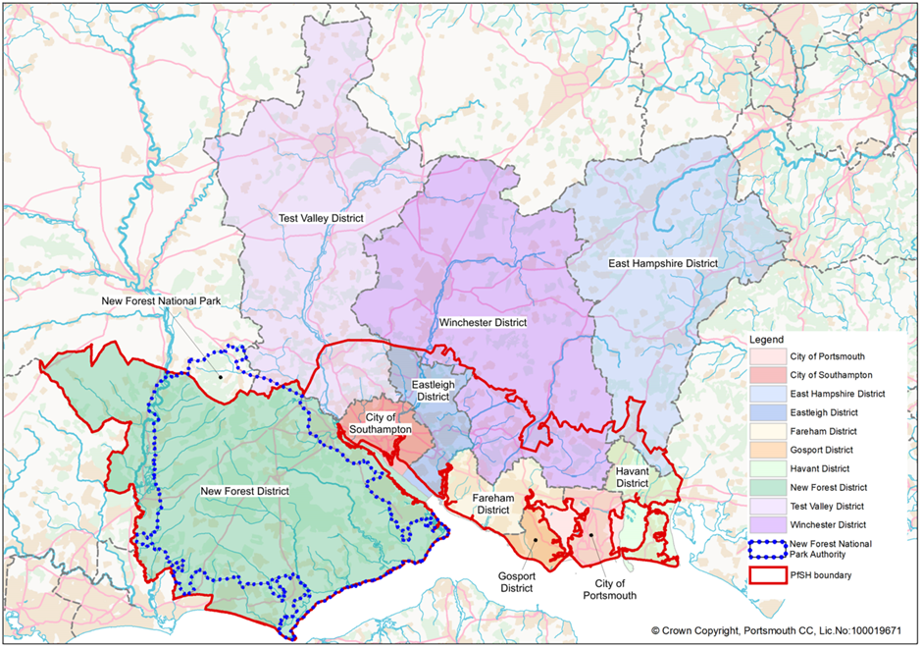

The Partnership has a strong track record in collaborative working to achieve common goals in South Hampshire.

The ethos of collaborative cross boundary working continued in South Hampshire after the abolition of regional planning and the revocation for the South East Plan in 2013. As well as joint working between member authorities, PfSH works with partner agencies in the sub-region and Government departments to prepare joint strategies and pool resources.
Growth in the sub-region is constrained as it is bounded by two national parks, an Area of Outstanding Natural Beauty, the coast/estuaries, a range of international, national and local biodiversity designations and it needs to accommodate land for biodiversity mitigation and net gain. South Hampshire is already heavily built up in places, with areas of valued countryside often important in landscape terms or as settlement gaps protecting the identity of individual towns and villages. Some areas are less accessible by public transport.

The PfSH Spatial Position Statement was approved by Joint Committee in December 2023. It aims to provide guiding principles for local plans to help deliver sustainable development within South Hampshire. It should be noted that it is not an upper tier plan with which future local plans will need to conform. It does, however, help inform the preparation and strategic co-ordination of local plans under the duty to cooperate. Table 1 of the Spatial Position Statement compares housing need and supply along with shortfalls and surpluses for each local authority in PfSH as a snapshot in time. On this basis the latest shortfall is 11,771 dwellings (2023 – 2036). It is noted that the Spatial Position Statement only covers the period up to 2036 and both WCC and HBC’s Local Plans will have a longer plan period. Several evidence based documents supporting the Spatial Position Statement were published at the same time including the Broad Areas of Growth Assessments.

The Spatial Position Statement retains the strategic principle of focusing growth on cities/urban areas first to maximise housing delivery within existing urban areas and identifies a number of existing strategic development locations in SPS7. It also identifies new Broad Areas of Search for Growth in SPS8 as follows:

• South-east/east of Eastleigh Town (Eastleigh);
• Havant Town Centre (Havant);
• Waterlooville Town Centre (Havant);
• Southleigh (Havant);
• East of Romsey (Test Valley);
• South-west of Chandler’s Ford (Test Valley); and
• East of Botley (Winchester).

Agreed Position:

Both WCC and HBC agree to work with all other PfSH authorities to continue collaborating to explore and resolve cross-boundary planning in South Hampshire. Both WCC and HBC also agree that whilst a helpful first step, the PfSH Spatial Position Statement does not fully discharge the duty to cooperate.

- Governance Arrangements
For the purpose of this statement of common ground, and to evidence the cooperative process undertaken between Winchester City Council and Havant Borough Council, it has been decided that the signing of the Statement of Common Ground can be at the Head of Service level.

- Timetable for review and ongoing cooperation
Winchester City Council will continue to work collaboratively with Havant Borough Council to address strategic matters that, in addition to the above, arise through the plan-making process, including the examination into the Winchester District Local Plan. Notably, the Statement of Common Ground would be updated in the event that the 1,900 unmet need allowance set out in table H2 were amended for whatever reason throughout the course of the examination,. The contents of this SoCG will be reviewed and updated accordingly.

The Town and Country Planning (Local Planning) (England) Regulations 2012 (legislation.gov.uk)
National Planning Policy Framework (publishing.service.gov.uk) (Dec 2023) para 35
National Planning Policy Framework (publishing.service.gov.uk) (Dec 2023)
Plan-making - GOV.UK (www.gov.uk) Maintaining Effective Cooperation
Planning and Compulsory Purchase Act 2004 (legislation.gov.uk)
Localism Act 2011 (legislation.gov.uk)
download (havant.gov.uk)
Identified by Table 1 of the Council’s Housing Delivery Position Statement
The Council’s evidence on windfall development will be updated to inform the new Local Plan.
The standard method calculation of 516 dwellings per annum (dpa) is used from 2022, though the standard method need calculation for 2024 is 512 dwellings per annum prior to the publication of the 2023 affordability ratio which is due to be published in March 2024. The former is used as a worst case scenario.
Winchester City Council, East Hampshire District Counicl, South Downs National Park Authority, Chichester District Council, Portsmouth City Council, Gosport Borough Council, Fareham Borough Council.
Portsmouth City Council have also been part of these discussions – a separate bilateral Statement of Common Ground is in place between Portsmouth City Council and Winchester City Council. An addendum is currently being prepared which will be published on the respective websites in due course.
Based upon the unmet need allowance of 1,900 homes set out in Table H2 in the Proposed Submission Plan, this would equate to 570 homes for Portsmouth City and 1330 homes for Havant Borough.
2022 10 31 Winchester GTAA Final Report (5).pdf
Local Plan Evidence: Studies and Strategies | Havant Borough Council

